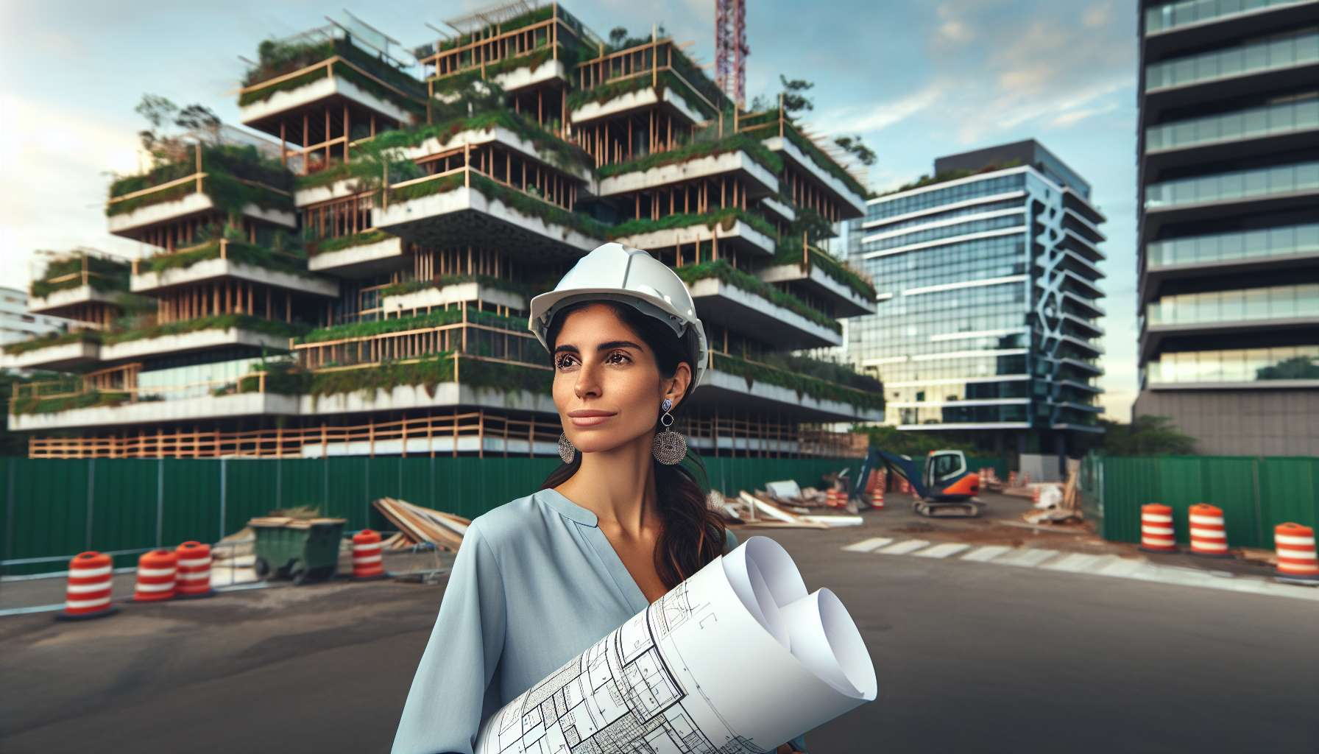

Channel 21, also known as the Channel of Materialization, is formed by the connection of gates 43 and 23. It's a channel of the form matrix, connecting the throat center to the heart center. This channel brings a powerful and constant energy of materialization, the ability to give form and substance to visions and inspirations.  
  
When this channel is defined, it grants the individual an innate talent for transforming ideas into tangible and enduring realities. People with this defined channel are often builders, entrepreneurs, artists who excel in the art of materializing their dreams and those of others. They have a gift for gathering the resources, skills, and energies needed to successfully carry out concrete projects, from conception to realization.  
  
However, this same materialization energy can also manifest as a tendency towards over-identification with external achievements, rigidity in execution, or difficulty letting go. People with the Channel of Materialization defined may struggle to adapt to plan changes, to delegate, or to consider a project finished. They may also tend to neglect relational or emotional aspects in favor of the tangible advancement of things.  
  
Let's take the example of a project manager with the Channel of Materialization defined. In her work, she demonstrates a remarkable ability to coordinate teams, deadlines, and budgets to deliver quality achievements on time and according to specifications. Her energy of materialization seems to allow her to visualize each step clearly, anticipate obstacles, and find pragmatic solutions to overcome them. However, she may also tend to be too directive, too attached to her way of doing things, risking demotivating or alienating certain collaborators. She must learn to trust, to value everyone's contributions, and to celebrate collective successes as much as concrete deliverables.  
  
For individuals with this defined channel, learning to balance their materialization energy with flexibility and attention to people is a significant challenge. They must learn to remain open to adjustments along the way, to seek creative solutions with others, and to find value and satisfaction in the process as much as in the result. They must also be careful not to burn out or disconnect from their feelings in their quest for accomplishment, but to respect their own rhythms and needs.  
  
This channel is closely linked to Channel 4 (Channel of Form) that we previously explored. Together, these two channels form a powerful circuit of manifestation and structuring energy in the physical world. The Channel of Materialization brings the ability to gather elements and to take action, while the Channel of Form brings the ability to give a solid and functional structure to visions. When these two channels are defined, the individual has immense potential for concrete realization and project leadership, combining inspiration and pragmatism.  
  
On the other hand, for people with the Channel of Materialization open, the challenge is to learn to initiate and participate in others' projects without letting themselves be defined or limited by them. They can be excellent catalysts and facilitators, bringing their energy and ideas to help visions take shape in reality. However, they should be careful not to let themselves be confined to roles or tasks that do not suit them, and to keep their own creativity and sense of materialization alive.  
  
It's interesting to note that the Channel of Materialization is linked to the theme of breakthrough and accomplishment in the I Ching. Gates 43 and 23 are associated with the hexagrams of "Breakthrough" and "Bursting," which evoke images of overcoming limits, releasing potentials, and the ability to bring about the new in reality. This channel carries a deeply creative and entrepreneurial energy that knows how to overcome obstacles to manifest its aspirations.  
  
Imagine an architect with the Channel of Materialization defined. Since his earliest years, he has dreamed of building buildings that are both beautiful, functional, and ecological. His energy of materialization gives him the strength and perseverance to undertake long studies, gain experience on various construction sites, and finally create his own firm. Today, he is recognized for his ability to design and implement innovative projects that combine aesthetics and environmental performance. However, he may also tend to over-invest, to want to control every detail, at the risk of exhausting himself or creating tensions with his teams. He is gradually learning to trust, to delegate, and to savor the journey as much as the destination.  
  
In conclusion, the Channel of Materialization is a valuable source of creative energy and the ability to make visions come to life in concrete reality. But as with any powerful energy, it requires channeling with discernment, balance, and attention to others. When learning to honor our impulse for materialization while remaining flexible and attentive, we can use this channel to build works that have meaning, beauty, and durability, and that positively contribute to the world. This is a great gift and a significant responsibility for those who have this defined channel, and an invitation to cultivate our ability to bring our dreams into matter for everyone.  
  
Key takeaways:  
  
- Channel 21, also called the Channel of Materialization, links gates 43 and 23, connecting the throat center to the heart center. It brings constant energy of realization and ability to give shape to visions.  
  
- When it's defined, this channel grants an innate talent for turning ideas into tangible realities. People with this defined channel excel in the art of making their dreams and those of others materialize.  
  
- However, this energy can also manifest as over-identification with external achievements, rigidity in execution, or difficulty in letting go and adapting to changes.  
  
- To balance this energy, it is important to learn to remain open to adjustments, to value everyone's contributions and to find satisfaction in the process as much as in the result.  
  
- Channel 21 is closely connected to Channel 4 (Channel of Form), together forming a powerful circuit of manifestation and structuring energy in the physical world.  
  
- For individuals with Channel 21 open, the challenge is to learn to initiate and participate in others' projects without letting themselves be defined or limited by them, while keeping their own creativity alive.  
  
- This channel is associated with the theme of breakthrough and accomplishment in the I Ching, carrying a deeply creative and entrepreneurial energy.  
  
- The Channel of Materialization is a valuable source of creative energy but requires discernment, balance, and attentiveness to others to build meaningful works that make a positive contribution to the world.