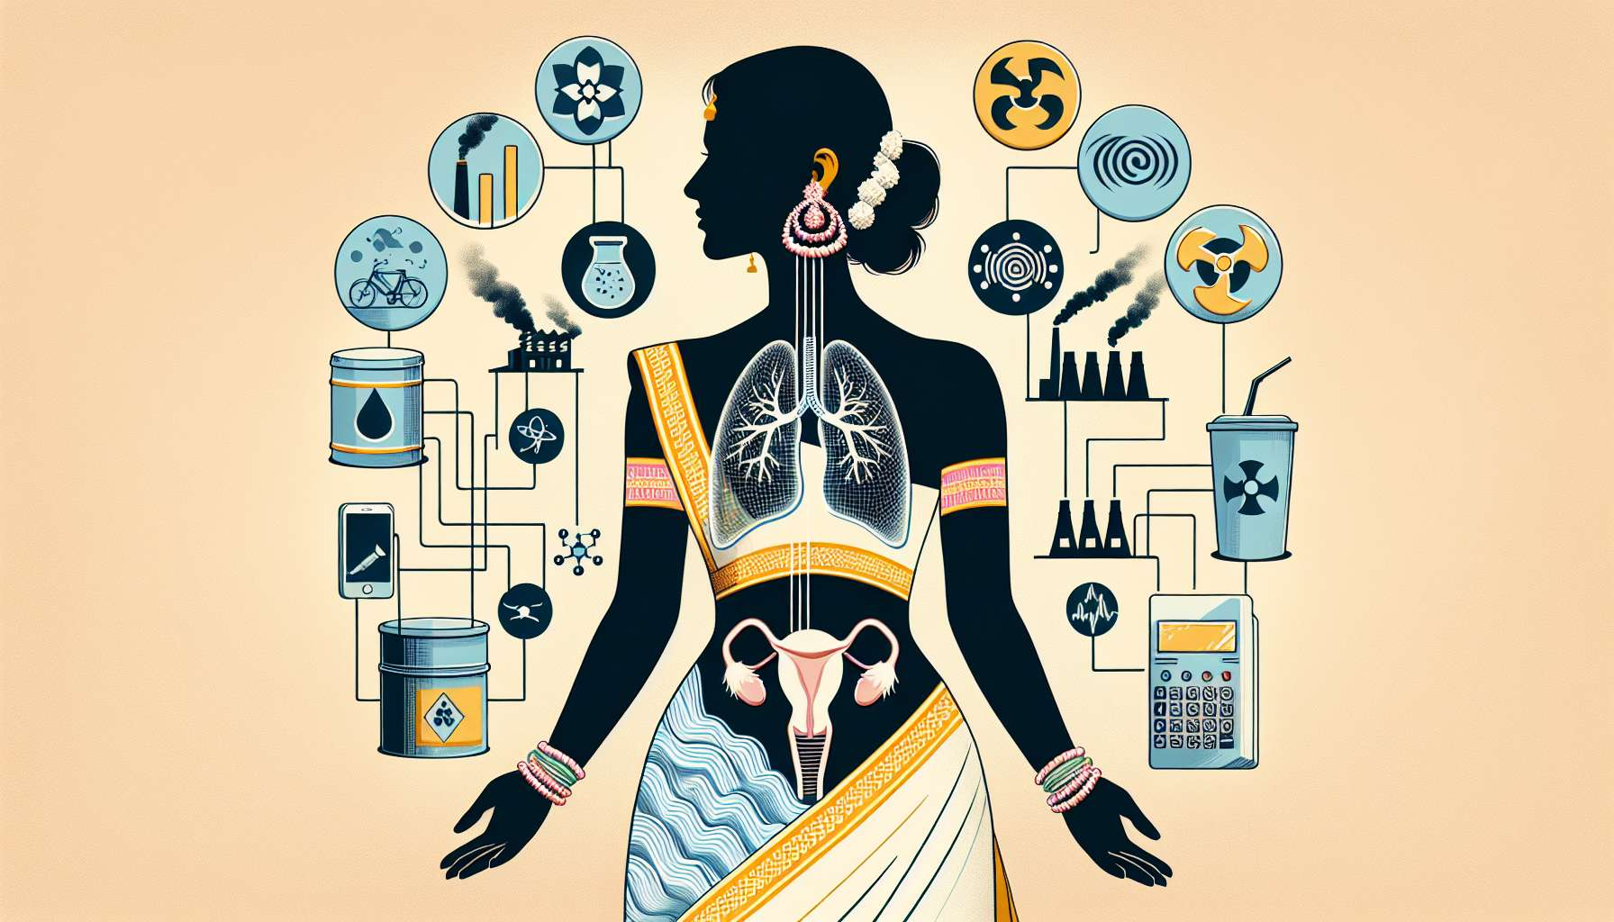

Environmental factors, such as pollution and endocrine disruptors, can have a significant impact on the menstrual cycle and women's reproductive health. Indeed, we are daily exposed to a multitude of chemical substances present in the air, water, food, and everyday consumer products, some of which have the ability to interfere with the hormonal system and disrupt the balance of the menstrual cycle.   
  
Endocrine disruptors are natural or synthetic compounds that mimic, block or alter the action of endogenous hormones by binding to their receptors or interfering with their synthesis, transport or metabolism. Among the most common endocrine disruptors are phthalates (present in plastics, cosmetics), bisphenol A (BPA, used in food packaging), parabens (preservatives in hygiene products), organochlorine pesticides (DDT, chlordane) and persistent organic pollutants (dioxins, PCBs).   
  
These substances can act as "hormonal lures", mimicking the action of estrogens or blocking that of androgens, thus disrupting the fine regulation of the hypothalamo-pituitary-ovarian axis. Chronic exposure to endocrine disruptors can lead to ovulation disorders, irregular cycles, luteal insufficiency or endometriosis. Some studies have also shown a link between prenatal or perinatal exposure to endocrine disruptors and an increased risk of early puberty, polycystic ovary syndrome (PCOS) or infertility in adulthood.   
  
Example: Sophie, 32, has been trying to conceive a child for over a year without success. After an infertility assessment, her gynecologist suspects premature ovarian insufficiency, possibly related to chronic exposure to endocrine disruptors. Indeed, Sophie has worked for several years in a plastics factory, where she is exposed daily to phthalates and BPA. Her gynecologist advises her to reduce her occupational exposure (wearing protective equipment, ventilation) and to adopt preventive measures at home (choice of natural products, avoidance of plastic containers).  
  
Air pollution, particularly in large cities, is also an environmental factor that can disrupt the menstrual cycle. Fine particles (PM2.5, PM10), nitrogen oxides (NOx) and polycyclic aromatic hydrocarbons (PAHs) emitted by road traffic and industrial activities have pro-inflammatory and pro-oxidant effects on the body. However, chronic inflammation and oxidative stress can alter the quality of ovarian follicles, disrupt oocyte maturation and lead to ovulation disorders.  
  
Epidemiological studies have shown that women living in areas with high air pollution have an increased risk of irregular cycles, dysmenorrhea (painful periods) and infertility compared to women living in less polluted areas. Chronic exposure to air pollution can also advance the age of menopause and reduce ovarian reserve, by accelerating follicular aging.   
  
Anecdote: Julie, 28, lives in a large metropolis and commutes daily by bike to work. For several months, she notices that her cycles are more irregular and that her periods are more painful than before. After discussing it with her gynecologist, she realizes that this worsening of her symptoms coincides with the winter pollution peaks in her city. Her gynecologist advises her to favor less exposed routes (parks, bike paths), to wear an anti-pollution mask and to support her ovarian function with antioxidants (vitamin C and E, coenzyme Q10).  
  
Certain physical environmental factors, such as electromagnetic fields (EMF) or ionizing radiation, can also have an impact on the menstrual cycle. Low-frequency EMFs, emitted by electrical appliances and high-voltage lines, have been associated with an increased risk of irregular cycles, dysmenorrhea and endometriosis in some studies, although the data remain controversial. Ionizing radiation (X-rays, gamma rays), used in certain medical examinations or present in specific occupational environments (nuclear power plants, airports), can alter ovarian reserve and accelerate the onset of menopause.  
  
Example: Marie, 35, works as a radiology technician in a hospital. Despite wearing a dosimeter and complying with radioprotection measures, she is concerned about the potential impact of radiation on her fertility. After discussing it with her occupational physician, she decides to limit her exposure to X-rays (rotating positions, choosing less irradiating exams) and to regularly check her ovarian reserve by measuring the anti-Müllerian hormone (AMH).  
  
In summary, environmental factors such as endocrine disruptors, air pollution or radiation can have a significant impact on the menstrual cycle and reproductive health of women. These chronic exposures can lead to ovulation disorders, irregular cycles, premature ovarian failure or endometriosis, by interfering with hormonal regulation and inducing oxidative stress. It is therefore important to limit exposure to these harmful environmental factors by adopting preventive measures in daily life (choice of natural products, avoidance of plastic, wearing protections) and supporting ovarian function with an antioxidant-rich diet. In case of persistent menstrual disturbances or doubts about the impact of one's environment on the menstrual cycle, it is recommended to consult a health professional (gynecologist, occupational physician) for personalized support and appropriate management.  
  
Key takeaways:  
  
- Environmental factors such as pollution and endocrine disruptors can disrupt the menstrual cycle and women's reproductive health.  
  
- Endocrine disruptors (phthalates, bisphenol A, parabens, pesticides) mimic, block or alter the action of hormones, leading to ovulation disorders, irregular cycles, luteal failure or endometriosis.  
  
- Air pollution (fine particles, nitrogen oxides, polycyclic aromatic hydrocarbons) has pro-inflammatory and pro-oxidant effects, altering the quality of ovarian follicles and disrupting ovulation.  
  
- Women living in highly polluted areas have an increased risk of irregular cycles, dysmenorrhea and infertility, as well as an earlier menopause.  
  
- Electromagnetic fields and ionizing radiation can also impact the menstrual cycle and ovarian reserve.  
  
- It is important to limit exposure to these harmful environmental factors by adopting prevention measures (natural products, avoidance of plastics, wearing protections) and supporting ovarian function with an antioxidant-rich diet.  
  
- In case of persistent menstrual disturbances, it is recommended to consult a health professional for personalized support.