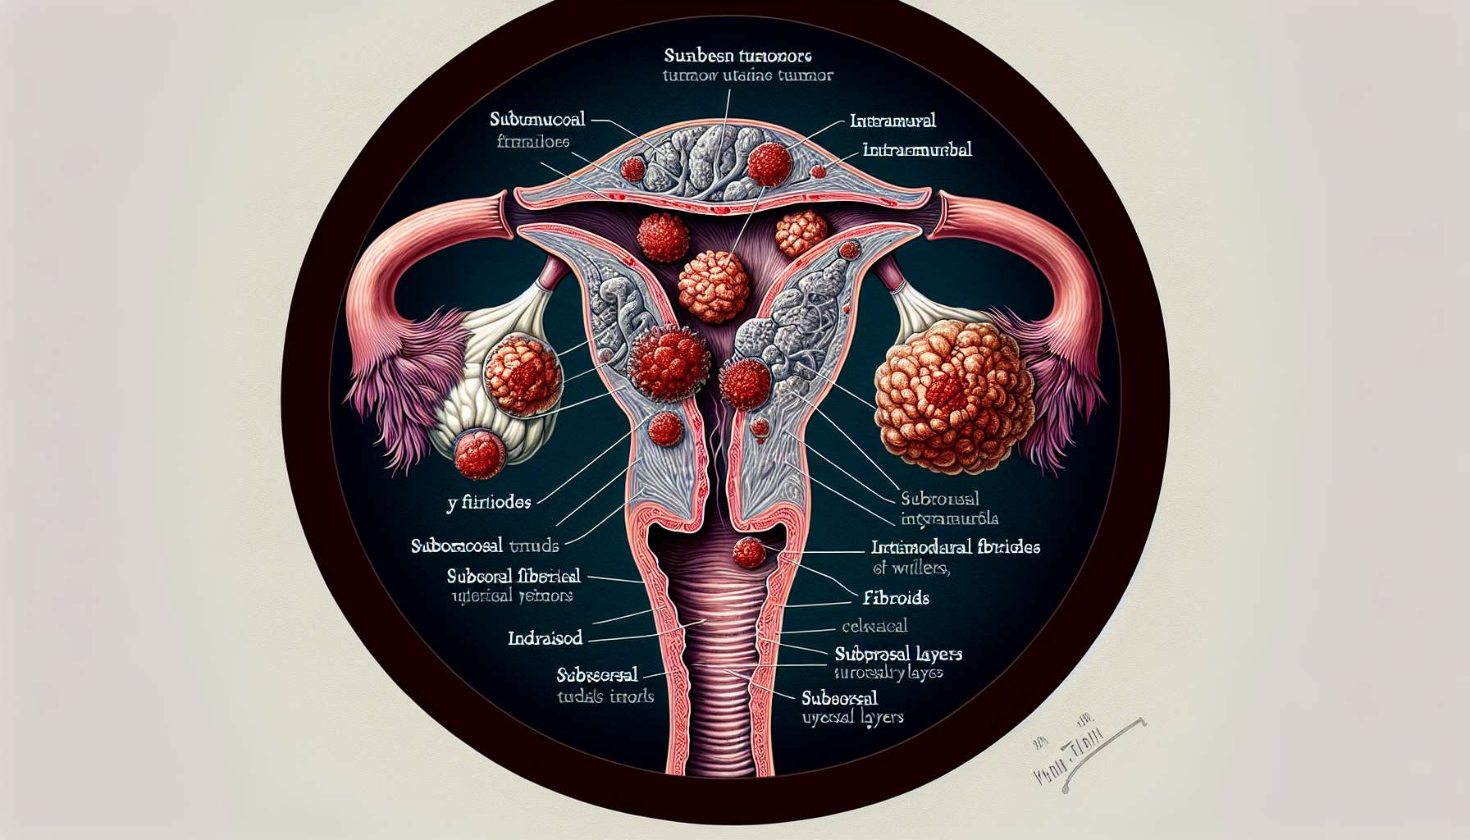

Uterine fibroids, also known as leiomyomas or myomas, are benign tumors that develop in the uterine muscle (myometrium). They account for the most common gynecological tumors, affecting approximately 20 to 40% of women of childbearing age. Their prevalence increases with age, peaking between 30 and 50 years old, and then decreases after menopause.  
  
Uterine fibroids may be solitary or multiple, of various sizes (from a few millimeters to several centimeters) and located in different places. We thus distinguish:  
  
- Submucosal fibroids, protruding into the uterine cavity and potentially distorting the endometrium  
- Intramural fibroids, located in the thickness of the myometrium, which can also distort the uterine cavity  
- Subserosal fibroids, which grow on the outer surface of the uterus, towards the pelvic cavity  
- Pedunculated fibroids, attached to the uterus by a pedicle, which can become necrotic in case of torsion  
  
Example: During a routine ultrasound, Sophie's gynaecologist, 42, detects several well-defined, rounded masses in the myometrium suggestive of uterine fibroids. He explains to her that these are common benign tumors at her age, requiring no treatment in the absence of symptoms. However, he suggests regular ultrasound monitoring to track their progress.  
  
The exact causes of uterine fibroids are still poorly understood, but several risk factors have been identified:  
  
- Hormonal factors: fibroids are hormone-dependent and regress after menopause. Estrogens and progesterone stimulate their growth.  
- Genetic factors: some genetic mutations have been identified in fibroids, and there is a familial predisposition.  
- Ethnic factors: women of African descent have a higher risk of developing fibroids, in a more premature and symptomatic manner.  
- Metabolic factors: obesity, diabetes, and insulin resistance are associated with an increased risk of fibroids.  
  
Anecdote: During a consultation, Julie, 38, asks her gynaecologist about her personal risk of developing uterine fibroids. Both her mother and elder sister underwent surgery for symptomatic fibroids. The gynaecologist explains that there is indeed a familial predisposition for fibroids, possibly linked to genetic factors. She advises her to regularly monitor her uterus through gynaecological examinations and ultrasounds, and to maintain a balanced lifestyle to limit metabolic risk factors.  
  
Most uterine fibroids are asymptomatic and discovered incidentally during a gynaecological examination or pelvic ultrasound. However, when they are voluminous or numerous, they can cause various symptoms:  
  
- Abnormal uterine bleeding: menorrhagia (heavy periods), metrorrhagia (bleeding outside periods), iron-deficiency anemia  
- Pelvic pain: pelvic heaviness, dysmenorrhea (painful periods), dyspareunia (pain during sexual intercourse)  
- Compression symptoms: frequency (frequent urge to urinate), constipation, lower back pain  
- Infertility or repeated miscarriages, in the case of uterine cavity distortion  
  
Example: For several months, Léa, 45, has been suffering from increasingly debilitating menorrhagia, requiring her to change hygiene protection every hour. She also feels pelvic heaviness and lower back pain. Her gynaecologist prescribes a pelvic ultrasound which reveals the presence of multiple uterine fibroids, including a voluminous submucosal fibroid distorting the uterine cavity. He proposes surgical intervention to remove the fibroids and relieve her symptoms.  
  
The diagnosis of uterine fibroids is based on a gynaecological clinical examination, supplemented by a pelvic ultrasound (suprapubic and endovaginal). The ultrasound allows specifying the number, size, location, and vascularization of the fibroids. In the case of diagnostic doubt or atypical symptoms, a pelvic MRI may be indicated to better characterize the fibroids and look for other associated diseases (adenomyosis, endometriosis). Hysteroscopy allows direct visualization of submucosal fibroids and resection at the same time.  
  
The management of uterine fibroids depends on their number, size, location, and the patient’s symptoms. In the absence of symptoms, simple clinical and ultrasound monitoring may suffice. For symptomatic fibroids, several therapeutic options can be offered:  
  
- Medical treatments: progestogens, GnRH analogues, selective progesterone receptor modulators (SPRM), to reduce the volume of fibroids and control bleeding  
- Minimally invasive techniques: uterine artery embolization, high-intensity focused ultrasound ablation (HIFU), to reduce the vascularization and size of the fibroids  
- Conservative surgery: myomectomy by hysteroscopy, laparoscopy, or laparotomy, to remove the fibroids while preserving the uterus, especially in the case of desired pregnancy  
- Hysterectomy (removal of the uterus), in the case of multiple, voluminous or recurrent fibroids, in a woman who is not looking to become pregnant  
  
Example: After an extensive discussion with her gynaecologist about the various therapeutic options, Léa opts for a laparoscopic myomectomy. The procedure allows for the removal of the fibroids while preserving her uterus, offering her the possibility of future pregnancy. The post-operative period is simple and Léa quickly notices a significant improvement in her symptoms, with a return to regular and painless cycles.  
  
In summary, uterine fibroids are common benign tumors, affecting nearly one in three women of childbearing age. Their pathophysiology is still poorly understood, but several hormonal, genetic, and metabolic risk factors have been identified. Often asymptomatic, they can however cause abnormal bleeding, pelvic pain, and infertility when they are voluminous or numerous. Their diagnosis is based on the clinical examination and pelvic ultrasound, sometimes supplemented by MRI or hysteroscopy. Their management depends on their clinical impact and the patient's wish to conceive, ranging from simple monitoring to conservative or radical surgery, via medical or minimally invasive treatments. Clear information and personalized support are essential to help affected women choose the therapeutic strategy best suited to their situation and life project.  
  
Key points to remember:  
  
- Uterine fibroids are common benign tumors of the uterine muscle, affecting 20 to 40% of women of childbearing age.  
- We distinguish submucosal, intramural, subserosal, and pedunculated fibroids, according to their location in the uterus.  
- Identified risk factors are hormonal (estrogens, progesterone), genetic (mutations, familial predisposition), ethnic (African origin) and metabolic (obesity, diabetes).  
- Most fibroids are asymptomatic, but they can cause abnormal bleeding, pelvic pain, compression symptoms, and infertility.  
- Diagnosis is based on clinical examination and pelvic ultrasound, sometimes supplemented by MRI or hysteroscopy.  
- Management depends on symptoms and the desire for pregnancy: surveillance, medical treatments (progestogens, GnRH analogues, SPRM), minimally invasive techniques (embolization, HIFU), conservative surgery (myomectomy), or radical surgery (hysterectomy).  
- Clear information and personalized support are essential to help women choose the therapeutic strategy suited to their situation and life project.