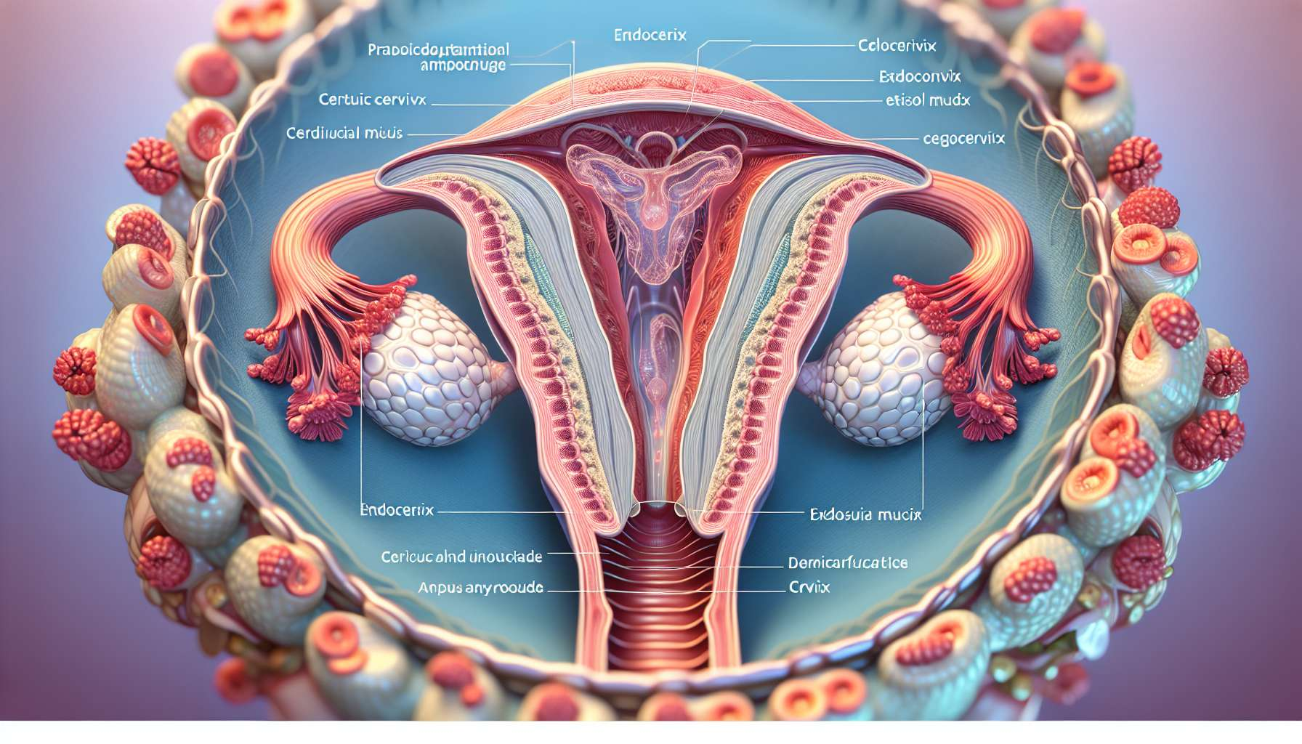

The cervix, also called the cervix, is the lower, narrower part of the uterus that connects with the vagina. It measures about 3 to 4 cm long and 2 to 3 cm in diameter in a woman of childbearing age. The cervix is divided into two parts: the endocervix, which corresponds to the internal portion in continuity with the uterine cavity, and the ectocervix, which projects into the vagina. The endocervix is lined with simple glandular epithelium, while the ectocervix is covered with stratified squamous epithelium, similar to that of the vagina.  
  
The main role of the cervix is to produce cervical mucus, a viscous and filamentous secretion produced by the glands of the endocervix. The amount and consistency of cervical mucus vary during the menstrual cycle under the influence of ovarian hormones. During the follicular phase, the gradual increase in estrogen levels stimulates the production of abundant, clear and filamentous mucus, favorable for the penetration of spermatozoa. This mucus is rich in water, mucopolysaccharides, and electrolytes which nourish and protect the spermatozoa during their cervical transit. At the time of ovulation, the mucus becomes even more abundant, transparent, and elastic, looking like raw egg white. This change in mucus, called ferning because of its crystallized aspect under the microscope, is a marker of the fertile period.  
  
After ovulation, under the effect of progesterone, the cervical mucus becomes thicker, opaque, and viscous, forming a mucous plug that obstructs the endocervical canal. This mucous plug has a protective role by preventing the penetration of germs from the vagina into the uterine cavity. It also constitutes a barrier to the progression of spermatozoa outside the fertile period.  
  
In addition to its role in mucus production, the uterine cervix also plays an important mechanical role. During pregnancy, the cervix remains closed and tonic to maintain the embryo and then the fetus in the uterine cavity. It constitutes a real lock that prevents premature childbirth. An opening or cervical insufficiency may be responsible for recurrent miscarriages or premature delivery. In this case, a cervical cerclage (suture thread to close the cervix) can be proposed to avoid these complications.  
  
At the time of childbirth, under the effect of uterine contractions and the pressure exerted by the fetal presentation, the cervix will progressively shorten, disappear, then dilate to allow the baby to pass. This cervical dilation is an active process involving proteolytic enzymes (collagenases, elastases) that remodel the extracellular matrix of the cervical connective tissue. The complete dilation of the cervix at 10 cm marks the beginning of the expulsive phase of labor.  
  
The uterine cervix is a transition zone between the sterile uterine cavity and the septic vagina. It constitutes an immunological barrier that protects the uterus from ascending infections. However, certain sexually transmitted germs such as Chlamydia trachomatis or Neisseria gonorrhoeae can infect the endocervix and cause cervicitis, which manifests as purulent vaginal discharge and provoked bleeding. If untreated, cervicitis can progress to a high genital infection (endometritis, salpingitis) and be responsible for tubal infertility.  
  
The cervix is also a frequent site of precancerous and cancerous lesions. Cervical cancer is the 4th most common female cancer in the world, caused in more than 99% of cases by a persistent infection with an oncogenic human papillomavirus (HPV). Precancerous and cancerous lesions of the cervix are detected by the Pap smear, which involves the removal of cells from the endocervix and ectocervix for cytological analysis. In recent years, primary screening with the HPV test has been offered to women over 30 years old. HPV vaccination is recommended for girls aged 11 to 14 to prevent cervical cancer. It protects against the most oncogenic genotypes (HPV 16 and 18), responsible for 70% of cervical cancers.  
  
Key points:  
  
- The cervix, or cervix, is the lower part of the uterus that connects it to the vagina. It is composed of the endocervix (internal part) and the ectocervix (external part).  
  
- The main role of the cervix is to produce cervical mucus, the amount and consistency of which vary during the menstrual cycle. During the follicular phase, the mucus is abundant, clear and filamentous, promoting the penetration of spermatozoa. After ovulation, it becomes thick and viscous, forming a protective mucous plug.  
  
- During pregnancy, the cervix remains closed to keep the fetus in the uterine cavity. During childbirth, it progressively dilates to allow the baby to pass.  
  
- The cervix is an immunological barrier protecting the uterus from infections, but certain sexually transmitted germs can cause cervicitis.  
  
-Cervical cancer, mainly caused by the human papillomavirus (HPV), can be screened by the Pap smear (PS) and the HPV test. HPV vaccination is recommended for young girls to prevent this cancer.