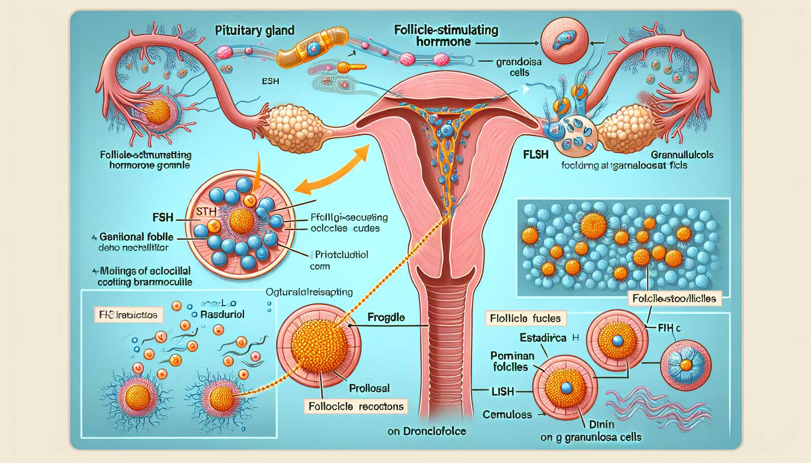

The follicle-stimulating hormone (FSH) is a glycoprotein secreted by the gonadotropic cells of the adenohypophysis, under the control of the hypothalamic GnRH. It plays an essential role in regulating the menstrual cycle by stimulating the growth and maturation of ovarian follicles, from the stage of primordial follicle to the pre-ovulatory follicle stage. FSH works in synergy with another pituitary gonadotropin, LH (luteinising hormone), to ensure the proper functioning of folliculogenesis and ovulation.  
  
At the beginning of each menstrual cycle, following the drop in estrogen and progesterone levels at the end of the luteal phase, the pituitary gland increases its secretion of FSH. This rise in FSH at the start of the follicular phase stimulates the recruitment of a cohort of primordial follicles that enter growth in the ovaries. Under the effect of FSH, the follicular cells multiply and differentiate into granulosa cells, forming several cellular layers around the oocyte.  
  
FSH binds to specific receptors present on the granulosa cells, activating intracellular signalling pathways that stimulate cell proliferation, estrogen synthesis, and expression of LH receptors. Indeed, the granulosa cells gradually acquire the ability to convert the androgens produced by the theca cells into estrogens, mainly estradiol, thanks to the aromatase enzyme induced by FSH.  
  
The progressive increase in estradiol levels secreted by the growing follicles exerts a negative feedback on the hypothalamus-pituitary axis, resulting in a decrease in FSH secretion in the middle of the follicular phase. This decrease in FSH is essential to allow the selection of the dominant follicle, which expresses more FSH receptors and becomes more sensitive to this hormone than the other follicles. The dominant follicle will therefore continue its growth and maturation despite the decrease in FSH levels, while the other follicles, deprived of stimulation, will degenerate by atresia.  
  
FSH also stimulates the synthesis of LH receptors on the granulosa cells of the dominant follicle. These receptors enable the follicle to respond to the ovulatory LH peak at the end of the follicular phase, triggering the final stages of oocyte maturation, follicle rupture, and ovulation. After ovulation, FSH levels decrease rapidly under the negative feedback effect of estrogens and progesterone secreted by the corpus luteum.  
  
Abnormalities in the secretion or action of FSH can disrupt follicle growth and oocyte maturation, leading to ovulation disorders and infertility. A lack of FSH secretion, for example in the context of premature ovarian failure or hyperprolactinemia, can block folliculogenesis and induce amenorrhea. In polycystic ovary syndrome, low FSH secretion in relation to high LH secretion can disrupt the selection process of the dominant follicle and lead to anovulation  
  
FSH levels in the early cycle (3rd day of the cycle) is a test commonly carried out in the assessment of female infertility. A high early cycle FSH level (above 10-12 IU/L) can be a sign of incipient ovarian failure, indicating a decrease in follicular reserve and a deterioration in oocyte quality. A normal or low FSH level does not rule out ovarian failure and should be interpreted in the context of other markers of ovarian reserve, such as AMH (anti-Mullerian hormone) and AFC (antral follicle count).  
  
In case of ovarian stimulation for IVF (in vitro fertilisation), recombinant FSH injections are used to induce multiple follicle growth and obtain several mature oocytes. The dose of FSH is adapted according to the patient's ovarian reserve and her response to treatment, assessed by hormonal assays and control ultrasounds. A GnRH antagonist is often associated to prevent a premature LH peak and optimise the timing of follicular maturation.  
  
In conclusion, FSH is a key hormone in the regulation of the menstrual cycle, which stimulates the growth and maturation of ovarian follicles in synergy with LH. Its action is finely regulated by feedback loops involving estrogens and progesterone, allowing for the selection of the dominant follicle and ovulation. Understanding the role of FSH is essential for understanding the pathophysiological mechanisms of ovulation disorders and infertility, and for optimising ovarian stimulation protocols in assisted reproduction.  
  
Key points to remember:  
  
- FSH is a hormone secreted by the pituitary gland that plays a critical role in regulating the menstrual cycle by stimulating the growth and maturation of ovarian follicles.  
  
- At the beginning of the follicular phase, the rise in FSH stimulates the recruitment of a cohort of primordial follicles that enter growth in the ovaries.  
  
- FSH binds to specific receptors on granulosa cells, stimulating their proliferation, estrogen synthesis, and the expression of LH receptors.  
  
- The increase in estradiol levels secreted by growing follicles exerts negative feedback on FSH secretion, permitting the selection of the dominant follicle.  
  
-The dominant follicle, more sensitive to FSH, continues its growth and maturation despite the drop in FHS levels, while the other follicles degenerate.  
  
- FSH stimulates the synthesis of LH receptors on the granulosa cells of the dominant follicle, allowing it to respond to the ovulatory LH peak.  
  
- Anomalies in FSH secretion or action can disrupt folliculogenesis and induce ovulation disorders and infertility.  
  
- FSH levels in the early cycle is a key test in the assessment of female infertility, a high level indicating incipient ovarian failure.  
  
- In case of ovarian stimulation for IVF, recombinant FSH injections are used to induce multiple follicle growth and to obtain several mature oocytes.