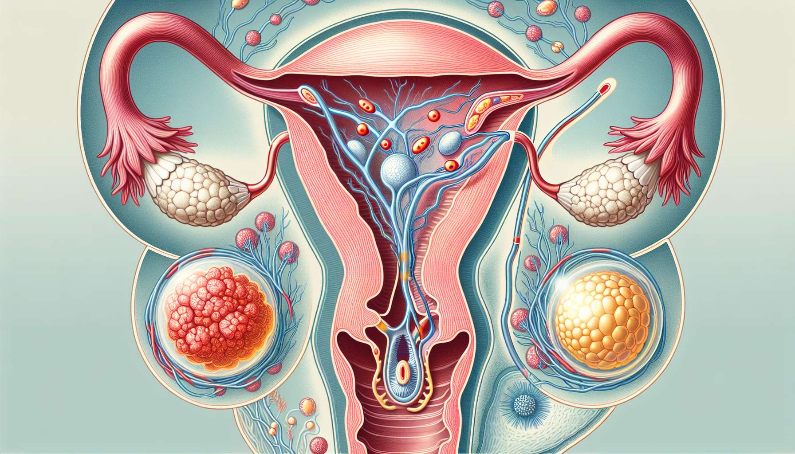

Ovulation is the central event of the ovarian cycle, marking the transition between the follicular phase and the luteal phase. It corresponds to the release of a mature ovum by the pre-ovulatory follicle, ready to be fertilized by a sperm in the fallopian tube. Ovulation usually occurs between the 12th and 16th day of a 28-day menstrual cycle, but can vary from woman to woman and from cycle to cycle.  
  
The triggering of ovulation is under the control of the hypothalamic-pituitary-ovarian axis. In the middle of the follicular phase, the progressive increase in estrogen levels secreted by the dominant follicle exerts a positive feedback on the hypothalamus and the pituitary gland, stimulating the pulsatile release of GnRH and LH. When the levels of estrogen reach a critical threshold for more than 36 hours, they trigger a massive LH spike, called the pre-ovulatory peak or LH ovulatory discharge.   
  
This LH surge, which can reach 10 to 20 times the basal levels, is essential for triggering the events leading to ovulation. It acts on the granulosa and theca cells of the pre-ovulatory follicle, inducing complex morphological, biochemical and genetic changes. Under the effect of LH, follicular cells secrete proteolytic enzymes (collagenases, plasmin) that digest the follicular wall and allow the expulsion of the oocyte. At the same time, LH stimulates the production of prostaglandins and progesterone by the follicular cells, contributing to the ovulatory process.   
  
About 24 to 36 hours after the LH surge, the mature oocyte is expelled from the ruptured follicle, surrounded by the cumulus oophorus and the corona radiata. This oocyte, blocked in metaphase II of the second meiotic division, is then captured by the pavilion of the fallopian tube and begins its tubal migration. It will only survive 24 to 48 hours if it is not fertilized by a sperm.  
  
Ovulation is accompanied by several clinical signs that can help to spot the fertile period of the cycle. The best known is the "raw egg white" appearance of the cervical mucus, stringy and stretchy, which facilitates the passage of sperm through the cervical canal. Other signs can be observed, such as mild pelvic pain (mittelschmerz), an increase in libido or basal hyperthermia. However, these signs are inconsistent and vary from woman to woman, and do not allow for accurate prediction of ovulation.  
  
Several methods exist for detecting ovulation and optimizing the chances of conception. Urine ovulation tests detect the LH surge in urine 24 to 36 hours before ovulation. Basal temperature curves can identify ovulation retrospectively, by an elevation in body temperature due to the secretion of progesterone in the luteal phase. Monitoring of cervical mucus and palpation of the cervix can also provide clues about the approach of ovulation. Finally, pelvic ultrasound allows for follicular growth monitoring and prediction of ovulation timing.  
  
After ovulation, the ruptured follicle transforms into a corpus luteum under the influence of LH, and begins secreting progesterone to prepare the endometrium for potential embryonic implantation. This luteal phase lasts about 14 days, whether the oocyte is fertilized or not. In the absence of fertilization and implantation, the corpus luteum degenerates, leading to a drop in progesterone levels and the onset of menstruation.   
  
Some ovulation disorders can disrupt female fertility and lead to infertility. Anovulation, characterized by the absence of ovulation, can be due to various hormonal or ovarian causes, such as polycystic ovary syndrome (PCOS), premature ovarian failure, or hyperprolactinemia. Anovulatory cycles are often irregular and can be accompanied by menstrual disorders such as amenorrhea or oligomenorrhea. The treatment for anovulation depends on its cause and may involve ovarian stimulation with gonadotropins, ovulation induction with clomiphene citrate, or ovarian drilling via laparoscopic surgery in the case of PCOS.  
  
Ovulation is therefore a key event of the menstrual cycle, allowing the production of a fertilizable oocyte and marking the start of the luteal phase. Understanding it is crucial to grasp the mechanisms of human reproduction and manage female fertility disorders. Ovulation detection methods can help couples optimize their chances of conception, while treatments for anovulation can restore ovulation and fertility in infertile women.  
  
Key Takeaways:  
  
1. Ovulation is the release of a mature ovum by the pre-ovulatory follicle, ready to be fertilized in the fallopian tube.  
  
2. The triggering of ovulation is controlled by the hypothalamic-pituitary-ovarian axis, with a key role of the LH surge.  
  
3. The LH surge induces changes in the pre-ovulatory follicle, allowing the expulsion of the oocyte approximately 24 to 36 hours later.  
  
4. The expelled oocyte, blocked in metaphase II, is captured by the pavilion of the fallopian tube and survives only 24 to 48 hours if it is not fertilized.  
  
5. Several clinical signs, such as stringy cervical mucus, can help spot ovulation, but they are inconsistent and variable.  
  
6. Various methods for detecting ovulation exist, such as urine ovulation tests, basal temperature curves, and pelvic ultrasound.  
  
7. After ovulation, the ruptured follicle transforms into a corpus luteum and secretes progesterone to prepare the endometrium for potential implantation.  
  
8. Anovulation, characterized by the absence of ovulation, can disrupt female fertility and be due to various hormonal or ovarian causes.  
  
9. The treatment for anovulation depends on its cause and may include ovarian stimulation, ovulation induction, or ovarian drilling.  
  
10. Understanding ovulation is crucial for grasping the mechanisms of human reproduction and managing female fertility disorders.