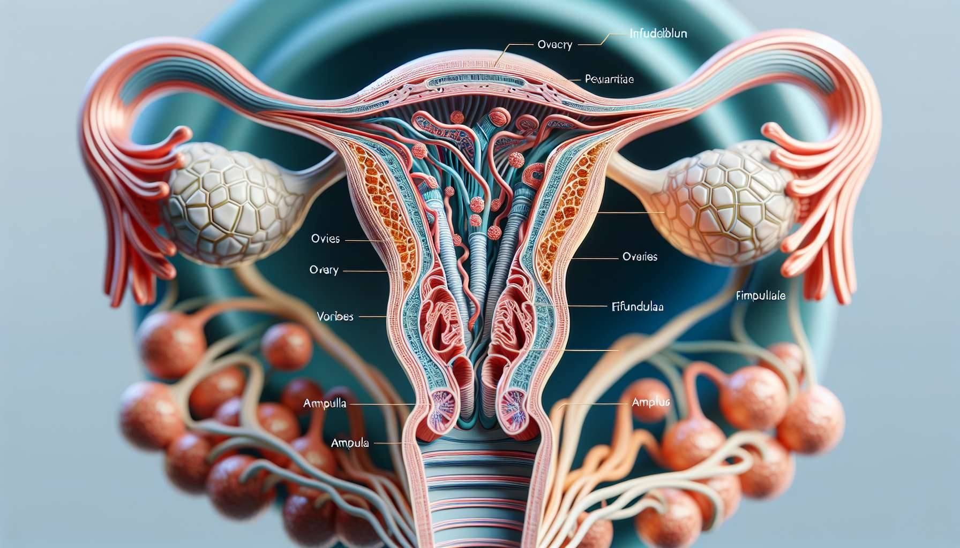

The Fallopian tubes, also called uterine tubes or oviducts, are two fine muscular-membranous ducts that connect the ovaries to the uterus. They measure approximately 10 to 12 cm long and are located in the upper part of the pelvic cavity, on each side of the uterus. Each tube is divided into four anatomical segments: the infundibulum, the fimbria, the ampulla, and the isthmus.  
  
The infundibulum corresponds to the ovarian end of the tube, which flares into a funnel shape to form the fimbria. The fimbria is bordered by fringes, called fimbriae, which come into contact with the ovary to capture the oocyte during ovulation. The ampulla is the widest and longest part of the tube, where fertilization usually takes place. The isthmus is the narrow portion that connects the ampulla to the uterine horn.  
  
The main role of the Fallopian tubes is to allow the meeting of the gametes and fertilization. During ovulation, the mature oocyte is expelled from the ovary and captured by the fimbriae of the tubal fimbria. Peristaltic contractions of the tubal musculature and the beating of the cilia of the mucosa allow the transit of the oocyte towards the ampulla. If sexual intercourse has taken place in the days preceding or following ovulation, sperm swim upstream the tube to reach the oocyte. The capacitation of the sperm, necessary for fertilization, is carried out during this intra-tubal journey thanks to the secretions of the mucosa.  
  
Once fertilization has occurred, the egg (or zygote) will gradually divide to form an embryo while continuing its tubal descent towards the uterine cavity. This journey lasts about 3 to 5 days and allows the embryo to reach the blastocyst stage before its implantation in the uterine endometrium. Implantation marks the beginning of intrauterine pregnancy.  
  
In addition to their role in the migration of gametes and the embryo, the Fallopian tubes also secrete essential substances for the survival and development of the early embryo, such as pyruvate and lactate. They create a favorable microenvironment for fertilization and the early stages of embryonic development.  
  
Any anatomical or functional anomaly of the tubes can disrupt the fertilization process and cause infertility. Bilateral tubal obstruction, for example following a pelvic infection or endometriosis, prevents the meeting of the gametes and makes natural conception impossible. A disturbance of tubal mobility, for example in the case of pelvic adhesions or uterine fibroids, can hinder oocyte capture and the transit of the embryo, promoting ectopic pregnancies. Tubal ectopic pregnancy is a medical emergency that requires rapid management to avoid severe complications such as tubal rupture and internal hemorrhage.  
  
In cases of tubal infertility, in vitro fertilization (IVF) allows bypassing the function of the tubes by performing fertilization and the early stages of embryonic development in the laboratory, before transferring the embryo directly into the uterine cavity.  
  
Points to remember:   
  
- The Fallopian tubes, also called uterine tubes or oviducts, are two ducts connecting the ovaries to the uterus. They are divided into four segments: the infundibulum, the fimbria, the ampulla, and the isthmus.  
  
- The main role of the tubes is to allow the meeting of the gametes and fertilization. During ovulation, the oocyte is captured by the fimbriae of the tubal fimbria, while the sperm swim upstream the tube to reach the oocyte.  
  
- After fertilization, the embryo continues its tubal descent towards the uterine cavity for 3 to 5 days, reaching the blastocyst stage before its implantation in the endometrium (implantation).  
  
- The tubes secrete substances essential to early embryonic development and create a favorable microenvironment.  
  
- Tubal abnormalities can cause infertility, such as bilateral obstruction preventing the meeting of the gametes, or alteration of tubal mobility promoting ectopic pregnancies.  
  
- Tubal ectopic pregnancy is a medical emergency requiring rapid management to avoid severe complications.  
  
- In cases of tubal infertility, in vitro fertilization (IVF) allows bypassing the function of the tubes by carrying out fertilization and the early stages of embryonic development in the laboratory.