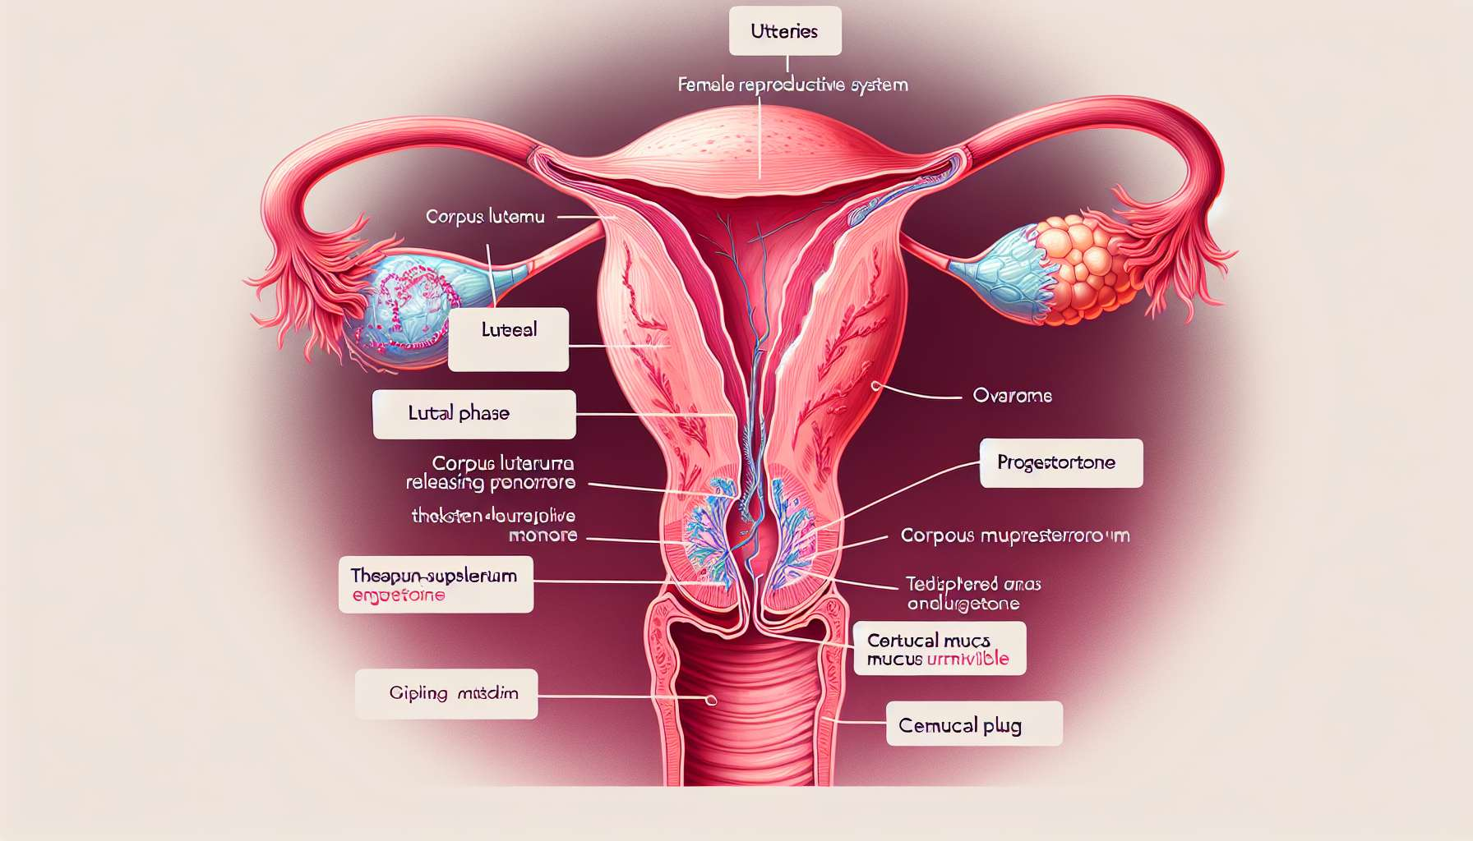

The luteal phase is the final phase of the menstrual cycle, beginning after ovulation and ending on the first day of the following menstrual period. It lasts on average 14 days (from 12 to 16 days), regardless of the total duration of the cycle. This phase is dominated by the secretion of progesterone by the corpus luteum, which exerts significant effects on the uterine endometrium and the entire female body.  
  
As described in sub-module 1.9, the corpus luteum forms from the residual follicular cells after the expulsion of the oocyte. Under the influence of LH, the granulosa and theca cells differentiate into luteal cells that acquire the ability to secrete large amounts of progesterone. Progesterone is the key hormone of the luteal phase, which acts in synergy with estrogens to prepare the endometrium for possible embryonic implantation.  
  
At the endometrium level, progesterone induces the secretory transformation of endometrial glands, which become tortuous and produce secretions rich in glycogen and mucus, necessary for the nutrition of the embryo. It also stimulates the growth and winding of spiraled arteries, thereby increasing the vascularisation of the endometrium. Under the combined effect of progesterone and estrogens, the endometrium reaches its maximum thickness (10 to 15 mm) around the 7th day after ovulation, when the embryo is likely to implant.  
  
Progesterone also exerts a thermogenic effect on the hypothalamus, resulting in an elevation of basal body temperature by about 0.3 to 0.5°C after ovulation. This physiological hyperthermia can be used to retrospectively identify the date of ovulation and confirm the occurrence of a luteal phase. It persists until the end of the cycle in case of pregnancy, or decreases before menstruation in the absence of fertilization.  
  
At the level of the cervical canal, progesterone modifies the features of the cervical mucus, which becomes thick, opaque and viscous, forming a mucous plug that obstructs the cervical canal. This plug plays a protective role in preventing the penetration of germs from the vagina to the uterine cavity, but it also serves as a barrier to the progression of sperm outside the fertile period.  
  
Progesterone also acts on the central nervous system, promoting relaxation, drowsiness and appetite. It may induce a feeling of bloating and water retention due to its anti-diuretic action. Some women may also feel breast tension, increased sensitivity or a change in libido due to the effect of progesterone.  
  
If the oocyte has been fertilised and an embryo has implanted in the endometrium, the trophoblastic cells of the embryo secrete gonadotropic chorionic hormone (hCG) that sustains the corpus luteum and stimulates its production of progesterone. The resulting gestational corpus luteum sustains the pregnancy until the placenta takes over around the 8th week of pregnancy. The persistence of a high progesterone level is crucial for maintaining myometrial quiescence and avoiding premature uterine contractions.  
  
In the absence of fertilisation or implantation, the corpus luteum is not sustained by hCG and regresses after 14 days, this is luteolysis. The degeneration of the corpus luteum causes a sharp drop in progesterone and estrogen levels, lifting the negative feedback on the gonadotropic axis and allowing the recruitment of a new cohort of follicles for the next cycle. Hormonal deprivation also triggers the endometrial desquamation and the onset of menstruation.  
  
Certain luteal phase disorders can disrupt fertility and cause early miscarriages. Luteal insufficiency, characterized by a deficiency in progesterone and/or a luteal phase duration of less than 10 days, can compromise the quality of the endometrium and embryonic implantation. It may be due to a defect in follicular development, delayed ovulation or premature luteolysis. Treatment is based on progesterone supplementation in the second part of the cycle to correct the deficiency and support the luteal phase.  
  
Premenstrual syndrome (PMS) is another common disorder of the luteal phase, characterized by a set of physical and psychological symptoms that occur cyclically in the days leading up to menstruation. The most common symptoms are breast tension, bloating, migraines, irritability, emotional instability and sleep disorders. Although the pathophysiology of PMS is not fully understood, it seems to be related to increased sensitivity to hormonal fluctuations in the luteal phase, particularly the drop in progesterone. PMS management combines hygienic-dietary measures (regular physical activity, reduction of salt and quick sugars intake), symptomatic treatments (analgesics, mild diuretics) and sometimes regulatory hormonal treatments (oral contraception, progestin treatment).  
  
Key points to remember:  
  
- The luteal phase lasts on average 14 days, independently from the total length of the menstrual cycle.  
- The corpus luteum forms from the residual follicular cells after ovulation and secretes progesterone under the influence of LH.  
- Progesterone acts in synergism with estrogens to prepare the endometrium for possible embryonic implantation by inducing secretory transformations and increasing vascularisation.  
- Progesterone causes an elevation of basal body temperature by about 0.3 to 0.5°C after ovulation.  
- Progesterone modifies the cervical mucus, making it thick and viscous, thus forming a protective mucous plug.  
- In case of fertilization and implantation, the hCG secreted by the embryo maintains the corpus luteum and progesterone production until the placenta takes over.  
- In the absence of fertilisation, the corpus luteum regresses after 14 days (luteolysis), causing a drop in progesterone and estrogen levels, which triggers menstruation.  
- Luteal insufficiency, characterized by a deficiency in progesterone and/or a short luteal phase, can disrupt fertility and is treated by progesterone supplementation.  
- Premenstrual Syndrome (PMS) is a common luteal phase disorder, related to increased sensitivity to hormonal fluctuations, and can be managed by hygienic-dietary measures, symptomatic treatments and sometimes regulatory hormonal treatments.