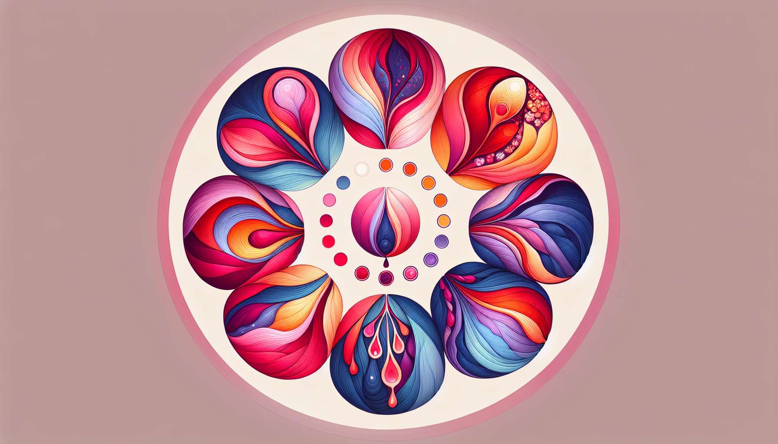

The menstrual cycle is divided into several distinct phases, each with a specific average duration. Understanding the length of each phase is crucial for better grasping the physical and emotional changes that occur throughout the cycle.  
  
The follicular phase, which begins on the first day of menstruation and ends at ovulation, lasts on average 14 days. However, this duration can vary from one woman to another and from one cycle to another, ranging from 10 to 21 days. During this phase, ovarian follicles develop under the influence of the follicle-stimulating hormone (FSH), thus preparing for ovulation.  
  
The ovulatory phase, which corresponds to the time of ovulation, is the shortest of the cycle, usually lasting only 24 to 48 hours. Ovulation generally occurs on the 14th day of a 28-day cycle, but it can happen earlier or later depending on the length of the follicular phase. This phase is characterized by a rapid increase in the luteinizing hormone (LH) level, triggering the release of the ovum.  
  
The luteal phase, which follows ovulation and precedes the next menstruation, is the most constant in terms of duration, lasting on average 14 days (from 12 to 16 days). This stability of the luteal phase indeed allows for the estimation of the ovulation date by subtracting 14 days from the projected date of the next menstruation. During this phase, the corpus luteum secretes progesterone to prepare the uterus for a possible embryonic implantation.  
  
Finally, menstruation, which marks the beginning of a new cycle, usually lasts from 3 to 7 days, with an average of 5 days. During this period, the endometrium breaks down and is expelled through the cervix, causing menstrual bleeding. The duration and abundance of periods can vary from one woman to another and from one cycle to another, depending on hormonal factors, age, and overall health.  
  
It is important to note that these average durations are general benchmarks, and that each woman may have a unique cycle, with individual variations. In addition, certain factors such as stress, weight changes, travel, or hormonal disturbances can influence the length of each cycle phase. Keeping a menstrual calendar can help better understand one's own cycle and spot any irregularities requiring medical consultation.  
  
Key takeaways:  
  
- The menstrual cycle consists of three main phases: the follicular phase, the ovulatory phase, and the luteal phase, followed by menstruation.  
  
- The follicular phase lasts on average 14 days, but can vary from 10 to 21 days. During this phase, ovarian follicles develop.  
  
- The ovulatory phase is the shortest, lasting 24 to 48 hours. Ovulation generally occurs on the 14th day of a 28-day cycle.  
  
- The luteal phase is the most constant, lasting on average 14 days (from 12 to 16 days). The corpus luteum secretes progesterone to prepare the uterus for a possible implantation.  
  
- Menstruation generally lasts from 3 to 7 days, with an average of 5 days.  
  
- The average lengths of each phase are general markers, and each woman can have a unique cycle with individual variations.  
  
- Certain factors such as stress, weight changes, travel, or hormonal disturbances can influence the length of each cycle phase.  
  
- Keeping a menstrual calendar can help better understand one's own cycle and identify any potential irregularities requiring medical consultation.