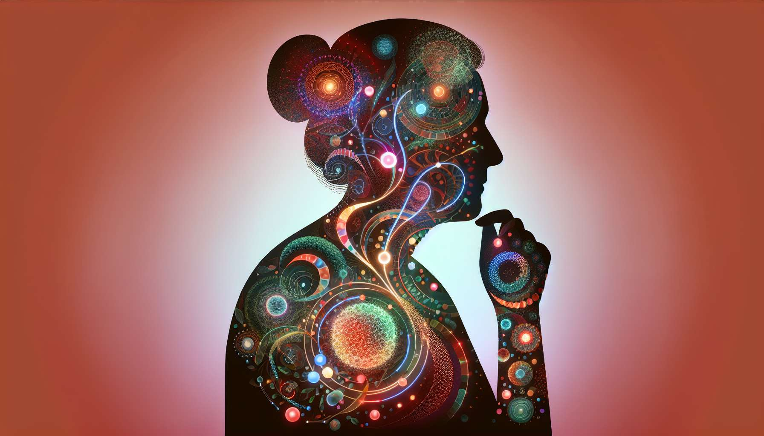

Perimenopause is a period of complex hormonal transition, marked by gradual changes in the production and regulation of female sex hormones. These hormonal changes are the cause of the characteristic symptoms of perimenopause, such as menstrual cycle disorders, hot flushes, mood disorders, and vaginal dryness.  
  
The main hormonal change observed during perimenopause is the gradual decrease in the production of oestrogens by the ovaries. This decrease is linked to the depletion of the ovarian reserve, namely the stock of primordial follicles present in the ovaries since foetal life. As we age, the number and quality of follicles decrease, resulting in a lesser response to stimulation by pituitary gonadotropins (FSH and LH) and alteration of ovarian function.  
  
Anecdote: During a consultation, Julie, 47 years old, is surprised at the great variability of her hormonal dosages from one cycle to another. Her gynaecologist explains to her that this variability is characteristic of perimenopause, where the production of oestrogens becomes more and more fluctuating and unpredictable, before gradually dying out.  
  
The decrease in oestrogen production is accompanied by a relative increase in FSH levels, which tries to stimulate the remaining follicles to maintain sufficient ovarian function. This phenomenon is the origin of the ovarian reserve test, which consists of dosing the FSH at the beginning of the cycle (J3) to evaluate the reactivity of the ovaries. High FSH (greater than 10-12 IU/L) is a marker of early ovarian failure and perimenopause.  
  
Example: Sophie, 45 years old, consults her gynaecologist for irregular cycles and hot flushes. A hormonal assessment is performed on the 3rd day of the cycle and shows an FSH at 15 IU/L, indicating a decrease in ovarian reserve. Her gynaecologist explains to her that she is probably in perimenopause and proposes regular follow-up to adapt her care.  
  
Alongside the decrease in oestrogens, there is a decrease in the production of progesterone by the corpus luteum in the second part of the cycle. This luteal insufficiency is related to the lower quality of ovulation and the reduced lifespan of the corpus luteum. It results in a shortening of the luteal phase and earlier onset of menstruation, contributing to the irregularity of cycles.  
  
Example: Marie, 48 years old, notes that her cycles have shortened, going from 28 to 24 days on average. Her gynaecologist explains to her that this shortening is likely due to luteal insufficiency, with a shorter post-ovulatory phase due to the decrease in progesterone production.  
  
Perimenopause also comes with a change in the oestrogen/androgen ratio, with oestrogens decreasing faster than testosterone. This relative hyperoestrogenism can manifest as clinical (acne, hirsutism, weight gain) or biological hyperandrogenism (elevation of free testosterone). It can also contribute to the decrease in libido and mood disorders often reported at this period.  
  
Anecdote: During a menopause conference, a speaker presents a study showing that DHEA (dehydroepiandrosterone) supplementation, a precursor to testosterone, can improve the quality of life and sexual function of women in perimenopause, without major side effects.  
  
Finally, perimenopause comes with a change in the regulation of pituitary gonadotropins, with a gradual loss of the negative feedback exercised by oestrogens and progesterone on the hypothalamic-pituitary axis. This lifting of the hormonal brake results in a more pulsatile and anarchic secretion of FSH and LH, contributing to the irregularity of cycles and vasomotor symptoms.  
  
Example: During a perimenopause monitoring, Sophie's gynaecologist observes erratic and high magnitude LH peaks, indicating a lifting of ovarian negative feedback. She explains to her that these peaks are the source of her hot flushes and the feeling of "emotional roller coaster" she describes.  
  
In summary, hormonal changes during perimenopause are complex and intertwined, involving a gradual decrease in oestrogens and progesterone, a relative increase in FSH, and a change in the oestrogen/androgen ratio. These changes are the cause of the characteristic symptoms of this transition period, which can have a significant impact on women's quality of life. A good understanding of these hormonal mechanisms is essential to offer adapted and personalized care, combining hygienic-dietary measures, substitutive hormonal treatments and psychological support if necessary.  
  
Key points to remember:  
  
1. Perimenopause is a complex period of hormonal transition, marked by gradual changes in the production and regulation of female sex hormones.  
  
2. The main hormonal change is the gradual decrease in the production of oestrogens by the ovaries, linked to the depletion of the ovarian reserve.  
  
3. This decrease in oestrogen production is accompanied by a relative increase in FSH levels, which attempts to stimulate the remaining follicles. High FSH is a marker of early ovarian failure and perimenopause.  
  
4. There is also a decrease in the production of progesterone by the corpus luteum in the second part of the cycle, contributing to the irregularity of cycles.  
  
5. Perimenopause comes with a change in the oestrogen/androgen ratio, with oestrogens decreasing faster than testosterone, potentially leading to clinical or biological hyperandrogenism.  
  
6. Perimenopause comes with a change in the regulation of pituitary gonadotropins, with a gradual loss of the negative feedback exerted by oestrogens and progesterone on the hypothalamic-pituitary axis.  
  
7. These hormonal changes are the cause of the characteristic symptoms of perimenopause, such as menstrual cycle disorders, hot flushes, mood disorders, and vaginal dryness.  
  
8. A good understanding of these hormonal mechanisms is essential to offer adapted and personalized care to women in perimenopause.