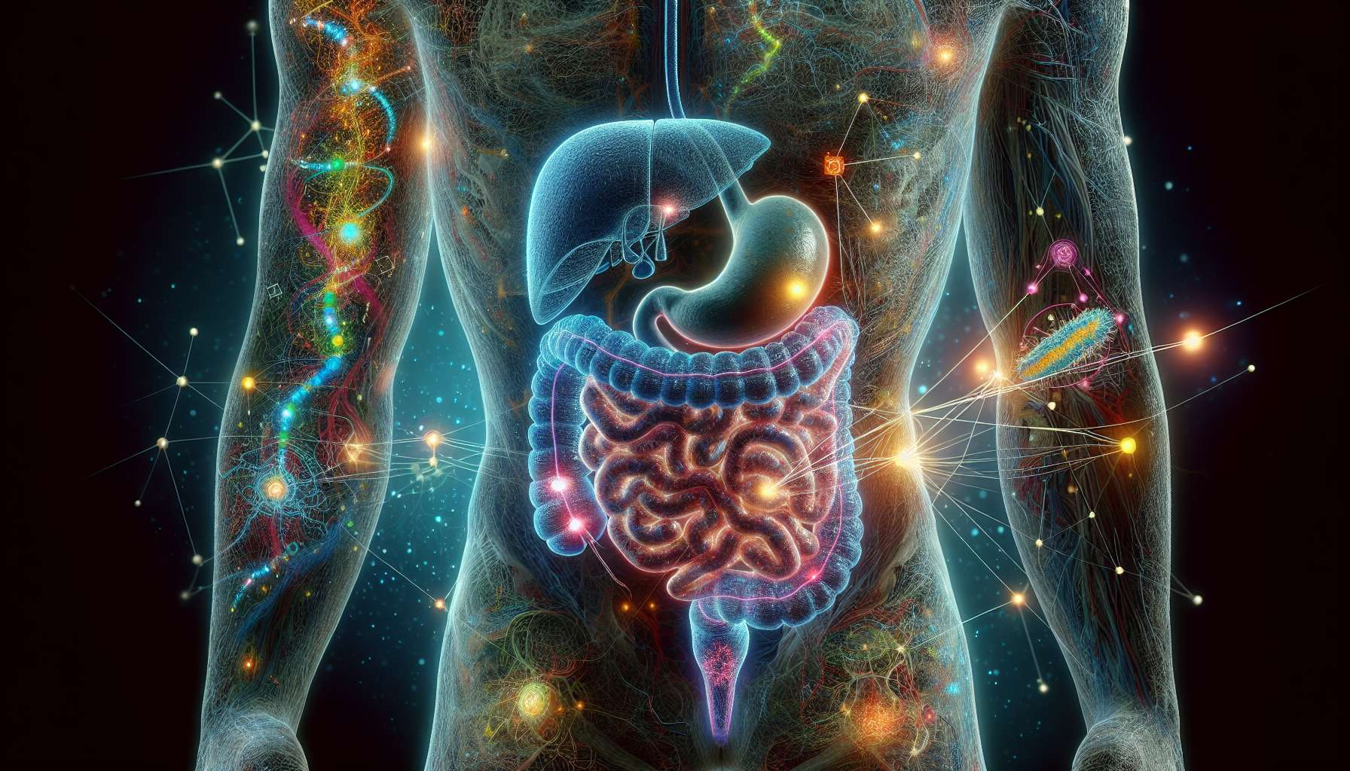

The microbiota, also known as gut flora or microbiome, is the set of microorganisms (bacteria, viruses, fungi) that colonize our digestive tract, mainly the colon. It is composed of over 100,000 billion bacteria, 10 times more than the number of cells in our body, and weighs roughly 2 kg. This intestinal microbiota is unique to each individual, is established from birth, and evolves throughout life depending on environmental factors (diet, stress, antibiotics).  
  
Beyond its role in digestion and immunity, the intestinal microbiota is a real endocrine organ that closely interacts with the host's hormonal system. It produces many active metabolites, such as short-chain fatty acids (SCFA), secondary bile acids or neurotransmitters, which can modulate the synthesis, metabolism and action of hormones. Reciprocally, the host's hormones, in particular estrogens and progesterone, can influence the composition and activity of the intestinal microbiota.  
  
This bidirectional communication between the microbiota and the endocrine system, called the "microbiota-gut-brain axis", plays a key role in the regulation of hormonal balance and metabolic health. Recent studies suggest that an imbalance of the intestinal microbiota (dysbiosis) could be involved in certain endocrine disorders, such as obesity, type 2 diabetes, polycystic ovary syndrome (PCOS) or menopause disorders.  
  
For example, the intestinal microbiota is able to metabolize circulating estrogens, via the action of bacterial β-glucuronidase which deconjugates and reactivates them. A dysbiosis with an increase in β-glucuronidase activity can thus lead to an increased reabsorption of estrogens in the enterohepatic circulation, promoting relative hyperestrogenism. This hyperestrogenia is a risk factor for hormone-dependent breast cancer, endometriosis, or PCOS.  
  
Conversely, certain bacteria of the microbiota, such as Clostridia, are able to convert dietary fibers into SCFA (acetate, propionate, butyrate), which have a protective effect on metabolic and hormonal health.SCFAs stimulate the secretion of enteroendocrine peptides (GLP-1, PYY) that regulate satiety and insulin sensitivity, and inhibit hepatic lipogenesis, thus preventing obesity and insulin resistance. A diet rich in fermentable fibers (prebiotics) can thus promote a protective microbiota and improve glycemic and hormonal balance.  
  
The vaginal microbiota, mainly composed of Lactobacilli, also plays an important role in women's hormonal and reproductive health. It protects against genital infections by maintaining an acidic pH and producing hydrogen peroxide and bacteriocins. An imbalance of the vaginal microbiota (bacterial vaginosis) is associated with an increased risk of sexually transmitted infections, spontaneous miscarriages and preterm delivery. Estrogens promote the growth of Lactobacilli by stimulating the production of glycogen by vaginal epithelial cells, while progesterone has a local immunosuppressive effect that can promote infections.  
  
Finally, the intestinal and vaginal microbiota interact closely with the immune system, which is itself regulated by sex hormones. Estrogens have an immunostimulating effect, while progesterone and androgens have an immunosuppressive effect. This immune modulation by hormones could explain the variations in the composition of the microbiota during the menstrual cycle and pregnancy, as well as the female predominance of certain autoimmune diseases.  
  
In conclusion, the microbiota is a key player in hormonal balance, which interacts complexly with the endocrine and immune systems. Its composition and functionality are influenced by many environmental factors, especially diet, stress and medical treatments. A better understanding of the microbiota-gut-brain axis opens up new perspectives for the prevention and treatment of endocrine and metabolic disorders, via nutritional approaches (prebiotics, probiotics) and microbiota modulation (fecal transplantation, phagotherapy). Taking into account the microbiota in the evaluation and management of hormonal imbalances is a major public health issue, requiring an integrative and personalized approach to medicine.  
  
Key Points to Remember:  
  
1. The intestinal microbiota is composed of over 100,000 billion bacteria, 10 times more than the number of cells in our body, and weighs roughly 2 kg. It is unique to each individual and evolves throughout life.  
  
2. The intestinal microbiota is a real endocrine organ that closely interacts with the host's hormonal system via the microbiota-gut-brain axis. This bidirectional communication plays a key role in regulating hormonal balance and metabolic health.  
  
3. An imbalance of the intestinal microbiota (dysbiosis) could be involved in certain endocrine disorders, such as obesity, type 2 diabetes, polycystic ovary syndrome (PCOS) or menopause disorders.  
  
4. The intestinal microbiota can metabolize circulating estrogens, and a dysbiosis with an increase in β-glucuronidase activity can lead to relative hyperestrogenism, a risk factor for certain hormone-dependent pathologies.  
  
5. Certain bacteria of the microbiota produce short-chain fatty acids (SCFA) that have a protective effect on metabolic and hormonal health by regulating satiety, insulin sensitivity, and hepatic lipogenesis.  
  
6. The vaginal microbiota, mainly composed of Lactobacilli, plays an important role in women's hormonal and reproductive health. An imbalance in this microbiota is associated with an increased risk of infections and obstetric complications.  
  
7. The microbiota closely interacts with the immune system, itself regulated by sex hormones, which could explain the variations in its composition during the menstrual cycle and pregnancy, as well as the female predominance of certain autoimmune diseases.  
  
8. A better understanding of the microbiota-gut-brain axis opens up new perspectives for the prevention and treatment of endocrine and metabolic disorders, through nutritional and microbiota modulation approaches. Taking the microbiota into account in the evaluation and management of hormonal imbalances requires an integrative and personalized approach to medicine.