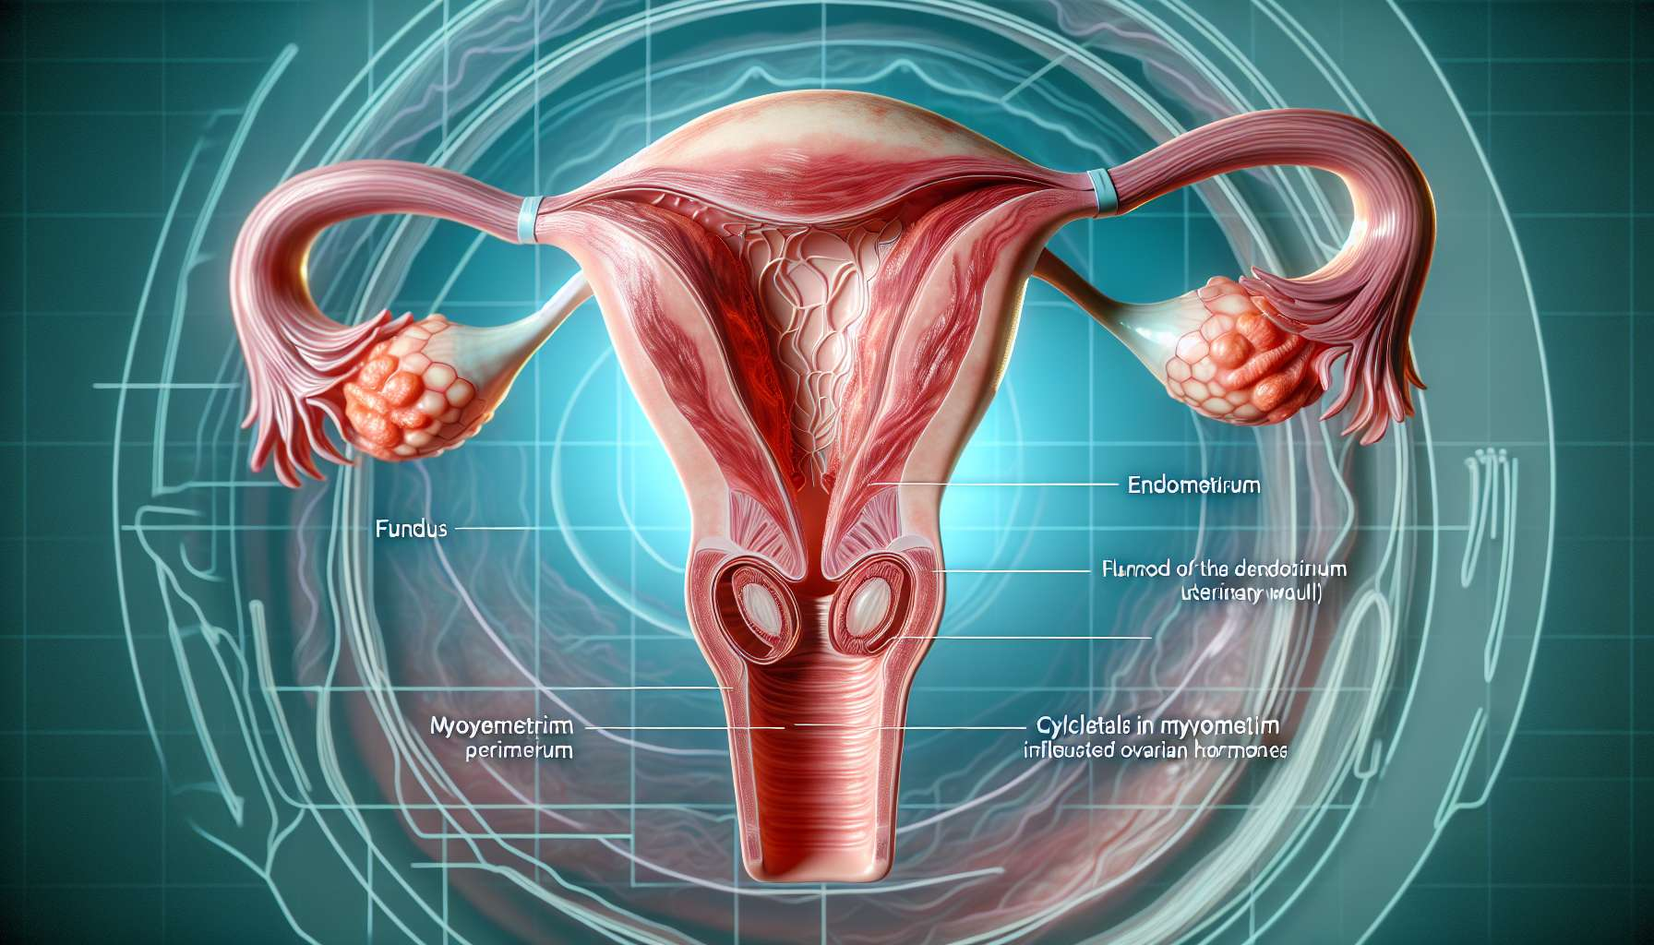

The uterus is the central female reproductive organ, located in the pelvic cavity between the bladder and rectum. It's a hollow, muscular and highly vascularized organ, which plays a crucial role in menstruation, gestation, and childbirth. Shaped like an inverted pear, the uterus measures about 7 to 8 cm in length in a nulliparous woman (who has never given birth) and weighs between 50 and 80 grams.   
  
The uterus is divided into three anatomical parts: the fundus, which corresponds to the rounded upper third, the body, which forms the slender intermediate part, and the cervix, which constitutes the cylindrical lower third. The uterine cavity, lined by the endometrial mucosa, communicates with the fallopian tubes at the uterine horns and with the vagina via the external cervical orifice.   
  
The uterine wall consists of three layers: the endometrium (inner mucosa), the myometrium (thick muscle), and the perimetrium (external serosa). The endometrium is a highly hormone-sensitive tissue that undergoes cyclical changes under the influence of ovarian hormones. During the follicular phase of the cycle, estrogens stimulate the proliferation of the endometrium, which gradually thickens. After ovulation, the progesterone secreted by the corpus luteum transforms the endometrium into the secretory phase, characterized by the appearance of tortuous glands and spiraled arterioles. This preparation phase for embryo implantation lasts approximately 14 days. In the absence of fertilization, the sharp drop in ovarian hormone levels causes the endometrium to desquamate, triggering menstruation.  
  
The main role of the uterus is to host the embryo after fertilization and allow its development until birth. When an embryo implants into the endometrium around the 6th day post-fertilization, it secretes the hormone chorionic gonadotropin (hCG) which maintains the corpus luteum and continuous secretion of progesterone, vital for the maintenance of pregnancy. The endometrium then transforms into the decidua, a richly vascularized tissue that nourishes the embryo until the placenta is established. Throughout pregnancy, the uterus adapts to fetal growth by significantly increasing in volume, from a virtual cavity of a few millimeters to a 5-liter organ at term. This expansion is enabled by the hypertrophy and hyperplasia of the myometrial muscle fibers under the effect of progesterone and estradiol.  
  
At childbirth, the uterine myometrium rhythmically and intensely contracts to enable the expulsion of the fetus. These contractions are triggered by a cascade of hormonal events, notably the drop in progesterone and an increase in oxytocin and prostaglandins. After delivery (expulsion of the placenta), the uterus will gradually regress to regain its initial size within a few weeks, which is referred to as the post-partum phase.   
  
Apart from pregnancy, the uterus also plays a role in pelvic statics by supporting the bladder and rectum. However, with age and pregnancies, the uterine ligaments can stretch and cause a prolapse (descent) of the uterus, causing a feeling of pelvic heaviness and urinary disorders.  
  
Certain conditions can affect the uterus and disrupt its function, such as congenital uterine malformations (septate uterus, bicornuate uterus...), uterine fibroids (benign myometrium tumors), endometrial polyps, adenomyosis (presence of endometrial tissue in the myometrium), or even endometrial cancers. These diseases can lead to menstrual disorders (menorrhagia, dysmenorrhea...), infertility, or obstetric complications.  
  
Key Points to Remember:  
  
- The uterus is the central female reproductive organ, located in the pelvic cavity, that plays a crucial role in menstruation, gestation, and childbirth.  
  
- It is divided into three parts: the fundus, body, and cervix, and its wall is made up of three layers: the endometrium, myometrium, and perimetrium.  
  
- The endometrium undergoes cyclical changes under the influence of ovarian hormones, preparing the uterus for potential embryo implantation.  
  
- The main role of the uterus is to host and allow the development of the embryo until birth, adapting to fetal growth.   
  
- During childbirth, the contractions of the myometrium, triggered by hormonal changes, enable the expulsion of the fetus.  
  
- Outside of pregnancy, the uterus contributes to the pelvic statics by supporting the bladder and rectum.  
  
- Various conditions can affect the uterus, resulting in menstrual disorders, infertility, or obstetric complications.