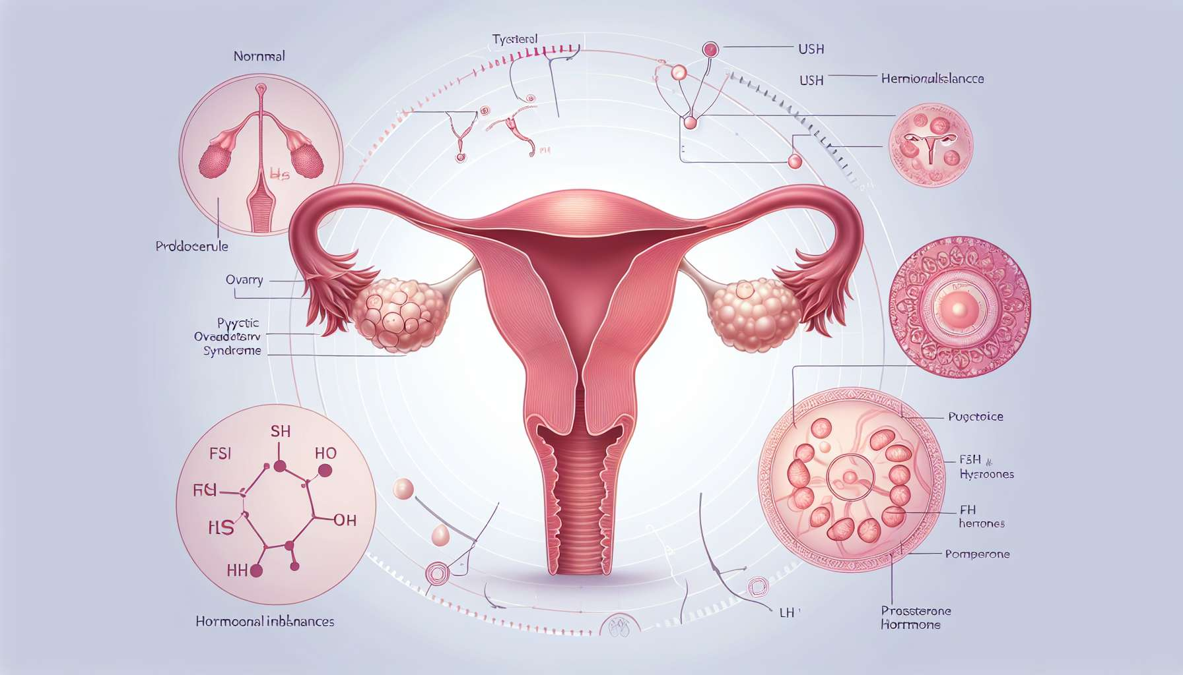

Ovulation disorders, such as anovulation and luteal insufficiency, are common disturbances of the menstrual cycle that can have a significant impact on women's fertility and reproductive health. These disorders are characterized by an absence or insufficiency of ovulation, leading to irregular cycles, abnormal bleeding, and difficulties in conceiving.  
  
Anovulation is defined as the absence of ovulation during a menstrual cycle. It can be occasional, affecting an isolated cycle, or chronic, recurring over several consecutive cycles. Anovulation is particularly common in teenagers in the first years following menarche, as well as in women approaching menopause, due to the immaturity or decline of ovarian function. However, it can occur at any age and may be a sign of an underlying hormonal imbalance.  
  
The causes of anovulation are multiple and can involve hormonal, metabolic, or environmental factors. Polycystic ovarian syndrome (PCOS) is the most common cause of chronic anovulation, affecting 5 to 10% of women of childbearing age. It is characterized by excessive androgen production and insulin resistance, disrupting follicular maturation and ovulation. Other causes of anovulation include thyroid disorders (hyperthyroidism, hypothyroidism), hyperprolactinemia, weight imbalances (anorexia, obesity), chronic stress, and certain medications (chemotherapy, corticosteroids).  
  
Example: Julie, 25, consults her gynecologist for irregular cycles and difficulties in conceiving for over a year. Her periods are spaced 40 to 60 days apart and she does not feel the usual signs of ovulation (slippery mucus, lateralized pain). After a hormonal assessment and a pelvic ultrasound, the diagnosis of PCOS is made. Her gynecologist suggests treatment with metformin to improve her insulin sensitivity and promote ovulation, along with nutritional care and psychological support.  
  
Luteal insufficiency, on the other hand, is defined as a defect in the secretion of progesterone by the corpus luteum after ovulation. Progesterone is essential to prepare the endometrium for embryo implantation and to maintain pregnancy in early gestation. Therefore, luteal insufficiency can lead to difficulties in conceiving or early miscarriages, even in the presence of ovulation.  
  
The causes of luteal insufficiency are still poorly understood, but several factors appear to be involved in its pathophysiology. Early ovarian aging, hyperprolactinemia, or endometriosis can affect the quality of ovulation and the secretion of progesterone. Environmental factors, such as stress, tobacco, or certain endocrine disruptors, may also interfere with luteal function.  
  
Anecdote: Sophie, 32, has been trying to conceive a child for 8 months without success. Her cycles are regular, and she feels ovulation signs each month, but her pregnancy tests remain negative. After an infertility assessment, her gynecologist suspects luteal insufficiency, confirmed by an endometrial biopsy in the second part of the cycle. Treatment with natural progesterone supplementation is initiated to promote embryo implantation and maintain pregnancy in case of conception.  
  
The diagnosis of ovulation disorders is based on a thorough clinical assessment, including a detailed history of menstrual and reproductive issues, a gynecological examination, and targeted additional tests. The temperature chart, which allows ovulation to be identified by a thermal rise in the second part of the cycle, can be a simple and inexpensive screening tool. The progesterone test in the second half of the cycle (Day 21 for a 28-day cycle) allows the quality of ovulation to be evaluated and luteal insufficiency to be detected. Other examinations, such as a hormonal assessment (FSH, LH, estradiol, testosterone, prolactin, TSH), pelvic ultrasound, or hysterosalpingography, may be indicated to seek an underlying cause.  
  
The management of ovulation disorders depends on their etiology and the woman's desire for pregnancy. In the case of chronic anovulation related to PCOS, treatment with clomiphene citrate or gonadotropins can be suggested to stimulate ovulation, along with management of metabolic factors (insulin resistance, obesity). In case of luteal insufficiency, natural progesterone supplementation (oral, vaginal, or intramuscular) may be prescribed in the second part of the cycle to promote implantation and maintain pregnancy. Hygiene-dietetic measures, such as adopting a balanced diet, regular physical activity, and stress management, can also help regulate cycles and improve fertility.  
  
Example: Marie, 30, suffers from severe endometriosis that disrupts her fertility. Despite regular cycles, she has luteal insufficiency linked to chronic inflammation and poor quality ovulation. After excision surgery of the endometriosis lesions, her gynecologist proposes an assisted reproductive technology (ART) protocol with ovarian stimulation and progesterone supplementation to optimize her chances of conceiving and carrying a pregnancy to term.  
  
In summary, ovulation disorders, such as anovulation and luteal insufficiency, are common disturbances of the menstrual cycle that can have a significant impact on women's fertility and reproductive health. These disorders may be related to hormonal, metabolic, or environmental factors, and require tailored management, depending on their etiology and the woman's desire for pregnancy. Close collaboration between the woman and her doctor is essential to make the diagnosis, seek an underlying cause, and propose individual treatment, combining medical (ovulation induction, progesterone supplementation) and hygiene-dietetic approaches. A multidisciplinary follow-up, including psychological support and nutritional care, can also help women better cope with these disorders and optimize their fertility.  
  
Key points to remember:  
  
1. Ovulation disorders, such as anovulation and luteal insufficiency, are common disturbances of the menstrual cycle that can impact women's fertility and reproductive health.  
  
2. Anovulation is characterized by the absence of ovulation during a menstrual cycle and can be occasional or chronic. Polycystic ovarian syndrome (PCOS) is the most common cause of chronic anovulation.  
  
3. Luteal insufficiency is a defect in the secretion of progesterone by the corpus luteum after ovulation, which can lead to difficulties in conceiving or early miscarriages.  
  
4. The diagnosis of ovulation disorders is based on a thorough clinical assessment, including a detailed history, a gynecological examination, and targeted additional tests (temperature chart, progesterone test, hormonal assessment, pelvic ultrasound, hysterosalpingography).  
  
5. The management of ovulation disorders depends on their etiology and the woman's desire for pregnancy. It may include medical treatments (clomiphene citrate, gonadotropins, progesterone supplementation), hygiene-dietetic measures, and multidisciplinary follow-up.  
  
6. Close collaboration between the woman and her doctor is essential to make the diagnosis, look for an underlying cause, and propose individual treatment, combining medical and hygiene-dietetic approaches, to optimize fertility and reproductive health.