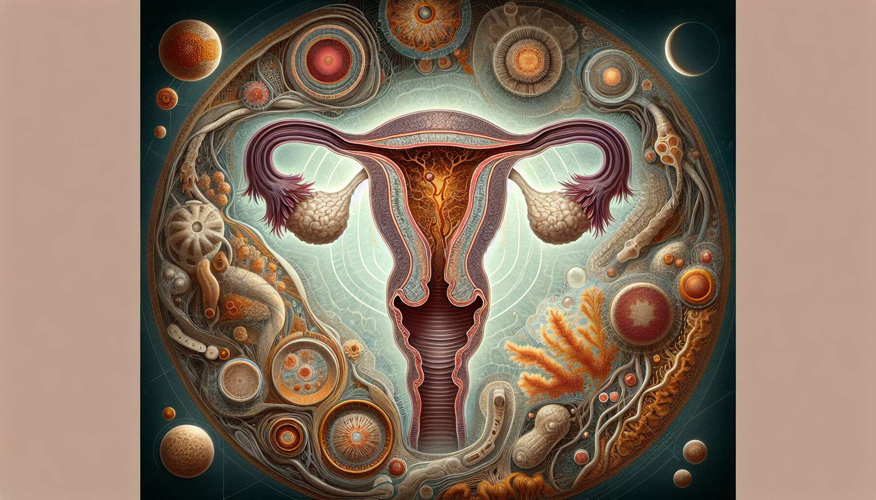

Menstruation, also known as periods, refers to the cyclical shedding of blood and endometrial debris from the vagina. They mark the beginning of a new menstrual cycle and occur in the absence of fertilization and embryonic implantation during the previous cycle. The average duration of menstruation is 3 to 7 days, but it can vary from one woman to another and from cycle to cycle.   
  
The onset of menstruation is linked to the abrupt drop in ovarian hormone levels (estrogens and progesterone) at the end of the luteal phase, following the involution of the unfertilized corpus luteum. This hormonal deprivation leads to a vasoconstriction of the spiral arteries of the endometrium, causing ischemia and necrosis of the superficial layers of the uterine mucosa. Proteolytic enzymes and prostaglandins released by endometrial cells cause a peeling of the functional endometrium, which is evacuated through the vagina in the form of blood and tissue debris.   
  
Menstrual flow is composed of blood, cervical and vaginal secretions, peeled endometrial cells, and prostaglandins. The total volume of menstrual loss is on average 30 to 80 ml, but can vary significantly from one woman to another. A loss of more than 80 ml per cycle defines menorrhea, which can lead to iron deficiency anemia and requires an etiological investigation.  
  
Menstruation often comes with physical and psychological symptoms related to hormonal changes and uterine contractions. The most common symptoms are pelvic pain (dysmenorrhea), lower back pain, fatigue, digestive disorders (bloating, diarrhea), headaches, and mood swings. These symptoms are usually relieved by analgesic and anti-inflammatory drugs, but sometimes require hormonal therapy in case of incapacitating dysmenorrhea.   
  
During menstruation, it is recommended to regularly change sanitary protection (pads, tampons, menstrual cups) to avoid genital infections and toxic shock syndrome. Proper intimate hygiene, without excess, is also important to maintain the balance of the vaginal flora and prevent irritation. It is possible to engage in physical activity and to have sexual intercourse during menstruation, depending on personal preferences and comfort.   
  
The regularity and abundance of menstruation are important indicators of female reproductive health. Amenorrhea (absence of periods), oligomenorrhea (long and irregular cycles), or menorrhea can be signs of hormonal disorders, anatomical abnormalities, or underlying organic diseases. It is important to consult a doctor in case of persistent or sudden onset menstrual disorders, in order to investigate the cause and propose appropriate treatment.  
  
In adolescents, the first menstrual cycles are often irregular and anovulatory, due to the immaturity of the hypothalamic-pituitary-ovarian axis. It generally takes 2 to 5 years after menarche (first periods) for cycles to become regular and ovulatory. In perimenopausal women, cycles also become irregular and shorter, with a progressive decrease in fertility, before ceasing entirely at menopause.   
  
Understanding the physiological mechanisms of menstruation and their variations throughout life is essential to support women in their gynecological follow-up and their experience of the menstrual cycle. Early education about the menstrual cycle and associated body changes helps to demystify periods and promote a positive image of femininity. Identifying menstrual disorders and providing appropriate care contributes to improving women's quality of life and reproductive health throughout their lives.  
  
Key points to remember:  
  
- Menstruation marks the beginning of a new menstrual cycle and occurs in the absence of fertilization and embryonic implantation during the previous cycle.  
  
- The onset of menstruation is linked to the abrupt drop in ovarian hormone levels, causing vasoconstriction of the endometrium arteries, ischemia, and necrosis of the superficial layers of the uterine mucosa.  
  
- Menstrual flow is composed of blood, cervical and vaginal secretions, peeled endometrial cells, and prostaglandins. A loss greater than 80 ml per cycle defines menorrhea.  
  
- The most common symptoms during menstruation are pelvic pain, lower back pain, fatigue, digestive disorders, headaches, and mood swings.  
  
- Proper intimate hygiene is important to maintain the balance of the vaginal flora and prevent infections.  
  
- The regularity and abundance of menstruation are important indicators of female reproductive health. It is important to consult a doctor in case of persistent or sudden onset menstrual disorders.  
  
- In adolescents, the first menstrual cycles are often irregular and anovulatory. In perimenopausal women, cycles also become irregular and shorter before stopping entirely at menopause.  
  
- Understanding the physiological mechanisms of menstruation and providing appropriate care contributes to improving women's quality of life and reproductive health throughout their lives.