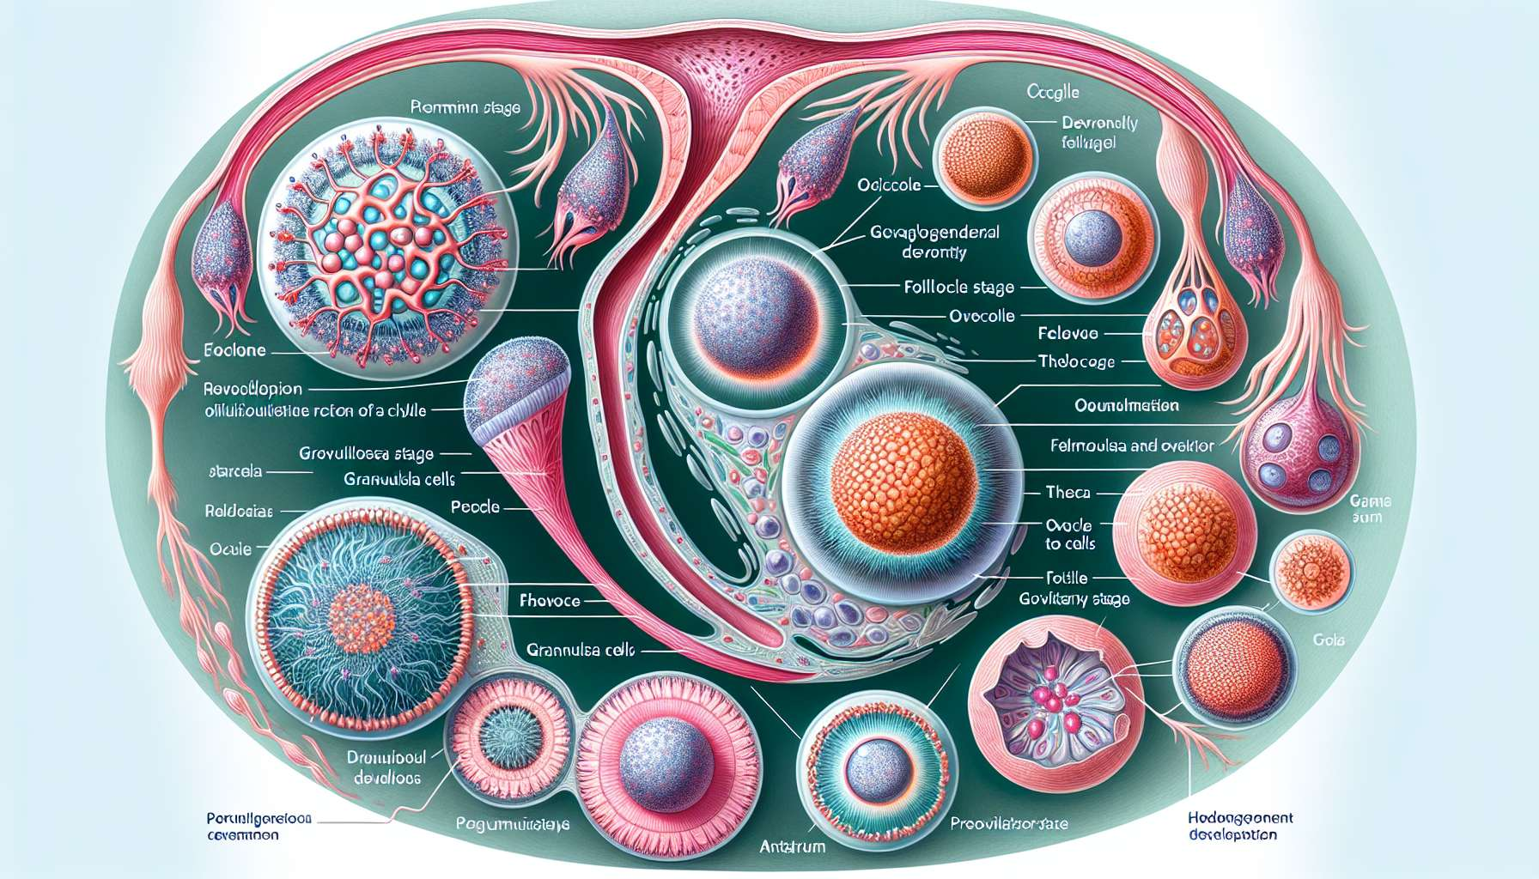

The ovarian cycle is a cyclical process that takes place in the ovaries and aims to produce a mature ovum capable of being fertilized. This cycle is closely linked to the development of ovarian follicles, called folliculogenesis. Folliculogenesis is a complex process that begins as early as fetal life and continues until menopause, involving many stages of follicular maturation under the control of endocrine and paracrine factors.  
  
In women, the stock of primordial follicles is established during embryonic life. At birth, each ovary contains about 1 to 2 million primordial follicles, which represent the total ovarian reserve. Each primordial follicle consists of an oocyte stuck at the prophase I stage of the first meiotic division, surrounded by a layer of flattened follicular cells. These follicles are said to be "quiescent" because they do not divide and have reduced metabolism. They can remain in this state for several decades, until their growth onset or their atresia (degeneration).  
  
Starting from puberty, under the influence of pituitary gonadotropins (FSH and LH), a cohort of primordial follicles is recruited each cycle to enter growth. This cyclic recruitment takes place continuously, regardless of menstrual cycles, and continues until the ovarian reserve is depleted, marking the onset of menopause. The number of follicles recruited at each cycle is determined by genetic and environmental factors, and decreases with age.  
  
The recruited follicles then undergo a series of morphological and functional transformations to reach the stage of pre-ovulatory follicle or De Graaf follicle. Several stages of follicle development can be distinguished: the primordial follicle stage, the primary follicle stage, the secondary follicle stage, the antral follicle stage, and the pre-ovulatory follicle stage. The transition from one stage to another is marked by changes in follicle size, the number of layers of follicular cells, and the appearance of an antral cavity.  
  
At the primary follicle stage, follicular cells elongate and become cubic, forming a granulosa layer around the oocyte. The oocyte begins its growth and is surrounded by an extracellular matrix, the zona pellucida. At the secondary follicle stage, granulosa cells multiply to form several cellular layers. An inner theca differentiates from ovarian stroma and surrounds the granulosa, providing vascularization and support to the growing follicle.  
  
When the follicle reaches a size of about 2 mm in diameter, liquid vacuoles appear in the granulosa and confluence to form a unique cavity, the antrum. The follicle is then said to be "antral" and the oocyte is offset in a mass of granulosa cells called cumulus oophorus. The follicular fluid, rich in steroids, enzymes, and growth factors, bathes the oocyte and plays a crucial role in its maturation.  
  
Among the recruited antral follicles, only one (sometimes two) will be selected to continue its growth until the pre-ovulatory stage, under the effect of a peak of FSH in the middle of the follicular phase. This dominant follicle, measuring 15 to 20 mm in diameter, is distinguished by its large size, its developed antrum, and its ability to produce large quantities of estradiol. The other antral follicles, deprived of FSH, will degenerate by atresia, a finely regulated apoptosis process.  
  
The pre-ovulatory follicle is characterized by a high synthesis activity of follicular cells. The cells of the inner theca, stimulated by the LH, produce androgens which are converted into estrogens by the granulosa cells, under the effect of the FSH. Estradiol exerts a positive feedback on the hypothalamic-pituitary axis, triggering the pre-ovulatory peak of LH that will induce ovulation.  
  
Just before ovulation, the oocyte completes its first meiotic division and expels the first polar body, becoming a haploid secondary oocyte. It then restarts its second meiotic division which will remain blocked in metaphase II until possible fertilization. The mature oocyte, surrounded by the cumulus oophorus and the corona radiata, is then released into the fallopian tube during ovulation, ready to be fertilized.  
  
Folliculogenesis is a highly selective process that allows a quality mature oocyte to be produced each cycle, while preserving the ovarian reserve. Out of the millions of primordial follicles present at birth, only 400 to 500 will be ovulated during a woman's reproductive life. The other follicles, over 99.9%, will degenerate by atresia at different stages of their development. This drastic follicular selection is necessary to ensure the quality of the ovulated oocytes and maintain long-term fertility.  
  
Several factors can influence folliculogenesis and oocyte quality, such as age, genetic factors, oxidative stress, exposure to toxins, or certain endocrine pathologies. With age, the ovarian reserve decreases and the quality of the oocytes deteriorates, leading to a decrease in fertility and an increase in embryonic aneuploidy risks. The evaluation of the ovarian reserve, by the dosing of AMH or the count of antral follicles, can help predict a woman's reproductive potential and adjust the management of infertility.  
  
In conclusion, folliculogenesis is a dynamic and finely regulated process that allows the development of a pre-ovulatory follicle each cycle, from the primordial follicle stage to ovulation. It is essential for the production of a fertilizable mature oocyte and the maintenance of female fertility. Understanding the mechanisms of folliculogenesis is crucial to grasp the physiology of the menstrual cycle and the causes of ovarian origin infertility.  
  
Key takeaways:  
  
- Folliculogenesis is a complex process that begins as early as fetal life and continues until menopause, involving many stages of follicular maturation under the control of endocrine and paracrine factors.  
  
- At birth, each ovary contains about 1 to 2 million primordial follicles, which represent the total ovarian reserve.  
  
- This cyclic recruitment takes place continuously, regardless of menstrual cycles, and continues until the ovarian reserve is depleted, marking the onset of menopause.  
  
- The oocyte begins its growth and is surrounded by an extracellular matrix, the zona pellucida.  
  
- The follicle is then said to be "antral" and the oocyte is offset in a mass of granulosa cells called cumulus oophorus.  
  
- The other antral follicles, deprived of FSH, will degenerate by atresia, a finely regulated apoptosis process.  
  
- Just before ovulation, the oocyte completes its first meiotic division and expels the first polar body, becoming a haploid secondary oocyte.  
  
- Out of the millions of primordial follicles present at birth, only 400 to 500 will be ovulated during a woman's reproductive life.  
  
- With age, the ovarian reserve decreases and the quality of the oocytes deteriorates, leading to a decrease in fertility and an increase in embryonic aneuploidy risks.  
  
- Understanding the mechanisms of folliculogenesis is crucial to grasp the physiology of the menstrual cycle and the causes of ovarian origin infertility.