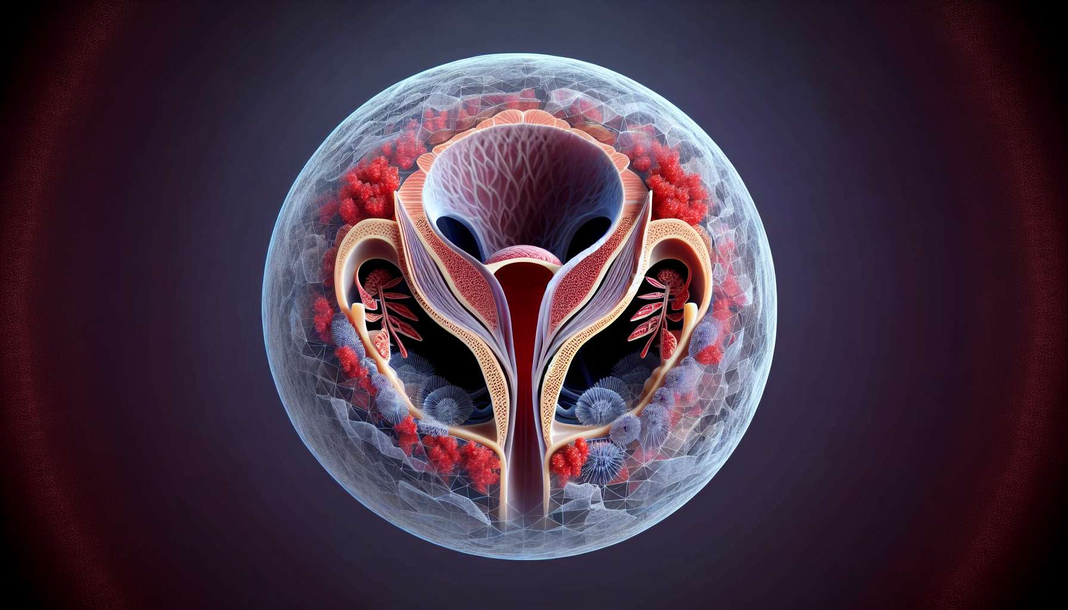

The pelvic floor is a set of muscles, ligaments and fascia that close the lower part of the pelvis and support the pelvic organs, including the uterus, bladder, and rectum. Its anatomical and functional integrity is essential for maintaining pelvic statics, ensuring urinary and fecal continence, and allowing for satisfactory sexual function. In women, the pelvic floor also plays an important role in menstrual health and reproductive function.  
  
The pelvic floor muscles, also called perineal muscles, are organized into three planes: the deep plane (pelvic diaphragm), the middle plane (uro-genital diaphragm), and the superficial plane (perineum). The pelvic diaphragm is mainly made up of the levator ani muscles (pubo-coccygeus, ilio-coccygeus and ischio-coccygeus) which form a hammock-like strap supporting the pelvic organs. The uro-genital diaphragm includes the deep and superficial transverse perineal muscles, which participate in urinary continence and stability of the central fibrous core of the perineum. The superficial plane includes the ischio-cavernous, bulbospongiosus and external anal sphincter muscles, involved in sexual function and anal continence.  
  
These muscles are richly innervated by the pudendal and pelvic nerves, which control their tone and voluntary contraction. They are also closely linked with the pelvic fascia and the uterine ligament apparatus, thus ensuring the suspension and physiological mobility of the uterus during the menstrual cycle and pregnancy.  
  
The pelvic floor plays a key role in menstrual health by supporting the uterus and facilitating its venous and lymphatic drainage. A normal perineal tone helps maintain the uterus in its anteverted position and prevent pelvic venous stasis, which can promote dysmenorrhea, menorrhagia, or endometriosis. During menstruation, rhythmical uterus contractions are accompanied by reflex activity of the perineal muscles, which participate in the expulsion of menstrual secretions and prevent menstrual blood reflux into the fallopian tubes.  
  
A weakening or dysfunction of the pelvic floor, often secondary to multiple pregnancies, obesity, chronic constipation or abdominal hyperpressure, can lead to pelvic static disorders and affect menstrual health. Uterine prolapse, characterized by a sagging of the uterus towards the vagina, can be accompanied by dysmenorrhea, menorrhagia and a sensation of pelvic heaviness. Urinary stress incontinence, related to sphincter insufficiency, may be aggravated during menstruation due to hormone impregnation and increase of uterine volume.  
  
Perineal rehabilitation, through voluntary contraction exercises (Kegel exercises) or electrostimulation, is an effective method for strengthening the muscles of the pelvic floor and preventing or treating pelvic static disorders. It is particularly indicated in the postpartum period to prevent urinary incontinence and promote the recovery of sexual function. In women suffering from dysmenorrhea or chronic pelvic pain syndromes, perineal rehabilitation can help release muscle tension and improve pelvic vascularization, thus reducing symptoms.  
  
Certain sports practices, like Pilates or yoga, emphasize the strengthening of core deep muscles, including perineal muscles, and may be beneficial for menstrual health and prevention of perineal disorders. Conversely, sports with repeated impact on the perineum, such as horse riding or cycling, can promote a weakening of the pelvic floor and require appropriate prevention measures.  
  
In conclusion, the pelvic floor is a complex and essential anatomical structure to female health, which supports pelvic organs and participates in menstrual, sexual and sphincter function. Its comprehensive management, associating hygienic-dietary measures, perineal rehabilitation and suitable physical activity, is a key element in the prevention and treatment of pelvic static disorders and menstrual health. A close collaboration between gynecologists, midwives, physiotherapists and sports coaches is often necessary to optimize the management of women suffering from perineal disorders and improve their quality of life.   
  
Key Points to Remember:  
  
1. The pelvic floor is a set of muscles, ligaments and fascia that support the pelvic organs and ensure urinary and fecal continence, as well as satisfactory sexual function.  
  
2. The muscles of the pelvic floor are arranged into three planes: the pelvic diaphragm, the urogenital diaphragm, and the superficial perineum. The pelvic diaphragm, primarily composed of the levator ani muscles, plays a crucial role in supporting the pelvic organs.  
  
3. The pelvic floor is closely tied to menstrual health by supporting the uterus, facilitating its venous and lymphatic drainage, and participating in the expulsion of menstrual secretions.   
  
4. A weakening or dysfunction of the pelvic floor can lead to pelvic static disorders, such as a uterine prolapse or urinary incontinence, and impact menstrual health.  
  
5. Pelvic floor rehabilitation, through Kegel exercises or electrical stimulation, is an effective method for strengthening the pelvic floor muscles, preventing and treating pelvic static disorders, and improving menstrual health.  
  
6. Certain sports practices, like Pilates or Yoga, can be beneficial to the health of the pelvic floor, while sports with repeated impact on the perineum require appropriate preventative measures.  
  
7. Comprehensive, multidisciplinary care, involving gynecologists, midwives, physiotherapists and sports coaches, is essential in optimizing the health of the pelvic floor and women's quality of life.