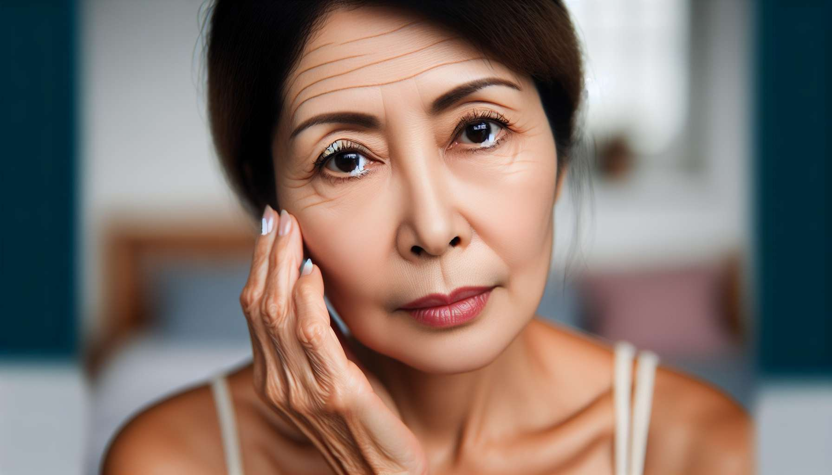

Menopause, marking the end of a woman's reproductive life, is characterized by a host of physical and psychological symptoms related to estrogen deficiency. These symptoms, of varying intensity and duration from woman to woman, can significantly impact quality of life and require appropriate management.  
  
Among the most frequent and characteristic symptoms of menopause, we find vasomotor disorders, such as hot flashes and night sweats. Hot flashes, described as a sudden and intense sensation of heat spreading to the face, neck, and chest, affect nearly 75% of menopausal women. They are often accompanied by redness, palpitations, and sweating, and can last from a few seconds to several minutes. Night sweats, meanwhile, occur during sleep and can result in frequent waking and daytime fatigue.  
  
Example: For a few months now, Sophie, 52, wakes up almost every night to copious sweats that dampen her sheets. She feels tired and irritable during the day, which impacts her professional and family life. During a consultation with her gynecologist, she explains that these night sweats are a classic symptom of menopause, linked to estrogen deficiency and changes in thermoregulation. She offers low-dose hormone replacement therapy to alleviate these disorders and improve her sleep.  
  
Menopause is also accompanied by cutaneous-mucosal changes, related to the atrophy of estrogen-dependent tissues. The skin becomes thinner, drier, and less elastic, promoting the appearance of wrinkles and fine lines. Mucous membranes, particularly the vaginal mucosa, thin and weaken, leading to vaginal dryness, itching, and dyspareunia (pain during sexual intercourse). These changes can also affect the urogenital sphere, with stress urinary incontinence, recurring urinary tract infections, and dysuria (painful urination).  
  
Anecdote: During a workshop on menopause, a participant shares her experience with vaginal dryness: "Since my menopause, it feels like I have sandpaper in my vagina. Intercourse has become so painful that I ended up avoiding it completely. Thankfully, my gynecologist prescribed a local estrogen-based treatment that has really improved things. I can once again have a fulfilling sexual life with my partner."  
  
Mood disorders and psychological symptoms are also common during menopause, affecting nearly one in two women. Hormonal fluctuations, along with physiological modifications and life changes that occur during this period, can lead to emotional instability, irritability, anxiety, or even depressive mood. Some women also report memory and concentration disorders, chronic fatigue, and a decrease in libido.  
  
Example: Since her menopause, Marie, 54, feels like she doesn't recognize herself anymore. Previously so cheerful and dynamic, she now feels sad and beaten down, with no energy for her usual activities. She struggles to concentrate at work and flies off the handle for nothing at home. Worried, she discusses this with her gynecologist who explains that these mood changes are common during menopause and can be managed through a comprehensive approach combining hormone therapy, psychotherapy, and dietary measures.  
  
Finally, menopause is accompanied by accelerated bone loss, related to estrogen deficiency. Estrogen indeed plays a key role in maintaining bone mass, by promoting the activity of osteoblasts (cells that form bone) and inhibiting that of osteoclasts (cells that absorb bone). Their deficit leads to an imbalance in bone remodeling, with bone loss of about 2 to 3% per year in the first years following menopause. This bone loss can lead to osteopenia, then osteoporosis, with an increased risk of fractures.  
  
Anecdote: At a conference on osteoporosis, a rheumatologist alarms about the importance of screening and prevention in menopausal women: "After age 50, one in three women will sustain an osteoporotic fracture in her life. These fractures, particularly hip fractures, can have dramatic consequences in terms of morbidity, mortality, and loss of autonomy. It is essential to screen for osteoporosis early with a bone densitometry test and to implement preventive measures: vitamin D/calcium supplements, regular physical activity, cessation of smoking, etc."  
  
In summary, menopause comes with many symptoms related to estrogen deficiency, which can affect women's quality of life. Vasomotor disorders, cutaneous-mucosal changes, psychological symptoms, and bone loss are the most frequent and characteristic manifestations of this period. Their management is based on a comprehensive and personalized approach, combining dietary measures, hormone replacement therapy, and psychological support if needed. Screening and prevention of long-term complications, in particular osteoporosis, are also an integral part of the care for menopausal women.  
  
Key points to remember:  
  
- Menopause marks the end of a woman's reproductive life and comes with symptoms related to estrogen deficiency.  
  
- Vasomotor disorders (hot flashes, night sweats) are the most frequent and characteristic symptoms, affecting nearly 75% of menopausal women.  
  
- Cutaneous-mucosal changes (dry skin, wrinkles, vaginal dryness, dyspareunias) are related to the atrophy of estrogen-dependent tissues.  
  
- Mood disorders and psychological symptoms (irritability, anxiety, depression) affect one in two women at menopause.  
  
- Menopause is accompanied by accelerated bone loss, potentially leading to osteoporosis and an increased risk of fractures.  
  
- The management of menopause is based on a comprehensive and personalized approach, combining dietary measures, hormone replacement therapy, and psychological support.  
  
- Screening and prevention of long-term complications, particularly osteoporosis, are essential in menopausal women.