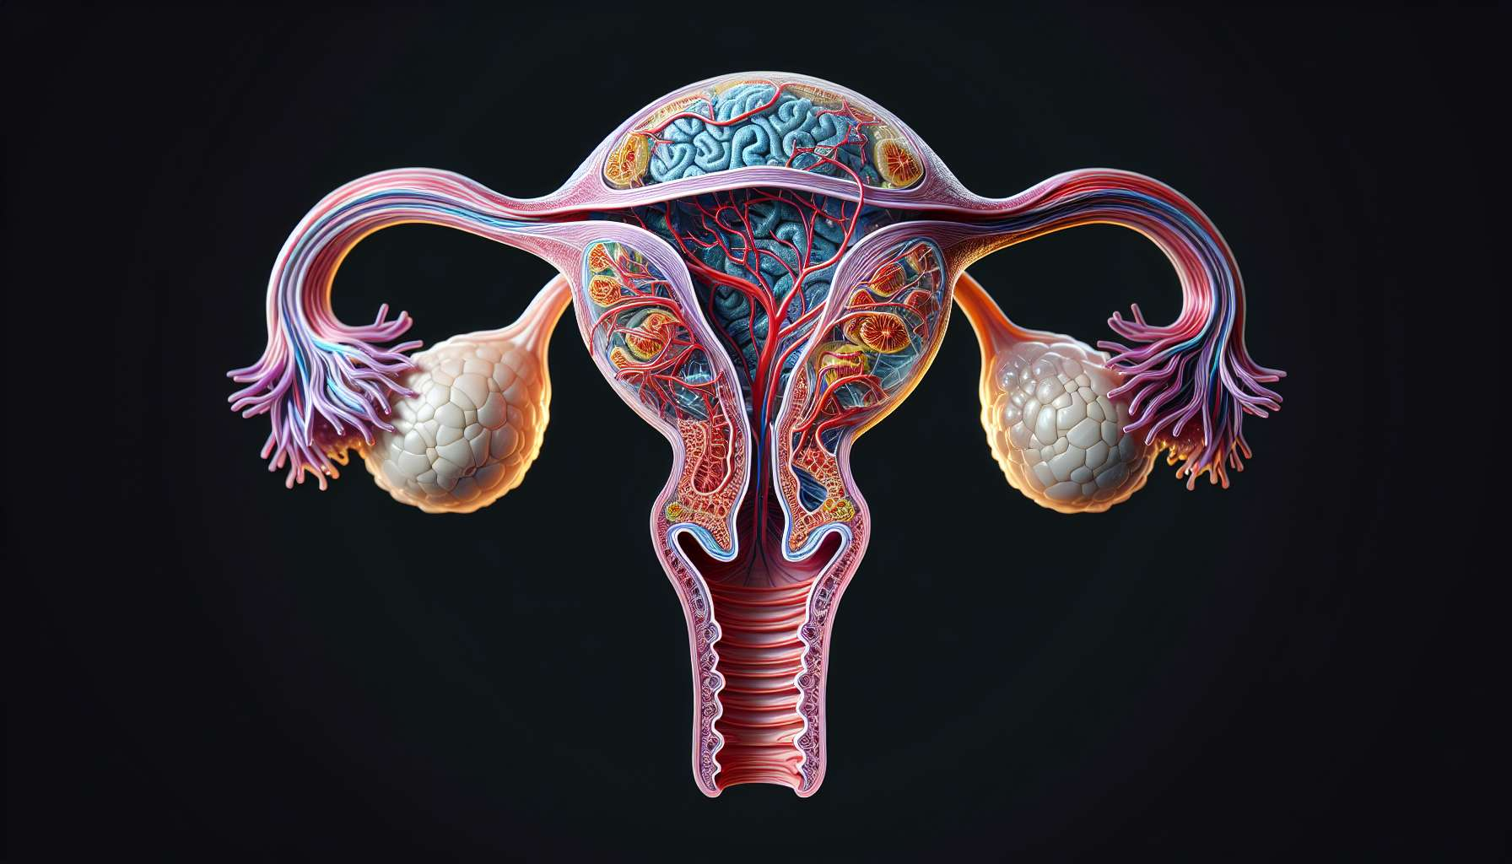

The ovaries are essential female reproductive organs, located on each side of the uterus in the pelvic cavity. They are ovoid in shape and measure about 3 to 5 cm long in an adult woman. The ovaries are made up of two main areas: the ovarian cortex, which contains ovarian follicles at different stages of development, and the ovarian medulla, which is richly vascularized and innervated.  
  
The main role of the ovaries is the production of oocytes, the female reproductive cells. At birth, each ovary contains about 1 to 2 million primordial follicles, each containing an immature oocyte. Throughout a woman's reproductive life, the follicles will develop according to a cyclical process called folliculogenesis, under the influence of gonadotropic hormones FSH and LH secreted by the pituitary gland. At each menstrual cycle, a cohort of follicles is recruited to start their maturation, but generally only one follicle, called dominant, will reach the stage of mature or De Graaf follicle. This follicle will release the mature oocyte during ovulation, about 14 days before the next period.  
  
In addition to their gametogenic function, the ovaries are also endocrine glands that secrete steroid hormones essential for the development of female sexual characteristics and the regulation of the menstrual cycle. The follicular cells that surround the oocyte, called granulosa cells and theca cells, will differentiate during follicular maturation to acquire steroidogenic capabilities. Under the influence of FSH, the granulosa cells will synthesize estrogens, mainly estradiol, from the androgens produced by the theca cells under the effect of LH. The estrogens will promote the growth of the uterine endometrium during the follicular phase of the cycle, but also stimulate the appearance of secondary sexual characteristics at puberty, such as breast development and the way fat is distributed in women.  
  
After ovulation, the residual follicular cells will transform into luteal cells under the action of LH to form the corpus luteum. This transient endocrine structure will mainly secrete progesterone, but also estrogens and relaxin. Progesterone will allow the transformation of the endometrium into the secretory phase, essential for embryonic implantation in case of fertilization. In the absence of pregnancy, the corpus luteum will degenerate after about 14 days, causing a sharp drop in progesterone and estrogen levels. This hormonal deprivation is what causes the shedding of the endometrium and the onset of menstruation.  
  
The ovaries therefore play a central role in the menstrual cycle, as they are responsible for the maturation and release of the oocyte, as well as the secretion of ovarian hormones that regulate all the cyclical changes of the female reproductive system. Their proper functioning depends on the hypothalamic-pituitary-ovarian axis, which will be discussed in more detail in module 1.18. Any disturbance of this axis or ovarian damage can lead to ovulation disorders and hormonal imbalances, resulting in menstrual disorders and infertility.  
  
Key points to remember:  
  
- The ovaries are female reproductive organs located on each side of the uterus, ovoid in shape and measuring 3 to 5 cm long in an adult woman.  
  
- The ovaries have two main roles: the production of oocytes (gametogenic function) and the secretion of steroid hormones (endocrine function).  
  
- Folliculogenesis is the cyclical process of maturation of ovarian follicles, regulated by the gonadotropic hormones FSH and LH. With each cycle, a dominant follicle releases a mature oocyte during ovulation.  
  
- Follicular cells (granulosa and theca cells) acquire steroidogenic capabilities during follicular maturation and produce estrogens, primarily estradiol.  
  
- Estrogens stimulate the growth of the uterine endometrium during the follicular phase and the development of female secondary sexual characteristics.  
  
- After ovulation, the corpus luteum forms and secretes progesterone, allowing the transformation of the endometrium into the secretory phase, necessary for embryonic implantation.  
  
- The ovaries play a central role in the menstrual cycle by ensuring the maturation and release of the oocyte, as well as the secretion of ovarian hormones regulating the cyclical changes in the female reproductive system.  
  
- The proper functioning of the ovaries depends on the hypothalamic-pituitary-ovarian axis, and any disturbance can cause ovulation disorders, hormonal imbalances, menstrual disorders, and infertility.