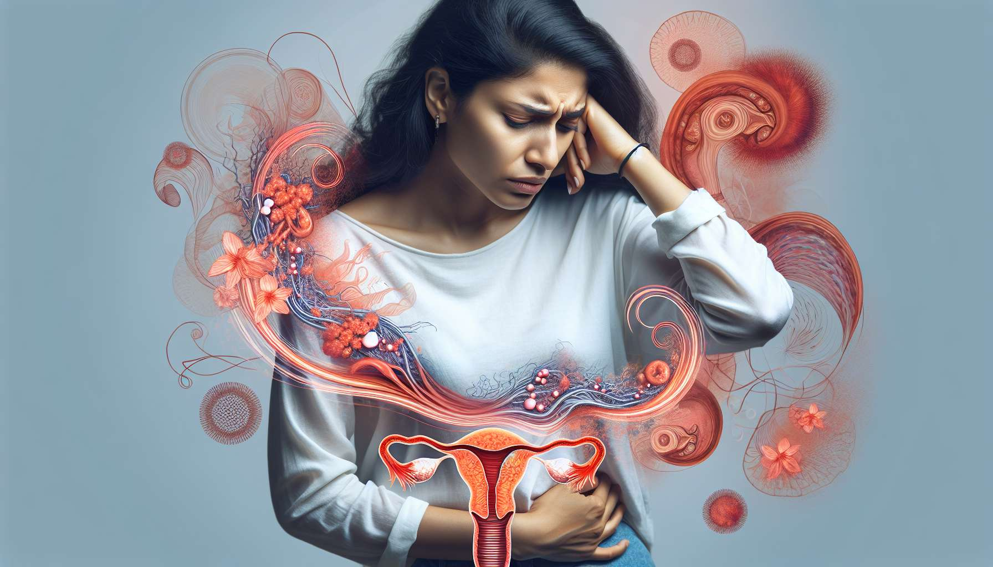

Endometriosis is a chronic and debilitating gynecological disease, affecting around 10% of women of childbearing age. It is characterized by the presence of endometrial tissue (uterine lining) outside the uterine cavity, mainly on the pelvic organs (ovaries, tubes, uterosacral ligaments, bladder, rectum). These endometriosis lesions react to the hormonal fluctuations of the menstrual cycle, causing local inflammation, adhesions, and progressive tissue damage.  
  
Symptoms of endometriosis vary from woman to woman, but classically include:  
  
- Dysmenorrhea (painful periods) intense, often debilitating, and resistant to usual analgesics  
- Chronic pelvic pain, which may radiate to the lower back, thighs, or rectum  
- Deep dyspareunia (pain during sexual intercourse), often described as a stab wound feeling  
- Heavy or prolonged menstrual bleeding (menorrhagia)  
- Digestive symptoms (bloating, pain during defecation, diarrhea) or urinary symptoms (dysuria, hematuria) during periods  
- Chronic fatigue and lowered quality of life  
- Infertility or difficulties in conceiving  
  
Example: Sophie, 28 years old, has suffered from debilitating pelvic pain since her adolescence, regularly forcing her to miss work or school. Her periods are very heavy, last more than 8 days, and are accompanied by pain during defecation and deep dyspareunia. After several years of medical journey, the diagnosis of severe endometriosis is established by pelvic MRI and laparoscopy. Sophie then begins medical treatment with GnRH analogues to rest her lesions, waiting for complete excision surgery to restore her quality of life and preserve her fertility.  
  
The exact causes of endometriosis are still not well understood, but several factors seem to intervene in its pathophysiology:  
  
- A genetic predisposition with an increased risk in women with a family history of endometriosis  
- A menstrual reflux (Sampson's theory), allowing the dispersion of endometrial cells into the pelvic cavity via the tubes  
- Cellular metaplasia, with abnormal differentiation of mesenchymal cells into endometrial tissue  
- Immune dysfunction, with macrophages' inability to eliminate endometriosis lesions  
- Environmental factors, such as exposure to endocrine disruptors or a microbiota imbalance  
  
Anecdote: Julie, 32 years old, was diagnosed with endometriosis 5 years ago, after several years of medical wandering. Since then, she has learned to adapt her lifestyle to better manage her pain and preserve her fertility. She has adopted an anti-inflammatory diet, regularly practices yoga and meditation, and uses essential oils to relieve her symptoms. She also advocates within a patient association to raise public and health professionals' awareness about this disease that is still too often unknown and trivialized.  
  
The diagnosis of endometriosis is based on a meticulous clinical evaluation, including a detailed interrogation of symptoms and histories, a thorough gynecological examination, and targeted imaging tests. The pelvic MRI is the reference examination to visualize deep endometriosis lesions and assess their extension. Transvaginal pelvic ultrasound can also detect ovarian endometriomas or rectovaginal nodules. However, the definitive diagnosis can only be made by laparoscopy with biopsy of the suspected lesions.  
  
The management of endometriosis is complex and multidisciplinary, combining medical treatments, surgical treatments and complementary approaches. Hormonal treatments, such as continuous progestin pills, the levonorgestrel intrauterine device (IUD) or GnRH analogues, aim to create a state of hypoestrogenism to atrophy endometriosis lesions and relieve pain. Excision surgery (laparoscopy or laparotomy) helps remove endometriosis lesions, restore pelvic anatomy, and preserve fertility. Complementary approaches, such as osteopathy, acupuncture, phytotherapy, or relaxation techniques, can help manage pain and improve quality of life.  
  
Example: Marie, 35 years old, underwent complete excision surgery for her severe endometriosis 2 years ago, after several years of unsuccessful medical treatments. Since the intervention, her pain has significantly decreased and she was able to naturally conceive a child. However, she continues to be regularly followed by her gynecologist and midwife, as the risk of endometriosis recurrence persists even after surgery. She has also incorporated osteopathy and yoga sessions into her daily life, which help her manage her residual pain and prevent pelvic adhesions.  
  
In summary, endometriosis is a chronic and debilitating gynecological disease, affecting one in ten women of childbearing age. It is characterized by the presence of endometrial tissue outside the uterine cavity, causing intense pelvic pain, abnormal bleeding, and infertility. Its diagnosis is based on meticulous clinical evaluation, targeted imaging exams, and laparoscopy with biopsy. Its management is complex and multidisciplinary, combining hormonal treatments, excision surgery, and complementary approaches. Comprehensive care, including psychological support and pain management, is essential to help women with endometriosis live better with their disease and preserve their quality of life. Raising awareness among the general public and health professionals about this disease, which is still often trivialized, is a major challenge for improving the early diagnosis and management of endometriosis.  
  
Key points:  
  
- Endometriosis is a chronic gynecological disease affecting about 10% of women of childbearing age.  
- It is characterized by the presence of endometrial tissue outside the uterine cavity, causing pain, abnormal bleeding, and infertility.  
- Symptoms include intense dysmenorrhea, chronic pelvic pain, deep dyspareunia, menorrhagia, digestive and urinary disorders, chronic fatigue, and infertility.  
- The exact causes remain poorly understood, but several factors seem to intervene: genetic predisposition, menstrual reflux, cellular metaplasia, immune dysfunction, and environmental factors.  
- The diagnosis is based on clinical evaluation, imaging (MRI and ultrasound) and laparoscopy with biopsy.  
- The management is multidisciplinary, combining hormonal treatments, excision surgery, and complementary approaches (osteopathy, acupuncture, phytotherapy, relaxation).  
- Comprehensive support, including psychological support and pain management, is essential for improving the quality of life of affected women.  
- Public and health professional awareness is crucial for early diagnosis and better management of endometriosis.