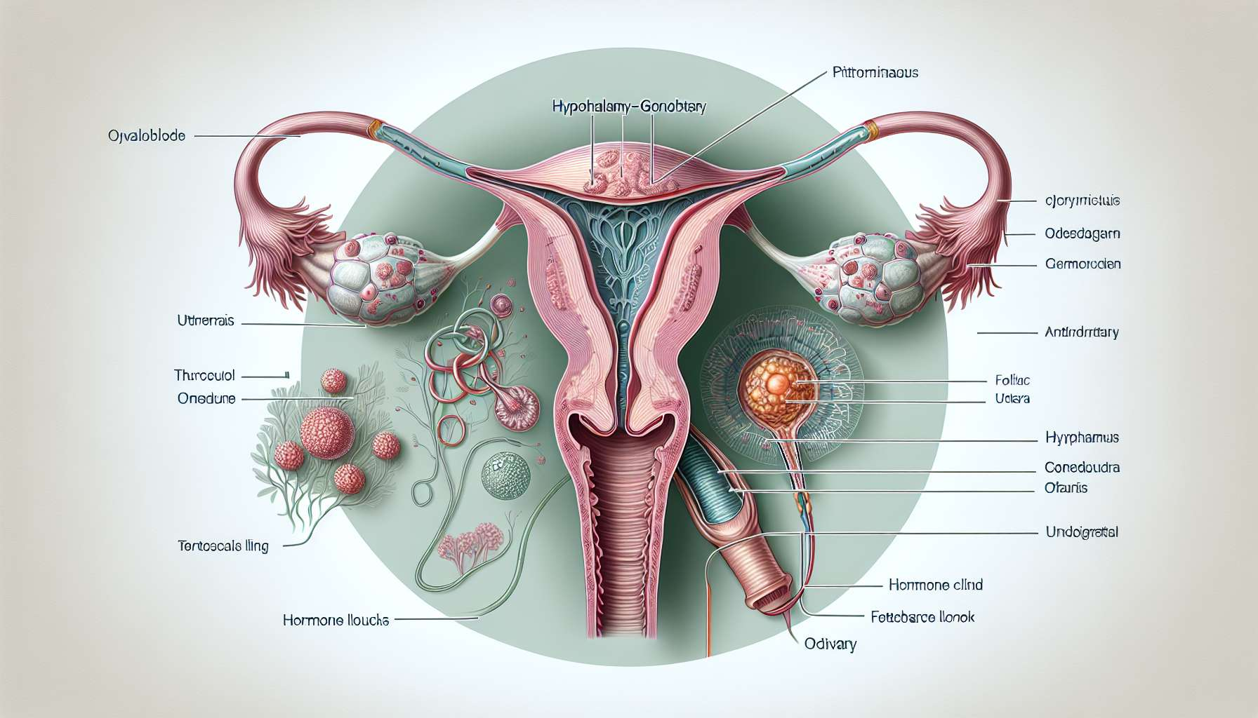

The follicular phase is the first phase of the menstrual cycle, beginning on the first day of menstruation and ending with ovulation. It averages 14 days for a 28-day cycle, but can vary from 10 to 21 days depending on the duration of the cycle and follicular maturation. This phase is characterized by the recruitment and growth of ovarian follicles under the influence of pituitary gonadotropins, FSH and LH, until the selection of the dominant follicle destined to ovulate.  
  
At the beginning of the follicular phase, following the drop in progesterone and estrogen levels at the end of the previous cycle, the pituitary increases its secretion of FSH. This rise in FSH stimulates the recruitment of a cohort of primordial follicles that begin to grow in the ovaries. Each follicle contains an oocyte blocked at the prophase I stage of the first meiotic division, surrounded by a layer of follicular cells. Under the effect of FSH, the follicular cells multiply and differentiate into granulosa cells, which secrete estrogens, mainly estradiol.  
  
As the follicular growth progresses, estradiol levels gradually increase, exerting a negative feedback on the secretion of FSH. Around the 6th-7th day of the cycle, a follicle stands out from the others by its size and its ability to produce estradiol, this is the dominant follicle. This follicle expresses more FSH receptors and becomes more sensitive to this hormone than other follicles. It will therefore continue its growth and maturation despite the decrease in FSH levels, while the other follicles, deprived of stimulation, will degenerate by atresia.  
  
The dominant follicle continues its development up to the stage of the pre-ovulatory follicle or De Graaf follicle, measuring 20 to 25 mm in diameter. The granulosa cells also acquire LH receptors, which will enable them to respond to the ovulatory peak of LH at the end of the follicular phase. Under the influence of estrogens, the oocyte resumes its meiosis and progresses to metaphase II, a stage at which it will remain blocked until possible fertilization.  
  
Parallel to follicular maturation, the increase in estradiol levels has important effects on the uterine endometrium. Estrogens stimulate the proliferation of endometrial cells, the growth of glands, and the vascularization of the uterine mucosa. The endometrium gradually thickens to reach 8 to 12 mm in thickness at the end of the follicular phase, thus preparing a favorable environment for embryonic implantation. Estrogens also act on cervical mucus, which becomes abundant, clear and stringy, facilitating the passage of sperm through the uterine cervix.  
  
The duration of the follicular phase determines the total duration of the menstrual cycle, as the luteal phase following ovulation is relatively constant (14 days on average). Thus, a short cycle (21-24 days) is often linked to a short follicular phase with early ovulation, while a long cycle (35-45 days) is associated with a prolonged follicular phase with delayed ovulation. These variations in the duration of the follicular phase may be physiological, related to age, stress, or environmental factors, or pathological, in case of ovulation disorders like polycystic ovary syndrome.  
  
At the end of the follicular phase, when estradiol levels reach a critical threshold for more than 36 hours, they exert a positive feedback on the hypothalamic-pituitary axis, triggering the pre-ovulatory LH peak. This LH peak is essential to induce the last stages of oocyte maturation, follicular rupture and ovulation, thus marking the transition to the luteal phase.  
  
Understanding the physiology of the follicular phase is essential to grasp the mechanisms of follicular growth, the selection of the dominant follicle, and the maturation of the oocyte. It also allows us to interpret hormonal tests and ovulation monitoring ultrasounds, used in infertility assessments or in assisted reproduction procedures. Finally, knowing the effects of estrogens on the endometrium and cervical mucus is important to understand the cyclical changes in the female genital tract and optimize the chances of conception.  
  
Key points:  
  
- The follicular phase is the first phase of the menstrual cycle, starting on the first day of menstruation and ending with ovulation, with an average duration of 14 days in a 28-day cycle.  
  
- The rise in FSH at the beginning of the follicular phase stimulates the recruitment and growth of a cohort of primordial follicles in the ovaries.  
  
- Follicular cells multiply and differentiate into granulosa cells, which mainly secrete estradiol.  
  
- Around the 6th-7th day of the cycle, the dominant follicle is distinguished from others by its size and ability to produce estradiol, continuing to grow despite the drop in FSH levels.  
  
- The dominant follicle reaches the pre-ovulatory follicle stage, and granulosa cells acquire LH receptors to respond to the ovulatory peak.  
  
- Estrogens stimulate endometrial proliferation, preparing a favorable environment for embryonic implantation, and modify cervical mucus to facilitate the passage of sperm.  
  
- The length of the follicular phase determines the total duration of the menstrual cycle and can vary according to physiological or pathological factors.  
  
- The pre-ovulatory LH peak, triggered by the positive feedback of estrogens, induces the final stages of oocyte maturation, follicle rupture, and ovulation.  
  
- Understanding the physiology of the follicular phase is essential to interpret hormone tests, ovulation monitoring ultrasounds, and optimize the chances of conception.