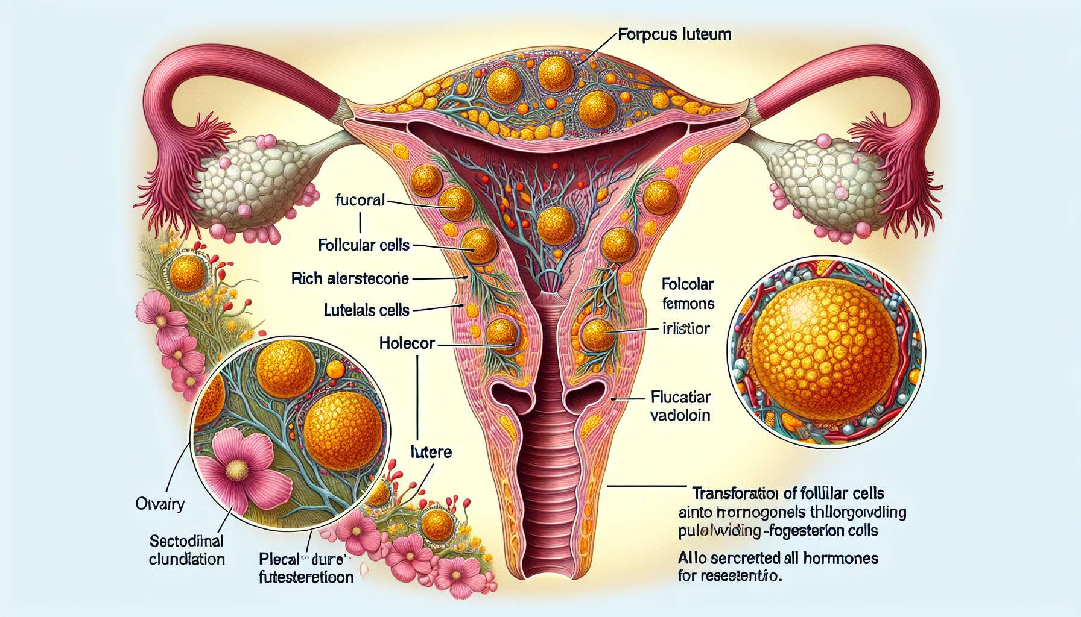

The corpus luteum, also called corpus luteum, is a transient endocrine structure that forms from residual follicular cells after ovulation. Its main role is to secrete progesterone and estrogens to prepare the endometrium for possible embryonic implantation and maintain pregnancy in case of fertilization. The formation and function of the corpus luteum are essential for understanding the hormonal regulation of the luteal phase of the menstrual cycle.  
  
Immediately after the expulsion of the oocyte during ovulation, the ruptured follicle undergoes a series of morphological and functional transformations to become a corpus luteum. Under the effect of LH, the cells of the granulosa and the theca interna differentiate into luteal cells, which hypertrophy and become charged with lipids and carotenoid pigments, giving the corpus luteum its characteristic color. The follicular wall collapses and folds, forming a richly vascularized glandular structure.  
  
Luteal cells acquire a strong ability to synthesize steroids, mainly progesterone, but also estrogens and relaxin. Progesterone is the key hormone of the luteal phase, which acts on the endometrium to induce its secretory transformation, essential for implantation and early embryonic development. It stimulates the proliferation and differentiation of endometrial glands, which secrete nourishing substances for the embryo. Progesterone also exerts a negative feedback on the hypothalamic-pituitary axis, inhibiting the secretion of GnRH and LH and preventing the recruitment of new follicles.  
  
The maintenance of the corpus luteum and its secretion of progesterone depends on the presence of a gonadotropic hormone, LH at the beginning of the luteal phase, then hCG (human chorionic gonadotropin) in case of pregnancy. If the oocyte is fertilized and an embryo implants in the endometrium, the trophoblastic cells of the embryo secrete hCG which will "rescue" the corpus luteum and stimulate its production of progesterone. The gestational corpus luteum thus formed will ensure the maintenance of pregnancy until the placenta takes over the secretion of progesterone, around the 8th week of pregnancy.  
  
In the absence of fertilization and implantation, the corpus luteum is not supported by hCG and will involute after 14 days, this is luteolysis. Luteolysis is a programmed degenerative process that involves the apoptosis of luteal cells and the decrease in vascularization of the corpus luteum. It is triggered by the secretion of prostaglandin F2α by the endometrium at the end of the luteal phase, which exerts a local luteolytic effect. The degeneration of the corpus luteum results in a sharp drop in progesterone and estrogen levels, lifting the negative feedback on the gonadotropic axis and allowing the recruitment of a new cohort of follicles for the next cycle.  
  
The decrease in progesterone levels at the end of the luteal phase is also responsible for triggering menstruation. Indeed, progesterone has an anti-proliferative and stabilizing effect on the endometrium, and its fall causes the desquamation of the uterine mucosa and the appearance of menstruation. Thus, the lifespan of the non-gestational corpus luteum determines the duration of the luteal phase, which is relatively constant from one cycle to another (14 days on average).  
  
Some luteal phase disorders can disrupt fertility and cause early miscarriages. Luteal insufficiency, characterized by a progesterone deficiency and/or a luteal phase duration of less than 10 days, can compromise the quality of the endometrium and embryonic implantation. It can be due to a follicular development defect, delayed ovulation, or premature luteolysis. The treatment of luteal insufficiency is based on progesterone supplementation in the second part of the cycle, orally, vaginally or intramuscularly, to correct the deficiency and support the luteal phase.  
  
The corpus luteum is therefore a key endocrine structure of the ovarian cycle, which ensures the secretion of progesterone necessary for the transformation of the endometrium and the maintenance of pregnancy. Its formation, function, and lifespan are finely regulated by complex hormonal interactions between the ovary, uterus, and embryo. Understanding the physiology of the corpus luteum is essential for understanding the mechanisms of implantation and gestation, as well as the causes of infertility due to luteal insufficiency.  
  
Key points to remember:  
  
- The corpus luteum is a transient endocrine structure that forms after ovulation from residual follicular cells. Its main role is to secrete progesterone and estrogens to prepare the endometrium for potential embryonic implantation and maintain pregnancy in case of fertilization.  
  
- Under the effect of LH, follicular cells differentiate into luteal cells that primarily synthesize progesterone. This acts on the endometrium to induce its secretory transformation, essential for implantation and early embryonic development.   
  
- If the oocyte is fertilized and an embryo implants, hCG secreted by the embryo will maintain the corpus luteum and stimulate its production of progesterone until the placenta takes over around 8 weeks of pregnancy.  
  
- In the absence of fertilization, the corpus luteum involutes after 14 days (luteolysis), causing a drop in progesterone that lifts the negative feedback on the gonadotropic axis and triggers menstruation. The lifespan of the corpus luteum determines the duration of the luteal phase.  
  
- Luteal insufficiency, characterized by a deficiency in progesterone and/or a short luteal phase, can disrupt fertility. Its treatment involves progesterone supplementation in the second part of the cycle.