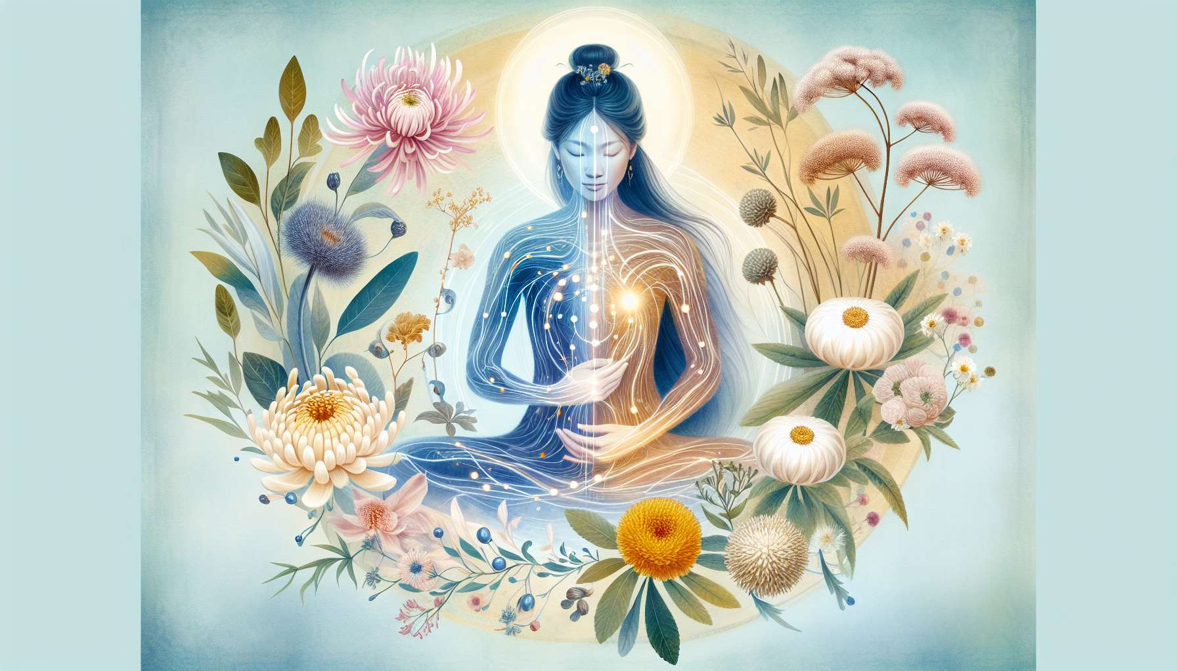

The Traditional Chinese Medicine (TCM) is a holistic care system rooted in a thousand-year tradition. It offers a profound understanding of the laws of the universe and their influence on the health and balance of human beings. At the heart of TCM is the concept of vital energy, the Qi, which circulates in the body through a network of meridians. According to this vision, illness is the result of an imbalance or stagnation of Qi, and the role of the practitioner is to restore harmony using various diagnostic and treatment methods.  
  
TCM pays particular attention to the balance between the two complementary forces, Yin and Yang. Yin, associated with femininity, represents the qualities of receptivity, calm, interiority, and nourishment. Yang, associated with masculinity, embodies the principles of action, movement, exteriority, and transformation. According to Chinese thought, health and well-being stem from harmony between these two polarities, both individually and collectively.  
  
For women, TCM offers valuable tools to understand and take care of their feminine energy. Meridians specific to reproductive and hormonal functions, such as the Liver meridian (linked to the menstrual cycle and emotional balance), the Kidney meridian (associated with vital essence and fertility), and the Conception Vessel meridian (which nourishes the uterus and fetus), are particularly important to harmonize. Imbalances on these meridians can manifest in menstrual disorders, conception difficulties, menopause symptoms, or emotional problems.  
  
Acupuncture, which involves stimulating specific points on the meridians with fine needles, is one of the best-known methods of TCM. It allows to unblock stagnations, nourish deficiencies and restore the free flow of Qi. Specific protocols exist to regulate the menstrual cycle, relieve premenstrual symptoms, promote fertility or accompany pregnancy and childbirth. Acupuncture also acts on the psycho-emotional level, helping to soothe stress, anxiety or depression that may affect the feminine balance.  
  
The Chinese pharmacopoeia, rich in several thousands of plant, animal, mineral substances, is another major branch of TCM. Herbal formulas, skillfully composed according to the principles of synergy and balance, allow for deep treatment of energetic imbalances. Formulas such as Xiao Yao San (to regulate Liver Qi and soothe emotions), Gui Shao Di Huang Tang (to nourish Yin and blood) or Wen Jing Tang (to warm the Kidney meridian and promote fertility) are commonly used for female disorders.  
  
TCM also provides dietary and lifestyle advice to preserve health and energetic balance. Food is considered a form of medicine in its own right, and personalized recommendations are given according to the constitution and needs of each woman. Thus, a woman presenting an excess of heat will be advised to favor cool-natured foods and to avoid spices or alcohol, while a woman suffering from internal cold will be advised warming and nourishing foods.  
  
Body practices such as Qi Gong or Tai Chi, which combine gentle movements, breathing and visualization, are a valuable complement to cultivating feminine energy. Specific sequences like the Breast Qi Gong or the Uterus Qi Gong help strengthen reproductive organs, regulate emotions, and promote harmonious Qi circulation in the body.  
  
By integrating the principles and tools of Traditional Chinese Medicine into our Divine Feminine Healing practice, we can offer women a holistic and personalized approach to their health and well-being. By harmonizing their vital energy, regulating their natural cycle and cultivating the balance between Yin and Yang, they can reconnect with their feminine essence and deploy their full life potential. TCM invites us to honor the innate wisdom of the body and to collaborate with the forces of nature to restore vitality and harmony at all levels of being.  
  
Key takeaways:  
  
- Traditional Chinese Medicine (TCM) is a holistic care system based on the concept of vital energy, Qi, circulating in the body through meridians.  
  
- TCM aims to restore the balance between the complementary forces Yin and Yang to maintain health and well-being.  
  
- For women, TCM focuses on harmonizing the meridians related to reproductive and hormonal functions, such as the Liver, Kidney, and Conception Vessel meridian.  
  
- Acupuncture, Chinese pharmacopoeia, dietary advice, and body practices like Qi Gong are key tools of TCM for regulating feminine energy.  
  
- The integration of TCM principles into Divine Feminine Healing allows for a holistic and personalized approach to women's health, promoting reconnection with their feminine essence and unleashing their full potential.