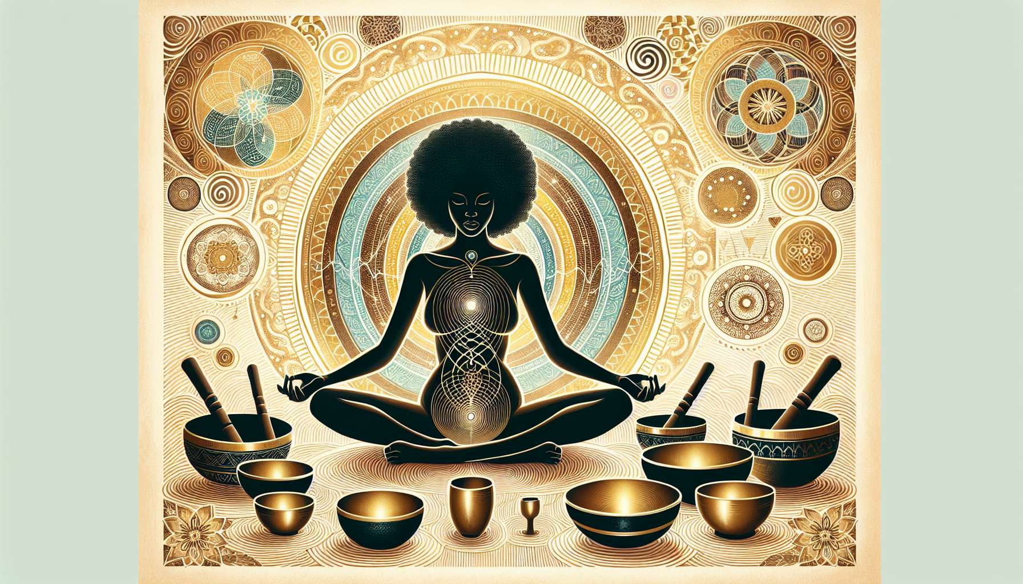

Working with sounds, notably through mantras and singing bowls, is a powerful ancestral practice to awaken and harmonize feminine energy. Sounds have the power to vibrate every cell of the body, to unblock energy stagnations, and to induce deep states of relaxation and meditation.  
  
Mantras are sacred formulas, usually in Sanskrit, which are recited or sung repetitively. Each mantra has a specific vibratory frequency and acts on a particular aspect of the being, whether physical, emotional, mental or spiritual. For women, certain mantras are particularly beneficial to honor the sacred feminine, such as the mantra "Om Shrim Maha Lakshmiyei Namaha" which invokes the energy of the goddess Lakshmi, symbol of beauty, abundance, and fertility. Recited 108 times consciously, this mantra helps to awaken the Shakti, the feminine creative power, and to reconnect with one's divine nature.  
  
Other mantras are effective for balancing female cycles, such as the mantra "Om Chandraya Namaha" which honors lunar energy and regulates hormonal flows. Combined with specific yoga practices like moon salutations (module 7.1), this mantra is particularly recommended during menstruation to soothe pains and intense emotions. Mantras can be sung alone or in a group, a capella or accompanied by instruments like the harmonium or the drum. The repetition of the sound and the concentration on its resonance in the body help to calm the mind, anchor presence, and connect to something greater than oneself.   
  
Singing bowls, on the other hand, are ancient instruments used in Himalayan traditions for meditation and healing. Made up of an alloy of several metals, they produce sounds rich in harmonics that propagate throughout the body and the environment. Each bowl has a unique note and vibration that resonate with the different chakras and subtle planes of the being. For women, bowls tuned to the "D" note are particularly beneficial to harmonize the sacral chakra and release emotional memories stored in the uterus. Quartz crystal bowls, with their vibratory purity, are also very effective in raising consciousness and reconnecting with one's inner guidance.  
  
During an energy healing session with singing bowls, the woman usually lies comfortably, with the bowls arranged around and on the body. The practitioner strikes and gently rubs the bowls to create an enveloping sound bath, inviting deep letting go. The vibrations penetrate each cell, dissolve blockages, and realign subtle bodies. This intense sensory and meditative experience allows one to reconnect with one's vibratory essence, to release memories crystallized in the feminine matrix, and to contact inner spaces of peace and vastness.  
  
To integrate sound work into a practice of Divine Feminine Healing, one could for example propose guided meditations accompanied by mantras and singing bowls, linked to feminine archetypes (module 1.4) or the phases of the menstrual cycle (module 2.4). Thus, during the preovulatory phase, one could use the mantra of the goddess Saraswati combined with bowls in "E" to stimulate creativity and self-expression. During the premenstrual phase, one would rather choose the mantra of Kali Ma and deep bowls in "G" to release repressed anger and set boundaries. Women circles with collective sound baths can also be created to promote connection to self and others, authentic sharing, and mutual healing.  
  
Here is a concrete example of meditation with a kansu bowl, a traditional Ayurvedic bowl composed of a five-metal alloy:  
1. Sit comfortably in meditation position. Place the kansu bowl in the palm of your receptive left hand, at heart chakra level. Close your eyes and take a few deep breaths to center yourself.  
2. With your right hand, gently strike the bowl with a wooden mallet to produce a clear, sustained sound. Listen attentively to the resonance of the bowl that spreads throughout your being.  
3. While maintaining the sound, visualize a golden light emanating from the bowl and spreading into your body, dissolving all tension and intrusive thoughts. Welcome the sensations of softness, warmth, and well-being that come over you.  
4. When the sound naturally fades, gently rub the outer edge of the bowl with your wooden mallet to create a continuous sound. Imagine that this sound nourishes every cell of your body with a vibration of love and harmony.  
5. Continue in this way for 5 to 10 minutes, alternating strikes and rubs, staying attentive to the subtle sensations that arise within you. Let your breathing deepen and your mind settle in the present moment.  
6. To finish, gently place the bowl and mallet in front of you. Join your hands in prayer mudra in front of the heart and bow your head in a sign of gratitude. Take a few moments to integrate the benefits of meditation before gently reopening your eyes.  
  
By regularly practicing sound work, women reconnect to the wisdom of their body and heart. They discover a powerful means to transform limiting vibrations into healing and alignment frequencies. Little by little, they find their authentic voice, their inner song, and radiate the light of their soul. Sounds become a sacred language to dialogue with visible and invisible worlds, and to celebrate the symphony of life within oneself.  
  
Key takeaways:  
  
- Sounds, through mantras and singing bowls, are powerful tools to awaken and harmonize feminine energy. They make every cell of the body vibrate, unblock energy stagnations, and induce deep states of relaxation and meditation.  
  
- Mantras are sacred formulas recited or sung repetitively. Each mantra has a specific vibratory frequency acting on different aspects of the being. Specific mantras honor the sacred feminine, like "Om Shrim Maha Lakshmiyei Namaha" to awaken the Shakti, or "Om Chandraya Namaha" to balance female cycles.  
  
- Singing bowls produce sounds rich in harmonics that spread throughout the body and the environment. Each bowl has a unique note resonating with different chakras. Bowls in "D" harmonize the sacral chakra, while crystal bowls raise consciousness.  
  
- During an energy healing session, the woman lays with bowls arranged around and on her body. The vibrations dissolve blockages, realign subtle bodies, and allow reconnection to one's vibratory essence.  
  
- Sound work can be integrated into a Divine Feminine Healing practice, in relation to feminine archetypes and menstrual cycle phases. Guided meditations and women circles with sound baths enhance connection to self and healing.  
  
- An example of meditation with a kansu bowl is detailed, inviting one to feel the resonance of the sound, visualize a golden light, and tune into sensations of inner well-being and harmony.