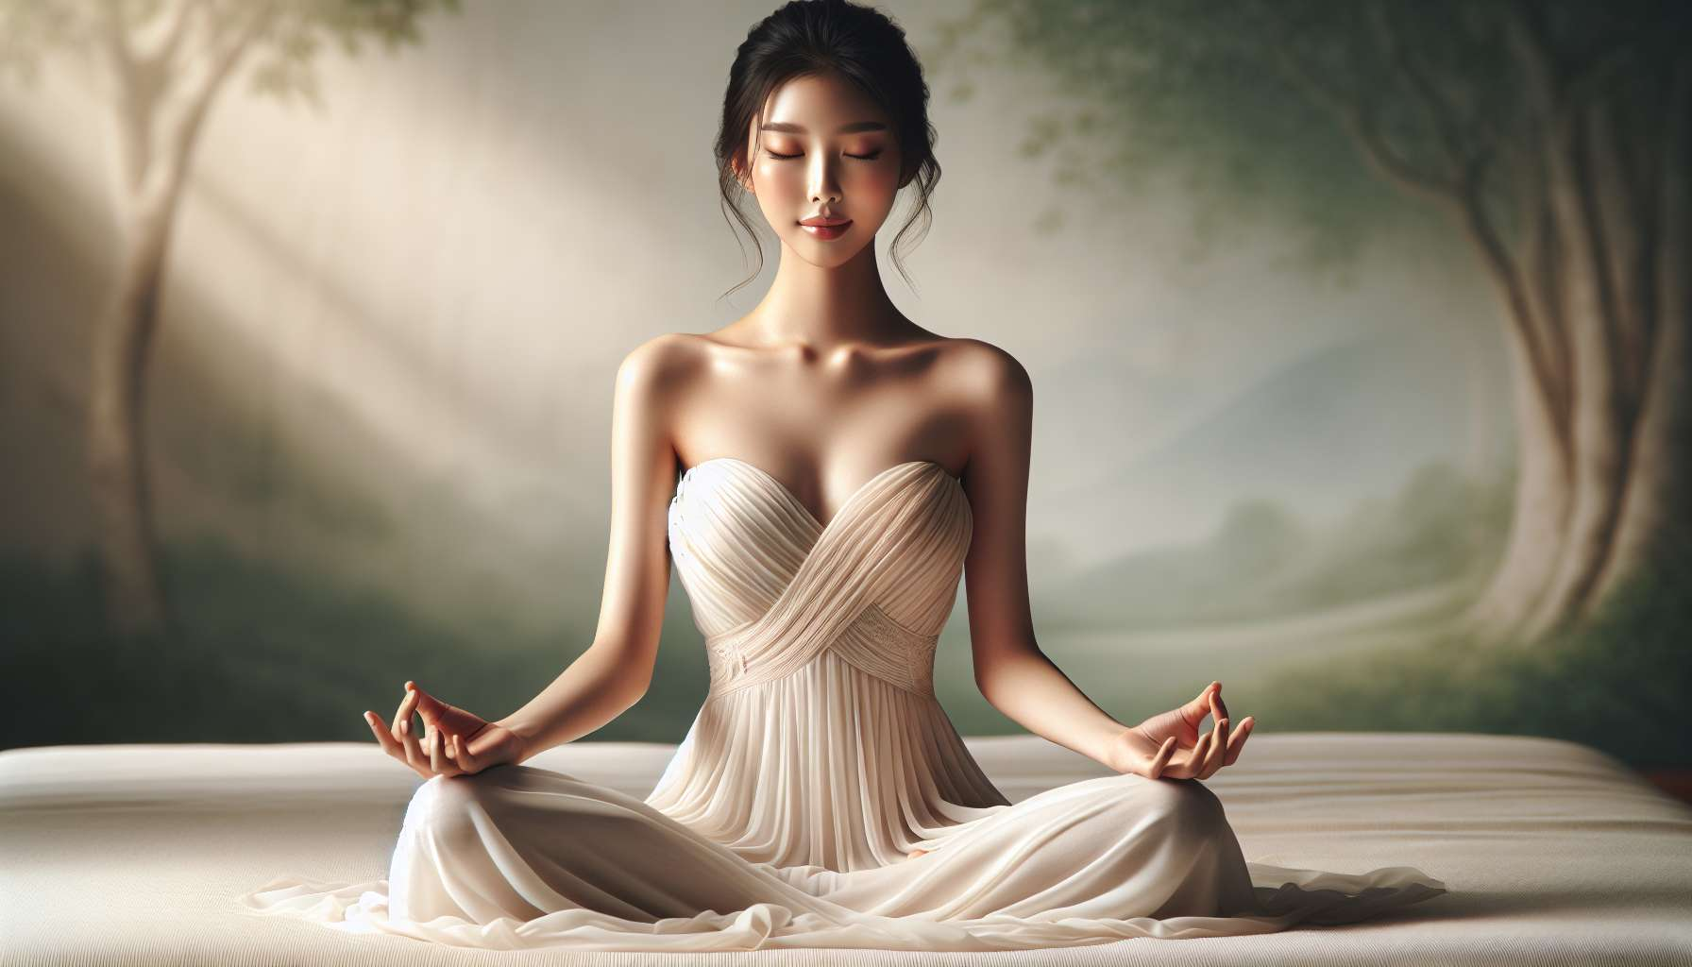

The body scan and deep relaxation are two complementary practices that allow reconnecting with one's body and releasing physical and mental tensions. These techniques, notably derived from mindfulness and sophrology approaches, are valuable tools to cultivate a compassionate presence to oneself and promote a state of relaxation and overall well-being.  
  
The body scan, also called "body sweep", is a guided meditation that involves focusing attention consecutively on different parts of the body, from the feet to the head. Lying down or sitting comfortably, one observes the sensations present in each area, without trying to change or judge them. One welcomes with kindness whatever presents itself, whether it be tensions, tingling, warmth, coldness, or even a lack of sensation. The intention is simply to become aware of one's bodily experience, as it is at this exact moment.  
  
This practice allows for the development of a better awareness of one's body and its needs. By regularly reconnecting to physical sensations, one learns to listen better to the messages of the body, to spot signs of stress or fatigue more quickly, and to respond to them in an appropriate way. This cultivates a more harmonious and respectful relationship with one's body.  
  
The body scan is also an invitation to release accumulated tensions in the body. By paying gentle and curious attention to a tense area, without trying to intervene, the tension often dissolves naturally. Simply recognizing and welcoming a tension with kindness can sometimes be enough to soothe it. This practice thus promotes a deep relaxation of the body and mind.  
  
For women in particular, the body scan can be a valuable ally in reconciling with one's body and honoring one's femininity. By taking the time to explore one's inner bodily landscape, one learns to welcome the body as it is, with its comfort and discomfort zones. A gentler and more accepting view of oneself is developed, beyond societal judgments and demands on the female body. One reconnects with the innate wisdom of the body and restores its rightful place.  
  
Deep relaxation is another essential practice for soothing the body and mind, and instilling a state of relaxation and serenity. There are many relaxation techniques, such as Jacobson's progressive relaxation, Schultz's autogenic training, and visualized relaxation. All have in common the combination of physical relaxation through the release of muscular tension, and mental relaxation via the calming of the stream of thoughts.  
  
By regularly practicing relaxation, one learns to manage stress and emotions better. Increased ability to relax and recharge is developed, even in situations of external pressure or agitation. A space of internal calm and tranquility is cultivated, from which one can respond to everyday challenges with more perspective and serenity.  
  
Relaxation is particularly beneficial for women, who are often called upon in many areas and prone to chronic stress. By regularly allowing oneself breaks and relaxation periods, physical and emotional exhaustion is prevented. Permission is granted to take care of oneself and recharge, in order to be more available for others and commitments thereafter.  
  
Relaxation is also a gateway to a better self-understanding. In immersing oneself in a state of deep relaxation, access is gained to subtle inner spaces, where insights, intuition, and unknown resources may emerge. One connects with a larger and wiser dimension of being, beyond the mind and its conditioning.  
  
By combing the practice of the body scan and relaxation, a global presence to oneself is cultivated, in all its dimensions - physical, emotional, mental and spiritual. One learns to fully inhabit the body, listen to it, respect it, and take care of it. A more loving and harmonious relationship with oneself is developed, laying the foundation for lasting, radiant wellbeing.  
  
To integrate these practices into one's daily routine, it is recommended to set aside dedicated time each day, even if only a few minutes, in a calm and comfortable environment. Guided sessions can be started with, before moving on to independent practice. The key is consistency and gentleness towards oneself, without pursuing perfection. Gradually, the benefits are felt, and these moments of presence to oneself become precious opportunities to recharge and cultivate inner balance.  
  
Key points to remember:  
  
- The body scan and deep relaxation are two complementary practices to reconnect with one's body and release physical and mental tensions.  
  
- The body scan involves focusing attention on different parts of the body to become aware of one's bodily experience, without judgment. It helps to develop a better understanding of one's body, release tensions and reconcile with oneself.  
  
- Deep relaxation aims to soothe the body and mind by combining physical and mental relaxation. It helps to manage stress better, cultivate an internal space of calm and take care of oneself.  
  
- For women, these practices are particularly beneficial in preventing exhaustion, recharging and honoring their femininity.  
  
- Relaxation also promotes a better understanding of oneself by connecting with a subtler dimension of one's being.  
  
- Regularly practicing body scan and relaxation, even just a few minutes per day, helps to cultivate a global presence to oneself and develop a more harmonious relationship with one's body and mind.