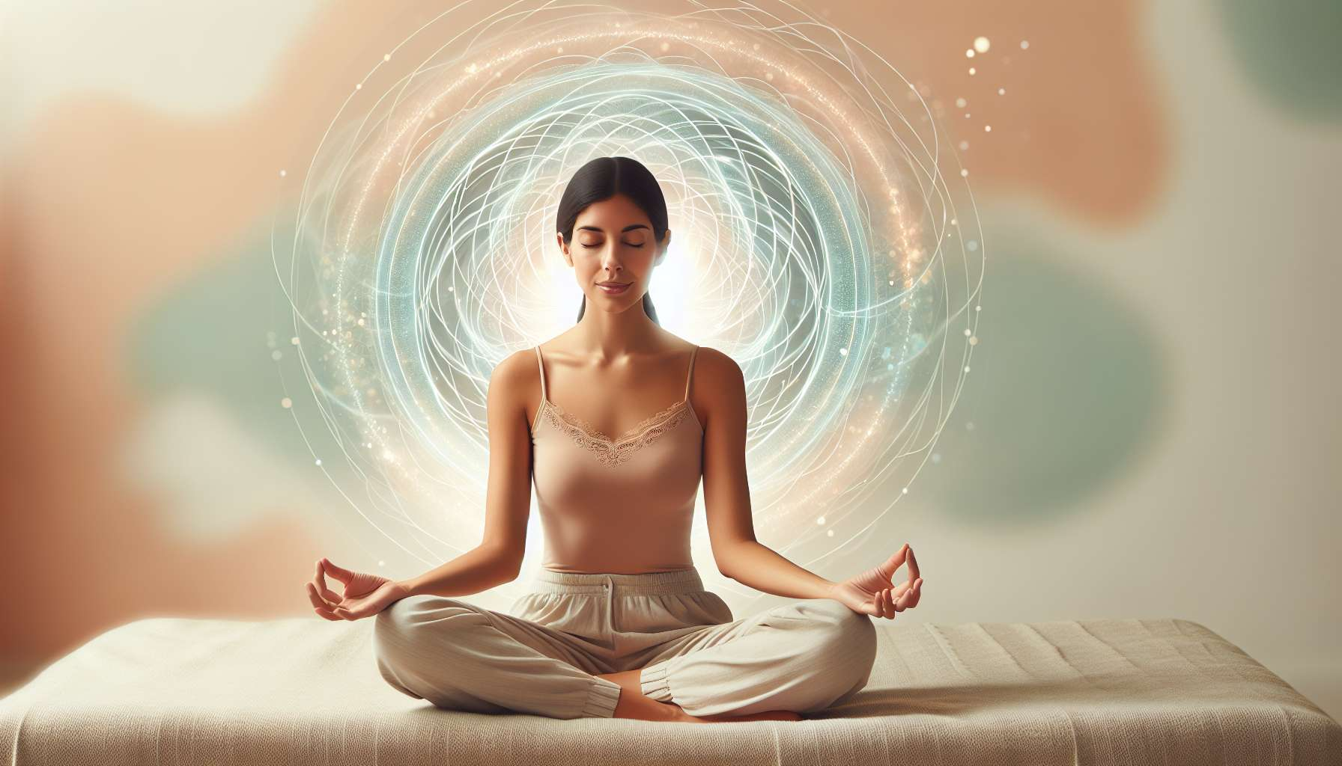

Seated meditation and walking meditation are two fundamental practices to develop mindfulness and cultivate a presence rooted in the present moment. These millennial techniques, mainly drawn from Buddhist traditions, are now recognized by science for their multiple benefits on physical, mental, and emotional health.  
  
Seated meditation is generally practiced in a stable and comfortable position, such as the lotus posture or simply sitting on a chair, with a straight but not stiff back. The key is to find a position that allows you to be both awake and relaxed. The eyes can be closed or half-closed, with a gaze resting before you. Attention is focused on natural breathing, observing the sensations of inhaling and exhaling, without trying to control the breath. Whenever the mind strays into thoughts, emotions, or sensations, it is gently brought back to the object of concentration. This training of attention gradually enables the development of greater stability and clarity of mind.  
  
Walking meditation, on the other hand, takes place in motion, back and forth over a few meters. Barefoot or shod, you progress slowly, focusing your attention on the sensations of the feet unrolling on the ground, the transfer of body weight, the contact with the earth. Breathing remains natural, and you sync your walk with the rhythm of your breath. When you reach the end of the path, you pause mindfully, turn around, and start back in the other direction. This practice promotes grounding in the body and the present moment, while bringing a certain dynamism compared to seated meditation.  
  
These two practices are complementary and allow the cultivation of mindfulness in different situations. They help to calm the stream of thoughts, reconnect with bodily sensations and emotions. They also develop qualities such as patience, concentration, emotional stability, and kindness towards oneself and others.  
  
For women in particular, these meditative practices can be very beneficial for reconnecting with one's body and feminine energy. By taking time to stop and be present to oneself, one learns to better listen, respect one's rhythms and needs. Meditation enables contact with an inner space of calm and serenity, from which it is easier to radiate feminine power and tenderness.  
  
Over the course of regular practice, even just a few minutes each day, the benefits of meditation make themselves felt in all areas of life. One gains in mental clarity, self-confidence, quality of presence to oneself and others. It is a wonderful tool for self-knowledge and inner transformation, which can support women to fully unfold their potential and fulfillment.  
  
Points to remember:  
  
- Seated meditation and walking meditation are two complementary practices for developing mindfulness and a presence rooted in the present moment.  
  
- Seated meditation is practiced in a stable and comfortable position, focusing the attention on natural breathing. It helps develop stability and clarity of mind.  
  
- Walking meditation is done in slow motion, synchronizing your walk with your breath. It promotes grounding in the body and the present moment.  
  
- These practices calm the mind, develop the connection to sensations and emotions, as well as qualities such as patience, concentration, and kindness.  
  
- For women, meditation helps to reconnect with one's body, one's feminine energy, and to better respect one's rhythms and needs.  
  
- Regular meditative practice brings numerous benefits: mental clarity, self-confidence, quality of presence, self-understanding, and inner transformation.  
  
- Meditation is a valuable tool to support women in unfolding their potential and self-fulfillment.