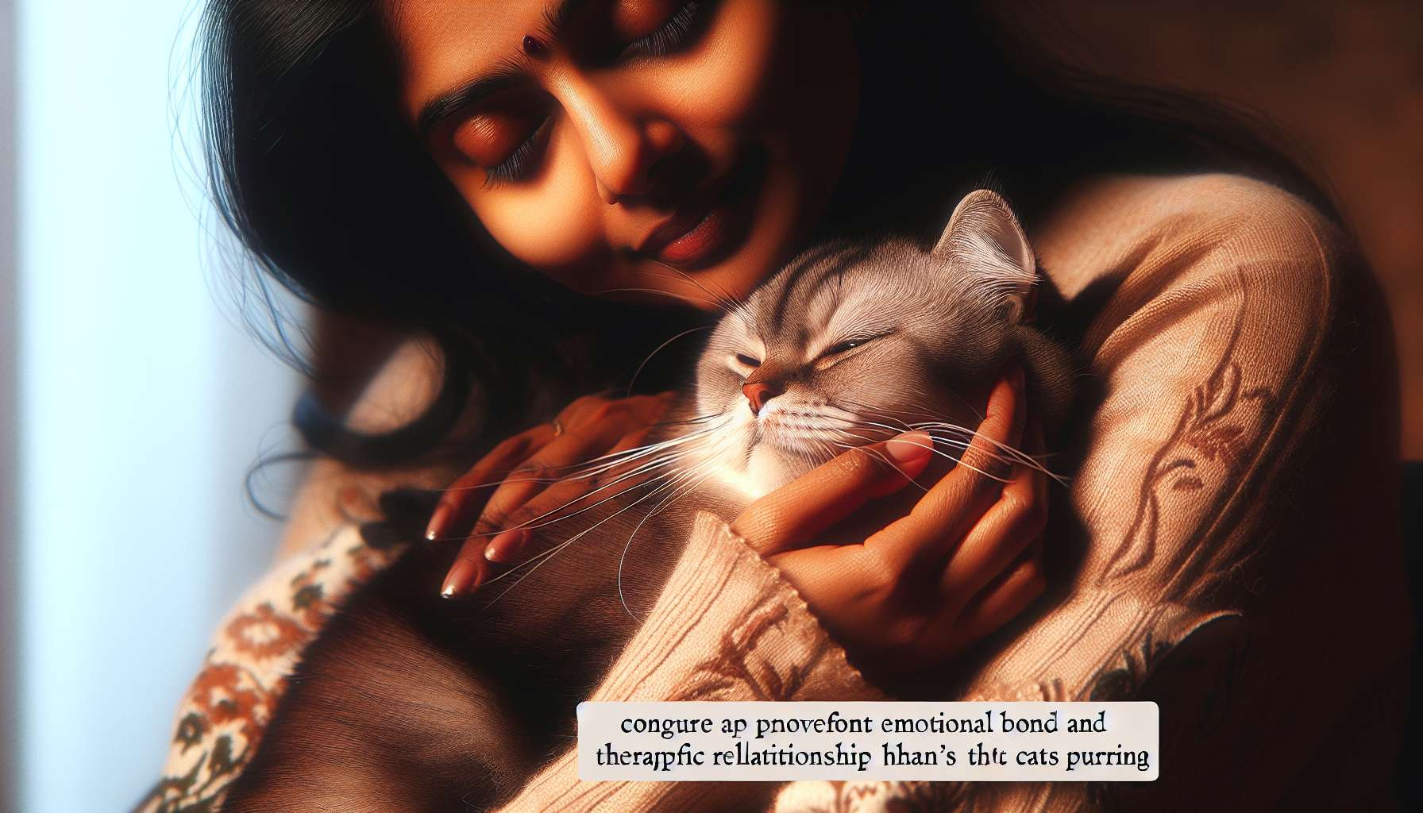

The human-cat relationship is unique and fascinating in many ways. Unlike the dog, the cat was not domesticated to assist man in specific tasks, but rather for its company and its ability to hunt rodents. The domestication of the cat goes back to about 10,000 years ago when the first wild felines approached human dwellings, attracted by the easy prey that mice and rats represented in grain reserves. This cohabitation gradually gave rise to a relationship of mutual tolerance, then of affection, without the cat losing its independence and hunting instinct.  
  
The cat is a territorial and solitary animal, which has not developed the same communication skills and cooperation with man as the dog. However, cats are capable of forming strong emotional bonds with their owners, based on trust, play, and the sharing of moments of tenderness. Contrary to popular belief, cats are not distant and indifferent animals, but they express their affection in a more subtle and individualized way than dogs. Each cat has its own personality and preferences in terms of interactions, which it is up to the owner to discover and respect.  
  
Human-cat communication involves visual, auditory, and tactile signals. Cats use a wide range of vocalizations to express their emotions and needs: purrs, miaows, hisses, growls... Each sound has a specific meaning, which the owner learns to decipher with experience. For example, a short, high-pitched meow may mean "I'm hungry," while a deep purring expresses well-being and relaxation. Cats also communicate a lot through body language: position of the ears, tail, whiskers, dilation of pupils... A cat that slowly blinks its eyes while looking at its master signifies its affection and trust.  
  
Play is a central element of the human-cat relationship. Cats are predators at heart, who need to express their hunting instincts in a playful manner. Playing with your cat, whether it's with a fishing rod, a ball or a laser pointer, helps to strengthen the bond, stimulate its physical and mental activity, and prevent unwanted behaviors related to boredom or frustration. Playing is also an opportunity for the owner to observe the dexterity, grace, and intelligence of their feline companion.  
  
Unlike the dog, the cat does not need daily outings or a master to guide its activities. It is perfectly capable of entertaining itself, provided it has a stimulating and secure environment. A happy cat is a cat that can express its natural behaviors: climbing, jumping, scratching, exploring, hiding... That's why it's important to furnish their living space with cat trees, scratching posts, hiding places, and a variety of toys. Access to the outdoors, whether it's a secure garden or a furnished balcony, is a plus to allow the cat to satisfy its curiosity and need for contact with nature.  
  
The human-cat relationship also has an increasingly recognized therapeutic dimension. The soothing presence of a cat, its gentle and warm touch, its relaxing purring can have beneficial effects on physical and mental health. Studies have shown that petting a cat reduces stress, lowers blood pressure, relieves pain, and improves mood. In nursing homes, resident cats provide emotional comfort to isolated elderly people and stimulate their desire to communicate. For people suffering from psychiatric disorders such as depression or anxiety, the cat can be a precious companion, offering a reassuring presence and unconditional support.  
  
For the Grief Coach specialized in pet bereavement, understanding the uniqueness of the human-cat relationship is essential to accompany bereaved people. The loss of a cat can evoke pain as intense as that of a loved one, as the bond that unites an owner to its cat is often intimate and exclusive. The cat is the confidant of joys and sorrows, the companion during moments of solitude, the benevolent witness to daily life. Its absence leaves a tremendous void, which only those who have shared such complicity can understand.  
  
By welcoming with empathy and compassion the emotions of the bereaved person, the coach will help them express their grief and legitimize their mourning. They may invite them to recall the tender moments shared with their cat, the daily rituals, the personality traits that made them unique. They may also encourage them to honor their memory in a personalized way: by creating a photo album, writing a farewell letter, planting a rose bush in their name in the garden...  
  
The coach may also discuss the delicate question of a new adoption. Some people feel the need to quickly fill the void left by the departed cat, while others need time to grieve. There is no right or wrong way to react, everyone has their own pace. The coach can help their client clarify their motivations and respect their emotions, without seeking to rush or judge them. If the person feels ready, the coach can encourage them to adopt a new cat from a shelter, reminding them that it is a way to perpetuate the love and values ​​transmitted by the lost companion.  
  
Finally, the coach can draw on their knowledge of the human-cat relationship to help the bereaved person navigate towards resilience. The grief of an animal is an opportunity to reflect on the meaning of life and death, the value of the bonds that unite us to other creatures. It is also an opportunity to become aware of one's own inner strength, the ability to love and overcome trials. By accompanying their client with gentleness and respect, the coach will help them integrate this loss into their life story and make it a source of learning and personal growth.  
  
Key takeaways:  
  
1. The human-cat relationship is unique, based on ancient domestication for companionship and rodent hunting, without the cat losing its independence and instinct.  
  
2. Cats form strong emotional bonds with their owners, expressed in a subtle and individualized way.  
  
3. Human-cat communication involves visual, auditory, and tactile signals, such as vocalizations and body language.  
  
4. Playing games is central in strengthening a bond, stimulating the cat's activities, and preventing undesirable behaviors.  
  
5. A stimulating and secure environment is essential for a cat to express its natural behaviors.  
  
6. The presence of a cat has recognized therapeutic effects on physical and mental health.  
  
7. For the Grief Coach, understanding the uniqueness of the human-cat relationship is essential to accompany grieving individuals.  
  
8. The Grief Coach should empathetically welcome the emotions of the bereaved person, helping them express their sorrow and honor the memory of the lost cat.  
  
9. The issue of a new adoption should be addressed respecting each individual's timing and motivations.  
  
10. Mourning a cat is an opportunity to move towards resilience, reflecting on the meaning of life and becoming aware of one's inner strength.