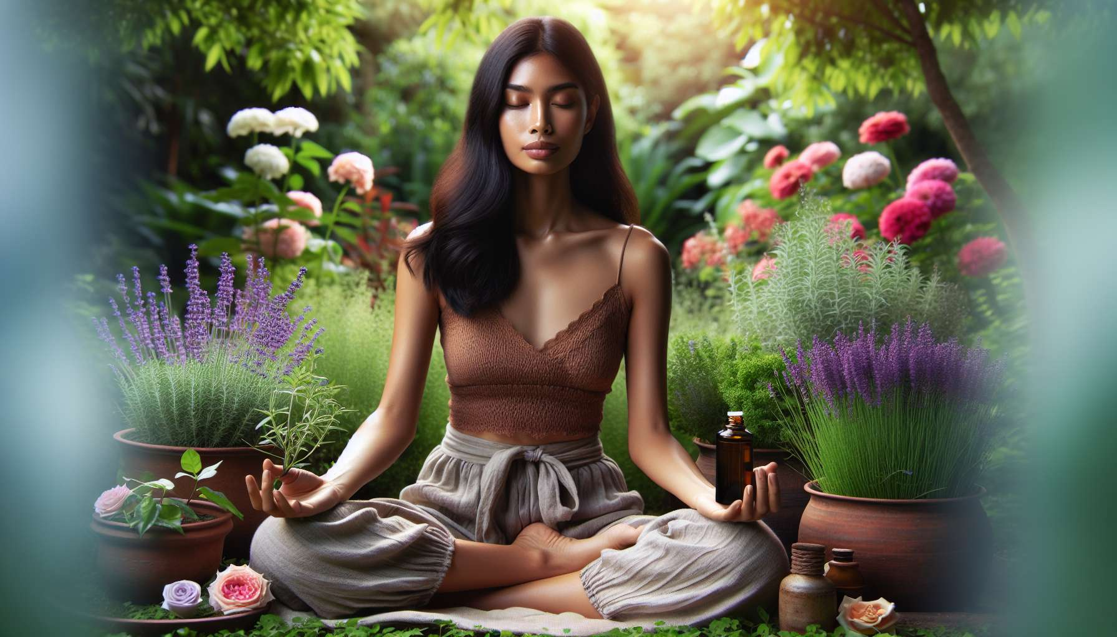

Aromatherapy is a branch of phytotherapy that uses essential oils extracted from aromatic plants to maintain or restore physical, emotional, and energetic balance. Essential oils are very concentrated and potent substances, which contain the very essence of the plant, its fragrant soul, and its active principles.  
  
Each essential oil has a unique biochemical and vibratory signature, which gives it specific therapeutic properties. Some oils are particularly suited to the needs and challenges encountered by women throughout their life, such as clary sage for regulating hormonal cycles, rose geranium for soothing emotions, or ylang-ylang for awakening sensuality.  
  
Essential oils can be used in various ways depending on the goal and individual preferences: in massage, in atmospheric diffusion, in inhalation, in aromatic bath or even by oral intake (only under the control of a qualified aromatherapist). Each mode of use allows different absorption and action of aromatic molecules.  
  
It is essential to choose high-quality essential oils, 100% pure and natural, derived from organic farming and extracted under optimal conditions. The quality of the oil conditions its effectiveness and its safety. It is recommended to purchase from recognized and certified brands, which guarantee the traceability and quality control of their products.  
  
Here are some examples of essential oils essential for women's health:  
  
- Clary sage, to regulate menstrual cycles, relieve menopause symptoms, and promote hormonal balance.  
- Rose geranium, to ease nerve tension, reduce stress, and harmonize emotions.  
- Ylang-ylang, to awaken sensuality, stimulate libido, and promote relaxation.  
- True lavender, to calm anxiety, facilitate sleep, and heal the skin.  
- Rosemary with verbenone, to relieve menstrual pain, stimulate circulation, and boost vitality.  
  
However, be careful to respect the precautions for use and contraindications of each essential oil, especially during pregnancy, breastfeeding, and in children. Some oils are not recommended in these situations or require adjusted dosages. In case of doubt, it is best to seek the advice of an aromatherapist.  
  
Beyond their therapeutic properties, essential oils also bring an olfactory and sensory dimension to the practice of Divine Feminine Healing. Smells have a powerful evocative and emotional power, capable of reconnecting us to memories, places, or people. Certain oils such as Damask rose, neroli, or myrrh have been used for millennia in sacred female rituals to promote heart-opening, soul-healing, and divine connection.  
  
Energetic aromatherapy is precisely interested in the impact of essential oils on subtle bodies and energy centers. Each essential oil has a particular affinity with certain chakras and can be used to rebalance them. For example, bergamot is associated with the solar plexus chakra and helps regain confidence and self-esteem, while frankincense is linked to the crown chakra and promotes spiritual elevation and meditation.  
  
Integrating essential oils into Divine Feminine Healing practice allows working simultaneously on the physical body, the emotional body, and the energetic body. It is a powerful tool to assist women in their process of harmonization and inner transformation. As a practitioner, it is important to train in scientific and energetic aromatherapy to use essential oils in a fair, subtle, and personalized way.  
  
Key points to remember:  
  
1. Aromatherapy uses essential oils extracted from aromatic plants to maintain or restore physical, emotional, and energetic balance.   
  
2. Each essential oil has a unique biochemical and vibratory signature, giving it specific therapeutic properties.   
  
3. Essential oils can be used in various ways: massage, atmospheric diffusion, inhalation, aromatic bath, or oral intake (under a qualified aromatherapist's control).   
  
4. It is critical to choose high-quality essential oils, 100% pure and natural, derived from organic farming, and extracted under optimal conditions.   
  
5. Certain essential oils are particularly suited for women's needs, such as clary sage, rose geranium, ylang-ylang, true lavender, and rosemary with verbenone.  
  
6. Precautions for use and contraindications of each essential oil must be respected, especially during pregnancy, breastfeeding, and in children.  
  
7. Essential oils bring an olfactory and sensory dimension to the practice of Divine Feminine Healing capable of reconnecting to memories, places, or people.  
  
8. Energetic aromatherapy focuses on the impact of essential oils on subtle bodies and energy centers (chakras).   
  
9. Integrating essential oils into Divine Feminine Healing practice allows working simultaneously on the physical body, the emotional body, and the energetic body.   
  
10. As a practitioner, it is important to train in scientific and energetic aromatherapy to use essential oils in a fair, subtle, and personalized way.