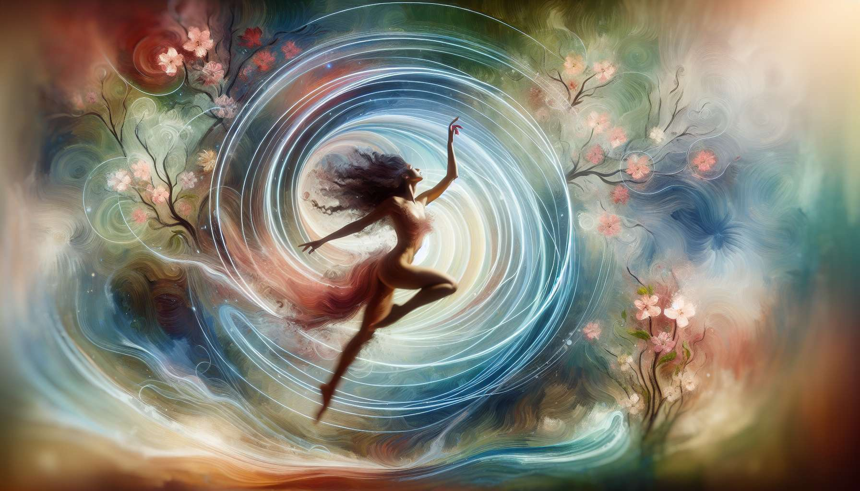
Intuitive dance and body expression are powerful practices for women who want to reconnect with their bodies, emotions, and creativity. Beyond just a physical activity, dancing becomes a non-verbal language for expressing one's inner world, releasing energy blockages, and celebrating femininity.
Intuitive dance encourages you to be guided by your feelings and spontaneous impulses, without following a preset choreography. It is an intimate dialogue between the body and the psyche, where each movement emerges from the present moment. By allowing themselves to freely explore different qualities of movement (fluid, jerky, fast, slow...), women learn to listen to their sensations, respect their limitations, and grant themselves complete freedom of expression. Intuitive dance thus promotes a better body awareness, greater self-confidence, and a deep connection to one's authentic self.
Body expression encompasses various creative approaches such as dance therapy, body theatre, and mime. The goal is to use movement as a therapeutic tool to explore and transform inner states. By playing with gestures, postures, and facial expressions, women can contact and externalize their repressed emotions, fears, or unfulfilled desires. Body expression is particularly suitable for women who struggle to verbalize their feelings or who have experienced trauma. By reclaiming their bodies and daring to fully inhabit them, they regain a sense of internal security and freedom to be.
To integrate intuitive dance and body expression into a practice of Divine Feminine Healing, thematic workshops related to feminine archetypes (module 1.4) or the four elements (module 6.6) can be offered. Thus, participants can be invited to explore the fluidity and sensuality of water, the stability and grounding of earth, the passion and intensity of fire, or the lightness and spontaneity of air. Evocative musical supports, symbolic accessories, or guided meditations can also be used to stimulate the imagination and facilitate letting go.
Here is a concrete example of a dance therapy exercise to release repressed anger:
1. Standing, become aware of your breathing and ground support. Connect to the feeling of your anger, without seeking to suppress or judge it.
2. Start moving freely to dynamic music, letting your body express the intensity of this emotion. Allow yourself to make abrupt gestures, fast movements, guttural sounds...
3. Gradually amplify the movement by engaging your entire body. Imagine that you are expelling the excess anger through your arms, legs, pelvis. Let all the emotional charge out without restraint.
4. When you feel the anger subsiding, gradually slow down the pace. Breathe deeply and release accumulated tensions. Take the time to feel the relief and lightness in your body.
5. To integrate the experience, you can write or draw about your experience, or share your feelings with the group if you feel confident.
By regularly practicing intuitive dance and body expression, women relearn to trust their bodies and their emotions. They discover a space of freedom and creativity where all their impulses are welcome, without fear of external judgment. By daring to fully embody their femininity, with its strengths and vulnerabilities, they reconnect with their inner power and radiate new vitality. Dance then becomes a path of fulfillment and healing, a sacred ritual to honor the wild and authentic woman within.
Key Takeaways:
- Intuitive dance and body expression allow women to reconnect with their bodies, emotions, and creativity.
- Intuitive dance invites being guided by one's feelings and spontaneous impulses, without following a preset choreography. It promotes better body awareness, self-confidence, and connection to authenticity.
- Body expression uses movement as a therapeutic tool to explore and transform inner states. It helps to externalize repressed emotions and regain a sense of internal security.
- These practices can be integrated into workshops related to feminine archetypes or the four elements, using musical supports, symbolic accessories, or guided meditations.
- An example of a dance therapy exercise is offered to release repressed anger, allowing the body to freely express this emotion, then releasing tensions.
- Regularly practicing intuitive dance and body expression allows trusting one's body and emotions, reconnecting to one's inner power, and flourishing in femininity.

