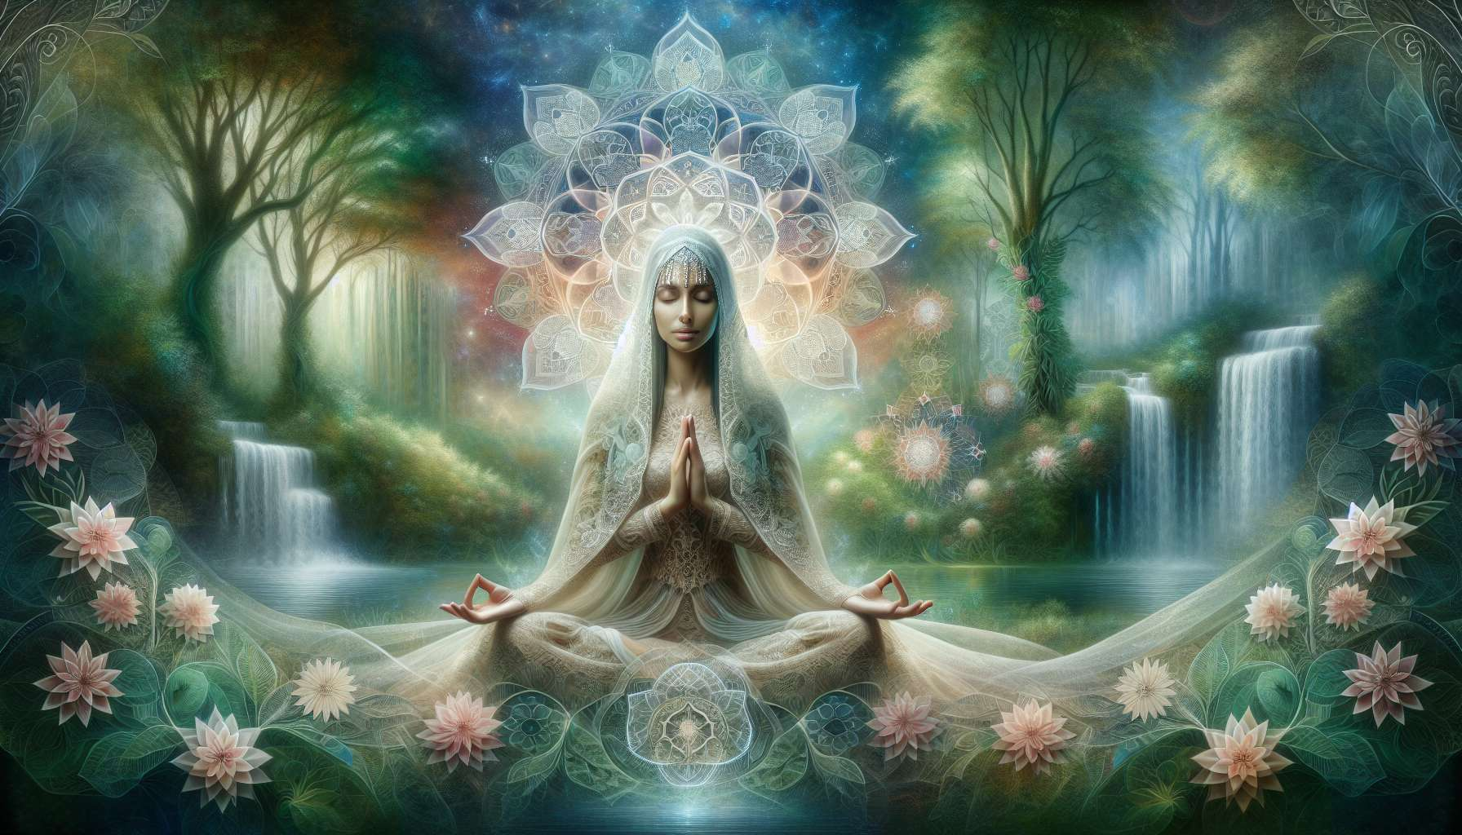

Guided visualizations are powerful tools for awakening and channeling feminine energy. They call upon our capacity for imagination and inner creation to explore and transform our subtle reality. By immersing ourselves in inspiring mental images, we activate our right brain, home to intuition and creativity. We open a space where everything becomes possible, where we can contact and manifest our unlimited potential.  
  
For women in particular, visualizations provide a privileged access to their deep essence and creative power. By connecting to archetypes and feminine symbols that carry meaning, they can awaken ancestral memories and unsuspected resources. They can revisit their personal and collective history to heal and transform it. They can connect to the wisdom of Mother Earth and the life forces that animate the universe.  
  
Different types of visualizations can be used to work with feminine energy. One could, for example, imagine cleansing and purifying their body and aura, using elements such as water or fire. One could visualize their chakras opening and radiating, focusing particularly on the root, sacral and heart chakras, seats of feminine energy. One could invoke goddesses from various traditions to embody their qualities, such as Quan Yin's gentleness, Durga's determination, or Aphrodite's sensuality.   
  
Other powerful visualizations involve imagining oneself in sacred natural settings, like an enchanted clearing, a womb-like cave, or a purifying spring. By merging with these spaces, we reconnect with our organic essence and open ourselves to deep healing of the body and soul. One can also visualize symbols like the cosmic egg, the lotus flower, or the sacred cup, which evoke the mystery of creation and the unfolding of life.  
  
A visualization I particularly enjoy involves imagining one's womb as a sacred sanctuary, a temple of femininity and creativity. By focusing one's attention on their lower belly and filling it with light and love, one awakens awareness of their creative power. One can place an intention, a project, or a dream they wish to see materialize in it. By connecting it to their heart and offering it to the universe, it is given the necessary impulse to manifest in one's life.  
  
The key to effective visualization is the involvement of all one's senses. The more one manages to feel the images in their body, hear the sounds, taste the fragrances, the more alive and impactful they become. It is also important to bring conviction and faith to it, to truly believe in the reality of what one is imagining. Finally, it is essential to cultivate a state of allowing, of receptivity and letting go, to allow energy to flow freely.  
  
To integrate the practice of visualization into one's daily life, one can set aside a time for self-connection each day, ideally upon waking or before bedtime. Comfortably settled, take a few deep breaths and let your imagination guide you. One can record oneself or be guided to experience more elaborate visualizations. The important thing is to cultivate this inner space of freedom and creation, and to allow oneself to dream big.  
  
Gradually, visualizations permeate our inner reality and transform our way of being in the world. They help us rid ourselves of conditioning and connect to our true nature. They invite us to express our magnificence and fully embody our feminine power of love and creation. By reconnecting us to the magic of life within us and around us, they make our existence a living, inspiring work of art.  
  
Key takeaways:  
  
- Guided visualizations are powerful tools for awakening and channeling feminine energy, using imagination and creativity.  
  
- They allow women to connect to their deep essence, their creative power, and unsung resources, through meaningful feminine archetypes and symbols.  
  
- There are different types of visualizations for working with feminine energy: body and aura purification, chakra activation, goddess invocations, connections to sacred places in nature, usage of symbols like the cosmic egg or the lotus flower.  
  
- Visualizing the womb as a sacred sanctuary can awaken the awareness of one's creative power and bring life to their projects.  
  
- For effective visualization, all senses should be engaged, along with conviction and faith, and it should be experienced in a state of receptivity and letting go.  
  
- Regular practice can transform our inner reality, free us of our conditioning, and connect us to our true nature, fully unveiling our feminine power of love and creation.