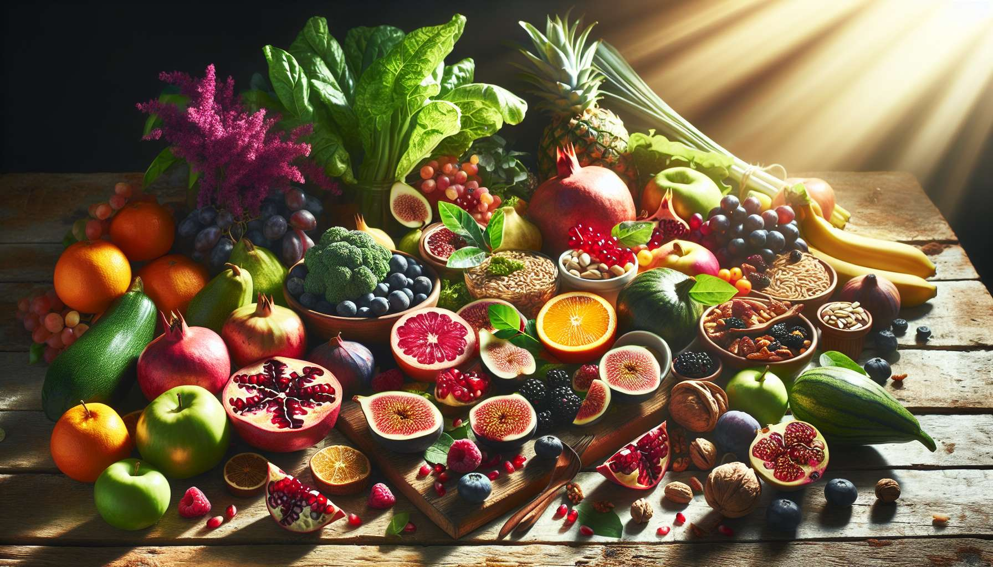

Intuitive and conscious eating is an approach to nutrition that invites you to reconnect with your body and its deep needs, by developing a healthy and fulfilling relationship with food. It's about learning to listen to the signals of hunger and satisfaction, making food choices in line with your values and overall well-being, and taking pleasure in eating mindfully, without guilt or restriction.  
  
This approach is particularly beneficial for women, who are often subjected to numerous social and cultural pressures around food and body image. By freeing themselves from restrictive diets and external injunctions, intuitive eating allows one to restore a relationship of trust and respect with their body, and to nourish their feminine energy optimally.  
  
The key principles of intuitive eating are:  
  
1. Listen to hunger and satiety signals: Learn to recognize physical sensations of hunger and satisfaction, and to respond to them appropriately, without being influenced by emotions or external stimuli.  
  
2. Making food choices in line with your values: Choose foods that nourish both the body and soul, favoring natural, quality products, preferably local and seasonal.  
  
3. Eat mindfully: Take time to savor meals, paying attention to flavors, textures, and bodily sensations, in a calm atmosphere conducive to relaxation.  
  
4. Free yourself from rules and restrictions: Abandon the notions of "good" and "bad" foods, and allow yourself to eat what you really want, without guilt or judgment.   
  
5. Respect your body and its unique needs: Acknowledge that nutritional needs vary from person to person, and from one time to another, depending on age, physical activity, hormonal cycle, etc.  
  
By practicing intuitive eating on a daily basis, women can establish a more serene and fulfilling relationship with food, and naturally support their vitality and well-being. This includes, for example:  
  
- Having a nourishing and varied breakfast that provides energy for a good start to the day, like a porridge of oat flakes with fresh fruit, flax seeds, and cinnamon.  
  
- Listening to specific cravings at each menstrual cycle phase, like the need to eat more protein and iron during menstruation, or more vegetables and fiber in the luteal phase.  
  
- Preparing colorful and creative meals, featuring sun-soaked, vitality-filled foods, like seasonal fruits and vegetables, whole grains, and good vegetable fats.  
  
- Taking time to eat in a pleasant and relaxing environment, chewing each bite thoroughly and savoring the flavors and textures of the food.  
  
- Treating yourself to gourmet and comforting breaks when you feel the need, like a piece of dark chocolate, a spiced tea, or a bowl of homemade soup, without guilt.  
  
Intuitive eating also encourages you to reconnect with natural rhythms and life cycles, by aligning your eating with the seasons and times of day. For instance, lighter and raw foods could be favored in summer, and more nourishing and cooked foods in winter; a healthier meal at midday when digestion is at its peak, and a lighter one in the evening to promote good sleep.  
  
This approach to eating integrates perfectly into a comprehensive Divine Feminine Healing process, synergistically with other tools like meditation, yoga, floral elixirs, or aromatherapy. By feeding your body consciously and kindly, you create favorable conditions to unleash your feminine potential and thrive in all areas of your life.  
  
Certain foods are particularly beneficial to support women's health and vitality, such as:  
  
- Foods rich in phytoestrogens (soy, flax, sage, hops...) which help regulate the hormonal system and alleviate menopause symptoms.  
  
- Anti-inflammatory foods (turmeric, ginger, omega-3...) which alleviate menstrual and joint pain, and prevent many chronic diseases.  
  
- Remineralizing foods (seaweed, green vegetables, sprouted seeds...) that fight fatigue and optimize bone density.  
  
- Probiotic foods (lacto-fermented products, natural sourdough...) that strengthen gut flora and support the immune system.  
  
As a practitioner of Divine Feminine Healing, it is essential to have a good understanding of the principles of intuitive eating and the foods beneficial to women's health. This enables personalised guidance for clients by assisting them in reconnecting with their deep needs and making food choices in line with their physical, emotional, and spiritual well-being.  
  
Intuitive eating is a path of healing and reconciliation with oneself, inviting a reconnection with your inner wisdom and nourishment of your sacred femininity. By freeing oneself from outside dictation and learning to genuinely listen, women can establish a healthy and satisfying relationship with food, exuding vitality and joy.  
  
Key Takeaways:  
  
1. Intuitive and conscious eating promotes reconnection with your body and its deep needs, fostering a healthier relationship with food.  
  
2. This approach is particularly beneficial for women, often subjected to social and cultural pressures around food and body image.  
  
3. The key principles of intuitive eating include: listening to signals of hunger and satisfaction, aligning food choices with personal values, mindful eating, liberating oneself from restrictions, and respecting one's body.  
  
4. Practicing intuitive eating allows women to regain a more serene relationship with food and naturally support their vitality and well-being.  
  
5. Intuitive eating encourages reconnection with natural rhythms and life cycles, aligning eating habits with the seasons and times of day.  
  
6. Certain foods are particularly beneficial for women's health, such as foods rich in phytoestrogens, anti-inflammatory, remineralizing, and probiotic foods.  
  
7. As a practitioner of Divine Feminine Healing, it is vital to understand the principles of intuitive eating to facilitate personalized guidance for clients.  
  
8. Intuitive eating is a path of healing and self-reconciliation, nourishing the sacred feminine and radiating vitality.