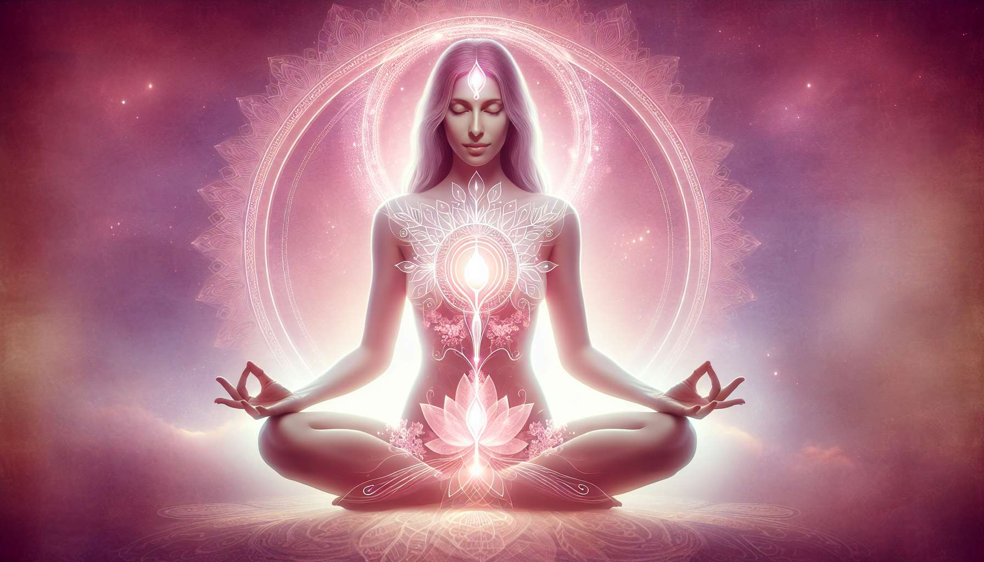

Mudras and hand postures are ancestral practices derived from yoga and ayurveda, aimed at channeling and balancing the flow of subtle energy in the body. In Sanskrit, "mudra" means "seal" or "symbolic gesture". Each mudra has a specific meaning and acts on a specific aspect of the being, whether it be physical, emotional, mental or spiritual. For women, certain mudras are particularly beneficial for harmonizing female energy, regulating hormonal cycles and awakening self-awareness.  
  
The Yoni goddess mudra, for example, is a powerful symbol of sacred femininity. It is achieved by joining the hands in front of the heart, the thumbs and index fingers touching to form a triangle pointed downward, evoking the shape of the yoni (vulva in Sanskrit). This mudra invokes the creative and nourishing energy of the Divine Mother, while strengthening the connection with one's deep feminine essence. Regularly practiced in meditation, it helps to heal wounds related to sexuality, regain confidence in one's feminine power, and radiate with grace and beauty.  
  
The Moon mudra, on the other hand, is particularly indicated during menstruation or the premenstrual period. It is achieved by pressing the thumb and ring finger together while keeping the other fingers extended. This mudra soothes the nervous system, regulates emotions, and promotes a feeling of inner peace. Physically, it relieves menstrual pains, regulates the cycle, and prevents disorders related to hormonal imbalances. By practicing it regularly, women reconnect with the natural rhythm of their cycles and cultivate a more harmonious relationship with their bodies.  
  
Other mudras are beneficial for specific female issues, such as the mudra of the goddess Kali to release repressed anger and assert boundaries, the Lakshmi mudra to cultivate abundance and prosperity, or the Saraswati mudra to awaken creativity and self-expression. By integrating them into a daily meditative practice, combined with pranayamas (breathing exercises) and visualizations, these mudras become powerful tools for inner transformation and personal fulfillment.  
  
To integrate the mudras into a Divine Feminine Healing session, they can be associated with meditations on goddesses (module 4.5) or yoga practices specific for women (module 7.1). For instance, during a guided meditation on the goddess Isis, archetype of the healer and magician, one can adopt the pyramid mudra (hands joined above the head) to amplify its transformation and regeneration power. During a Yin Yoga session on the theme of grounding, one can hold the earth mudra (tips of the fingers touching the base of the thumb) to strengthen inner stability and self-confidence.  
  
Here is a practical example of a sequence of mudras to balance the feminine and masculine energies within oneself:  
1. Sit comfortably in a meditation position, with a straight back and relaxed shoulders. Take a few deep breaths to center yourself.  
2. Bring your attention to your left hand, receptive and intuitive. Form the moon mudra by pressing the thumb and ring finger together, the other fingers extended. Breathe in this mudra for 3 to 5 minutes, visualizing a gentle white light soothing your mind and heart.  
3. Then bring your attention to your right hand, active and assertive. Form the sun mudra by pressing the thumb and ring finger together, the other fingers folded towards the palm. Breathe in this mudra for 3 to 5 minutes, visualizing a dynamic golden light strengthening your confidence and will.  
4. End by joining the hands in prayer mudra in front of the heart, thumb against thumb, symbolizing the harmonious union of the feminine and masculine within you. Breathe in this balance for a few moments, then gently release the hands onto the knees.  
5. Take time to feel the effects of the practice on your body and mind. Observe the sensations of peace, clarity, and fullness that inhabit you. Give thanks for this moment of reconnection to your inner nature.  
  
By regularly practicing mudras, women reclaim the symbolic language of the body and soul. They discover a simple and powerful way to interact with the subtle currents that run through them, to rebalance their energies, and to connect with their inner wisdom. Gradually, mudras become a form of embodied prayer, an intimate dialogue with the Goddess who slumbers within each one. Through these sacred gestures, women honor their inner temple and radiate the light of their true Self.  
  
Key points to remember:  
  
- Mudras are symbolic hand gestures from yoga and ayurveda that channel and balance the flow of subtle energy in the body.  
  
- Each mudra has a specific meaning and acts on a specific aspect of the being (physical, emotional, mental, spiritual).  
  
- Some mudras are particularly beneficial for women: the Yoni goddess mudra strengthens the connection with the feminine essence, the moon mudra soothes during the menstrual cycle.  
  
- Other female mudras: Kali mudra to assert boundaries, Lakshmi mudra for abundance, Saraswati mudra for creativity.  
  
- Mudras can be integrated into specific meditative and yoga practices for women, by associating them with visualizations and pranayamas.  
  
- A sequence of mudras (moon in the left hand, sun in the right, prayer mudra to end) allows to balance the feminine and masculine energies within oneself.  
  
- By practicing mudras regularly, women reconnect with their inner wisdom and honor their deep nature.