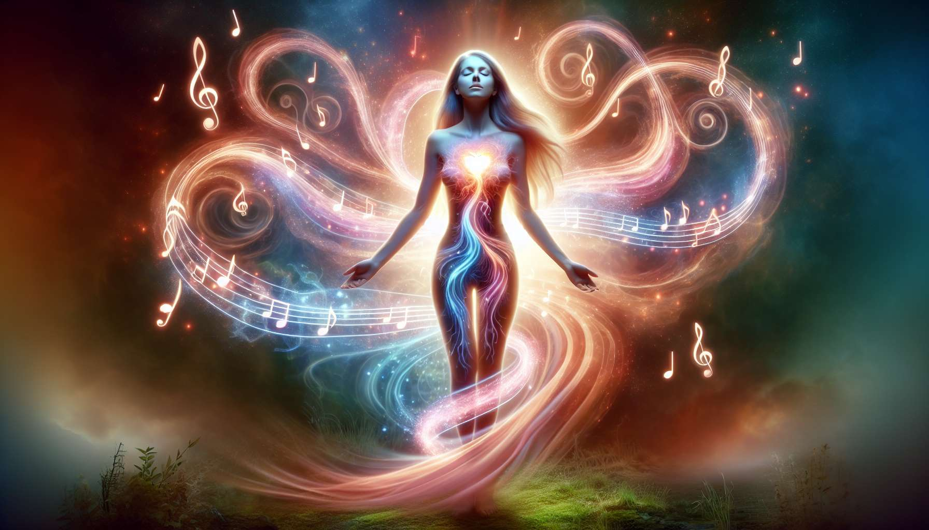

Music therapy is a therapeutic approach that uses sound, music, and rhythm to restore, maintain, and improve physical, emotional, mental, and spiritual well-being. It relies on the vibratory power of sound and on the innate ability of the human being to resonate with sound frequencies.  
  
In music therapy, it is considered that each organ, each cell of the body vibrates at a specific frequency. When these frequencies are harmonious, the body functions optimally. Conversely, when there are dissonances or blockages in the vibratory field, this can manifest as physical, emotional, or psychic imbalances.  
  
Music therapy uses different elements of sound to rebalance these frequencies and restore inner harmony:  
  
- The rhythm, which acts on the nervous system and can be used to energize or soothe, depending on the tempo chosen. For example, slow and regular rhythms, like those of lullabies, have a calming effect on the mind and promote sleep, while fast and lively rhythms, like those of tribal dances, have a stimulating and energizing effect.  
  
- The melody, which directly touches the emotions and can be used to evoke different states of mind. Soft and harmonious melodies, like those of classical music, have a soothing and comforting effect, while joyful and dynamic melodies, like those of Latin music, have an exhilarating and liberating effect.  
  
- Harmony, which refers to the combination of notes played simultaneously and can be used to create different atmospheres. Consonant harmonies, like those of perfect chords, bring a sensation of stability and fullness, while dissonant harmonies, like those of jazz, can arouse a feeling of tension or mystery.  
  
- The timbre, which corresponds to the specific sound color of each instrument or voice, and can be used to stimulate different parts of the body and different energy centers. For example, deep and bass sounds, like those of Tibetan bowls, resonate with the lower chakras and help to ground into the body, while high, crystalline sounds, like those of wind chimes, resonate with the upper chakras and promote the elevation of consciousness.  
  
For women in particular, music therapy offers valuable tools to accompany the various stages of their life and the hormonal and emotional changes that characterize them. For instance, during pregnancy, listening to gentle music can help to relax and connect with one's baby. During childbirth, singing, or uttering deep sounds can help better manage pain and let go. During menopause, practicing percussion or rhythmic dances can help release tensions and regain feminine power.  
  
There are many ways to integrate music therapy into one's Divine Feminine Healing practice. For example, you can create playlists adapted to the various needs of women (relaxation, energization, celebration, healing, etc.), use your voice to chant mantras or sacred songs, play an intuitive instrument like singing bowls or the shamanic drum, or even guide sound meditations with recordings of nature sounds.  
  
In a session, the practitioner may invite the client to lie down comfortably and let herself be carried away by music chosen according to her therapeutic intention. She may also suggest expressing emotions by singing, shouting, or moving freely to the music. The goal is to create a safe and nurturing space where a woman can reconnect with her body, her emotions, and her deep essence.  
  
Music therapy can be associated with other approaches such as meditation, visualization, conscious breathing or spontaneous movement to enhance its effects. It naturally integrates into a holistic view of health that sees the human being in its entirety and multidimensionality.  
  
Beyond its therapeutic benefits, music is also a wonderful tool for connecting with oneself, others, and the sacred. Since the dawn of time, women have gathered to sing, dance, and celebrate life at its key moments: births, unions, seasons, passages. These rituals are spaces of sharing, transmission, and healing that allow deep links between generations to be woven and to connect to something greater than oneself.  
  
As a practitioner of Divine Feminine Healing, it is essential to cultivate one's own relationship with music and sound. This involves exploring different instruments, developing your voice, creating spontaneous songs, participating in women's circles, etc. It is by contacting your own inner musicality that you can then share it with authenticity and accuracy.  
  
Integrating music therapy into your practice offers women a vibratory and inspiring healing path that invites them to tune into their inner rhythm, release their voice, and deploy their creativity. It offers them sound keys to cross their shadow areas, celebrate their life passages, and radiate their unique light. It is also about accompanying them in a process of overall harmonization where the body, heart, and soul can unify and vibrate in unison.  
  
Music therapy is a subtle art that requires listening, presence, and intuition. It invites us to dive into the ocean of sounds, taste its infinite nuances, and let ourselves be transformed by their alchemical power. It teaches us to welcome all the notes of our inner score, from the darkest to the brightest, to make a unique and lively symphony thereof.  
  
As guardians of the sacred feminine, may we pass on songs and rhythms, honor the Earth, and celebrate Life. May we instill in the women we accompany the confidence in their own inner music, and the courage to embody it fully in the world. For it is by daring to sing, dance, laugh, and cry without restraint that we become co-creators of a more vibrant, alive, and loving world.  
  
Key points to remember:  
  
- Music therapy uses sound, music, and rhythm to improve physical, emotional, mental, and spiritual well-being. It relies on the vibratory power of sound and the ability of the human being to resonate with sound frequencies.  
  
- Each organ and cell of the body vibrates at a specific frequency. The harmony of these frequencies is essential for optimal functioning of the body. Music therapy aims to rebalance these frequencies.  
  
- The key elements of music therapy are rhythm, melody, harmony, and timbre, each having specific effects on the body and emotions.  
  
- For women, music therapy offers valuable tools to accompany the different stages of their life and the associated hormonal and emotional changes (pregnancy, childbirth, menopause).  
  
- Integrating music therapy into the practice of Divine Feminine Healing can be done through the creation of adapted playlists, the use of the voice, the playing of intuitive instruments, or the guidance of sound meditations.  
  
- Music therapy creates a safe and nurturing space where a woman can reconnect with her body, her emotions, and her deep essence. It can be combined with other approaches such as meditation, visualization, conscious breathing, or spontaneous movement.  
  
- Beyond its therapeutic benefits, music is a tool for connection with oneself, others, and the sacred, embedded in an ancestral tradition of feminine rituals.  
  
- For practitioners, cultivating their own relationship with music and sound is essential for conveying with authenticity and accuracy.  
  
- Music therapy invites women to tune into their inner rhythm, liberate their voice, deploy their creativity and engage in a process of overall harmonization.