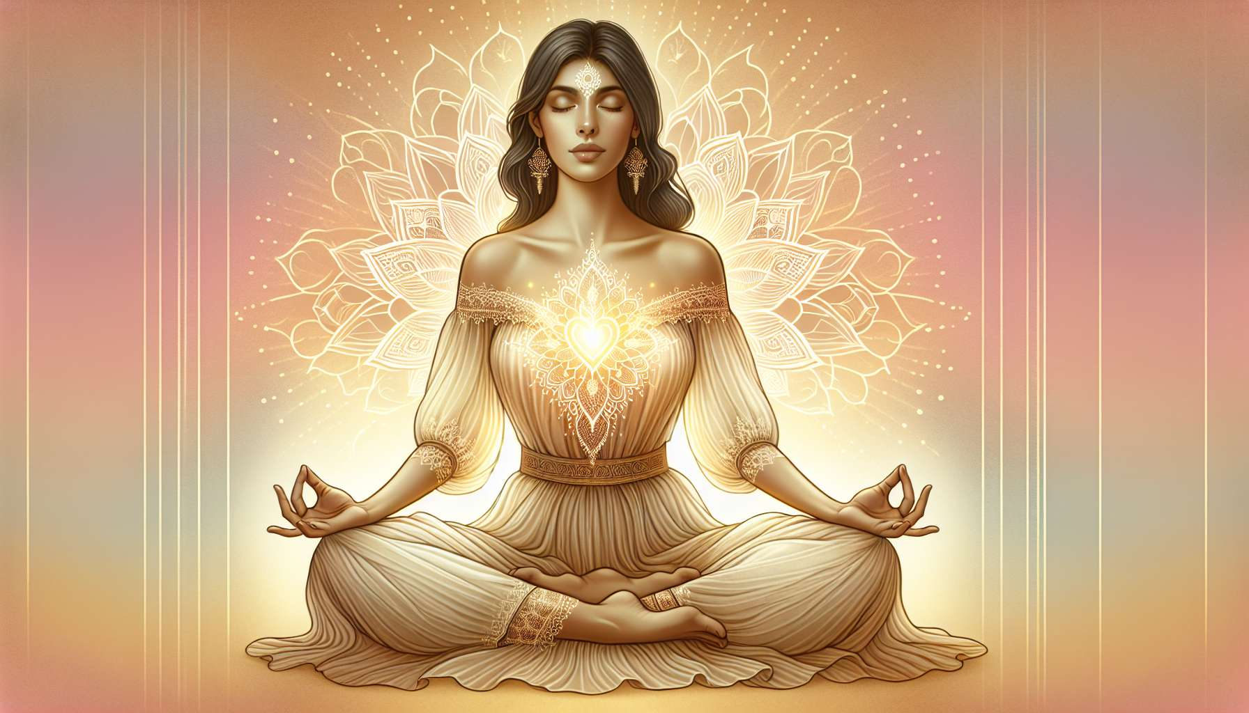

Breathing is a vital process that accompanies us every moment, from the first to the last breath. Yet, we often tend to breathe in an automatic and superficial manner, without paying attention to it. Conscious breathing invites us to reconnect with this essential movement, to make it an ally of our well-being and our inner balance.  
  
By deliberately focusing on our breath, we develop a greater awareness of ourselves and our inner states. We learn to observe the subtle variations in our breathing according to our emotions, thoughts, activities. This neutral and benevolent observation allows us to know ourselves better and develop a more harmonious relationship with ourselves.  
  
Conscious breathing is also a powerful tool for emotional regulation. In situations of stress or anxiety, our breathing tends to accelerate and become shorter, amplifying our state of tension. By becoming aware of our breath and deliberately slowing it down, we send a calming message to our nervous system, reducing the level of stress and finding more inner peace.  
  
Pranayama techniques, derived from the yogic tradition, offer numerous exercises for breath control to balance our vital energy. The Sanskrit term "prana" refers to the vital energy that animates us, and "ayama" means expansion or control. Thus, pranayama aims to direct and amplify the circulation of this subtle energy in our body and mind.  
  
Among the most well-known pranayamas, we can mention alternative nostril breathing, which involves inhaling through one nostril and exhaling through the other, switching with each cycle. This practice is known to balance the brain hemispheres and harmonize our inner states. Breath of fire, which consists of powerful and rapid exhalations through the nose, is used to energize the body and mind, and dissipate tensions. Conversely, the pot belly breath is practiced by inflating the abdomen on the inhale and pulling it in on the exhale, in a slow and deep movement that promotes grounding and introspection.  
  
Beyond these specific exercises, conscious breathing can be integrated into our daily lives as a mindfulness practice. By regularly taking "breathing breaks" throughout the day, concentrating on our breath for a few moments, we create spaces of presence and reconnection with ourselves. This practice is particularly valuable for women, who are often pulled in all directions, to recharge and center themselves.  
  
By cultivating conscious breathing, we also learn to better inhabit our bodies and take care of them. By breathing more deeply and slowly, we oxygenate our cells more, detoxify our organs, calm our nervous system. We invite more vitality and well-being into our physical bodies.  
  
For women especially, conscious breathing can be a precious ally to reconnect with their feminine energy. By focusing on the belly, the pelvis, the uterus, and directing the breath to these areas, we awaken and nourish our creative and sensual energy. We learn to ground ourselves in our female bodies, to honor our rhythms and natural cycles.  
  
Conscious breathing and pranayamas thus offer a simple and powerful path for self-care, calming, revitalizing, and connecting to our deep essence. By incorporating these practices into our daily lives, we cultivate a greater presence to ourselves and we offer ourselves a precious space for replenishment and regeneration. To breathe consciously is to give ourselves time to return to the essentials, at every moment.  
  
Takeaways:   
  
- Conscious breathing allows reconnecting with oneself and developing a greater awareness of one's inner states.  
  
- It's an effective tool for emotional regulation, especially in situations of stress or anxiety.  
  
- The pranayama techniques originating from yoga aim to control the breath to balance vital energy (prana).  
  
- Different pranayamas have specific effects: alternate nostril breathing balances the brain hemispheres, breath of fire energizes, pot belly breath encourages introspection.  
  
- Incorporating "breathing breaks" into daily life is a mindfulness practice that allows for recharging.  
  
- Conscious breathing oxygenates the body, detoxifies, soothes the nervous system, and improves physical well-being.  
  
- For women, conscious breathing allows reconnection with feminine energy by awakening the belly, pelvis and uterus zone.  
  
- Conscious breathing is a simple and powerful way to take daily self-care, to calm down, to revitalize and to connect with one's deep essence.