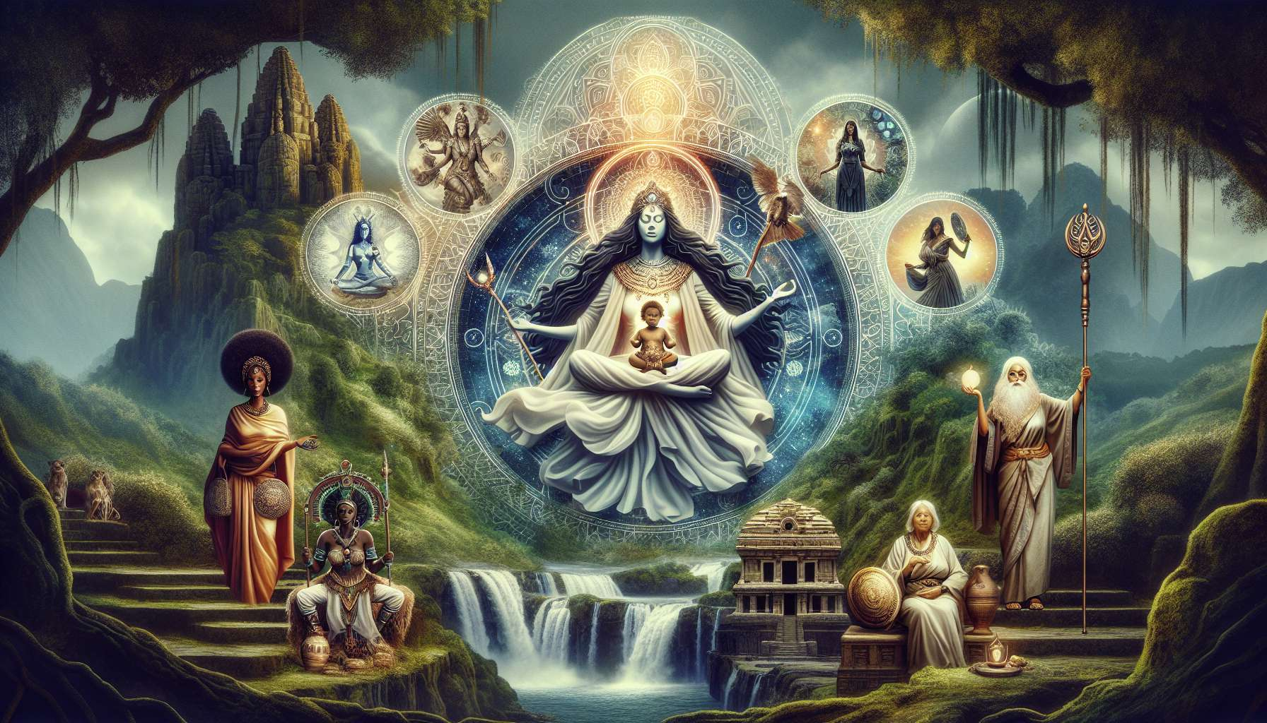

Meditations with feminine archetypes are powerful practices for awakening and embodying various facets of our femininity. Archetypes are universal patterns reflecting qualities and energies present within each of us, beyond our individual personality. By consciously connecting to these archetypes, we activate their strength within us and unfold our full potential as women.  
  
There are many feminine archetypes, derived from various cultural and spiritual traditions. Among the most famous, we can cite the Nurturing Mother, who embodies unconditional love, generosity, and protection; the Warrior, who represents courage, determination, and self-assertion; the Enchantress, who evokes sensuality, creativity, and magic; or the Wise Woman, who reflects inner knowledge, intuition, and guidance.  
  
To meditate with an archetype, you can start by learning about its symbolism and attributes, through readings of myths or stories. You can also contemplate artistic representations of this archetype, or even create your own drawing or collage that reflects your personal vision. The important thing is to resonate with the energy of this archetype and let it inspire you.  
  
Then, you can get comfortable and close your eyes, taking a few deep breaths to center yourself. You can then visualize a scene where you meet this archetype, for example in a sacred place in nature associated with it. You imagine its presence, its appearance, its gaze... You can ask it questions internally and listen to the answers that arise within you. You can also ask it to transmit its strength and wisdom to you, visualizing its luminous energy enveloping and permeating you.  
  
Personally, I love working with the archetype of the Mother Goddess, found in many cultures under different names - Isis, Demeter, Pachamama, Tara... For me, she embodies the primal source of life, the love that gives birth to everything that is. When I connect to her in meditation, I visualize a vast round belly like an ocean of milk, soft and nurturing. I imagine myself nestled in this belly, cradled by its warmth and tenderness. I feel a tremendous peace filling me, like a homecoming. From this space, I can lay down my burdens and deeply recharge. I reconnect with my natural ability to love and to care for life in all its forms.  
  
Another meditation that I often propose to my students is that of the Wild Woman, echoing the magnificent book by Clarissa Pinkola Estés. This archetype represents our instinctive and untamed nature, our visceral freedom, and our connection to the earth. Meditating with her, we can imagine running in a dense forest, feeling the earth and leaves under our bare feet, smelling the scent of the humus and the sap. We can let out a primal scream that releases all our repressed emotions and connects us to our raw power. We can dance around a fire celebrating our wild beauty and our belonging to the terrestrial matrix.  
  
Through practice, we can create our own meditations by combining different archetypes, depending on our needs and aspirations at the moment. For example, if we are going through a period of doubt where we need clarity, we can invoke the Inner Wise Woman who can see beyond appearances and guide us toward our truth. If we need to make a courageous decision, we can call upon the Warrior within us who dares to act according to her convictions. If we want to re-enchant our everyday life, we can connect to the Enchantress who finds beauty and magic everywhere.  
  
By regularly dialoguing with our inner archetypes, we develop a living and evolving relationship with the different facets of our being. We learn to recognize, welcome, and celebrate them, in their light as well as their shadow. We realize that we carry within us a real constellation of feminine energies, all equally precious and complementary. By honoring them in turn, we open ourselves to more fluidity and adaptability in our life.  
  
Meditations with archetypes also have a powerful transpersonal and spiritual dimension. By merging our consciousness with these universal models, we transcend our small separate identity and connect to something larger. We realize that we are traversed by forces that exceed and include us, and which seek to express themselves through us uniquely. By offering them a space for embodiment, we become co-creators with the Divine and fulfill our soul's mission on Earth.  
  
For women in particular, meditating with archetypes is a royal path to heal the feminine lineage and reinvent a sacred feminine. By reconnecting to these powerful models, we free ourselves from the conditioning and limitations that patriarchal society has imposed on women for centuries. We rebind with our original essence, our deep dignity, and our sovereign freedom. We awaken the ancestral memory of sorority, wisdom, and women's magic. And we participate in the emergence of a new culture that honors the sacred alliance of feminine and masculine in each being.  
  
Key Takeaways :  
  
- Meditations with feminine archetypes allow for awakening and embodying different facets of our femininity.  
  
- Archetypes are universal models reflecting qualities and energies present within each of us, such as the Nurturing Mother, the Warrior, the Enchantress, or the Wise Woman.  
  
- To meditate with an archetype, you can learn about its symbolism, contemplate artistic representations, and then visualize a meeting with it during a guided meditation.  
  
- The archetype of the Mother Goddess embodies the primal source of life and love. Meditating with her provides a space for inner peace and deep replenishment.  
  
- The archetype of the Wild Woman represents our instinctive, visceral freedom. Meditating with her reconnects us to our raw power and untamed beauty.  
  
- One can create their own meditations by combining different archetypes according to their current needs and aspirations.  
  
- By dialoguing with our internal archetypes, we develop a living relationship with the different aspects of our being and open up to greater fluidity.  
  
- These meditations have a spiritual dimension by connecting us to universal forces. They allow us to become co-creators with the Divine.  
  
- For women, this is a path to heal the feminine lineage, free from limiting conditioning and reinvent a sacred feminine, in alliance with the masculine.