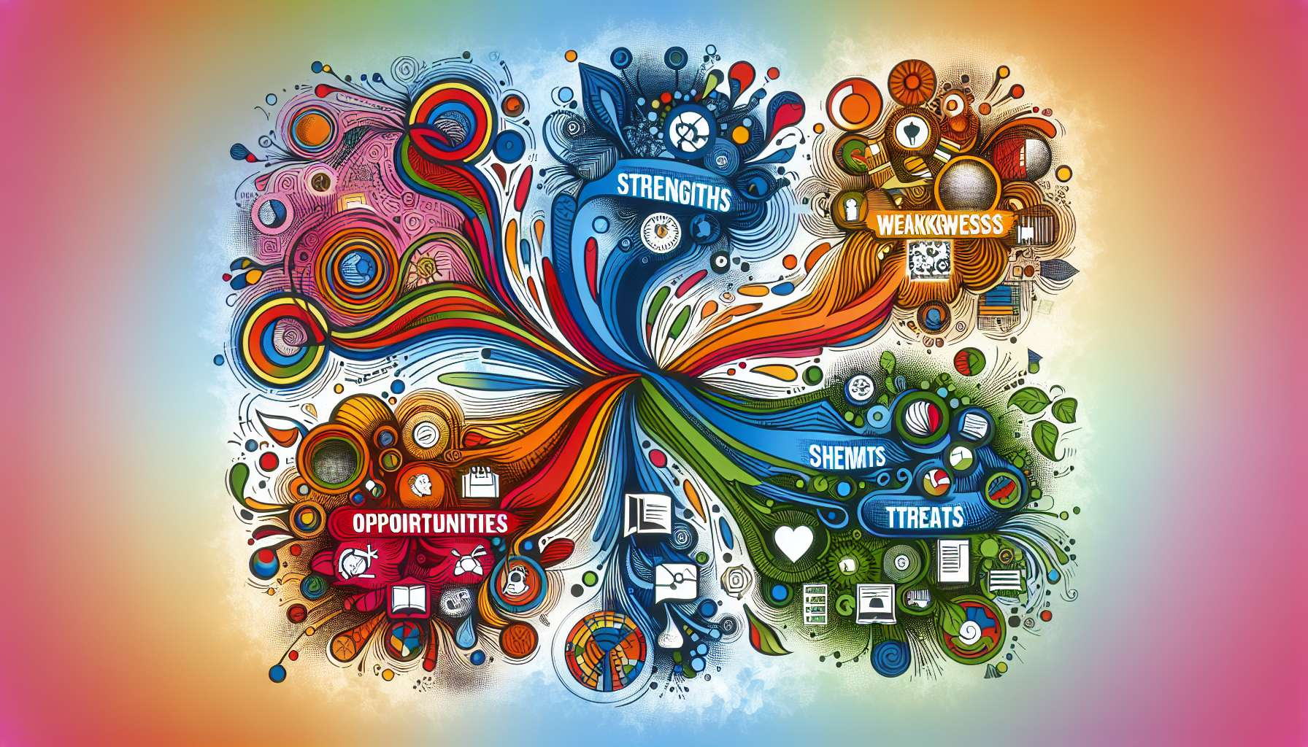

Personal SWOT analysis is a powerful tool to help LGBTQ+ individuals to better understand themselves and to guide their development. This method, originating from the corporate world, can be relevantly transposed to the individual level. It allows for a structured overview of the strengths, weaknesses, opportunities, and threats that characterize the current situation of the individual being coached.  
  
The SWOT acronym stands for: Strengths, Weaknesses, Opportunities, Threats. Strengths and weaknesses are internal factors, unique to the individual, while opportunities and threats come from the external environment. The analysis consists of exhaustively listing the elements corresponding to each category, then putting them in perspective to define a strategy of action.   
  
Strengths cover all the positive aspects that the individual can rely on: their qualities, skills, achievements, resources, etc. These might include strong creativity, a tight-knit group of friends, valuable experience in a non-profit organization, or resilience in the face of trials. Identifying one's strengths helps to solidify self-esteem and identify the levers that can be mobilized to achieve one's goals.  
  
Conversely, weaknesses correspond to points of vulnerability, limitations, and areas for improvement. For an LGBTQ+ person, this could be a difficulty asserting oneself, a tendency towards self-censorship, a lack of family support, low self-confidence, etc. Recognizing one's weaknesses without judgment is essential in targeting priority development areas. The coach helps to accept these aspects with kindness and transform them into opportunities for growth.  
  
Opportunities refer to favorable external factors, chances to seize, and potentially positive developments. These may include a proposal for training on LGBT+ themes, a legislative evolution favorable to equal rights, the emergence of new support networks, or an encouraging change of attitude in one's surroundings. Identifying opportunities helps to foster a positive outlook and actualize one's potential.  
  
Finally, threats encompass potential obstacles, risks to anticipate, and negative impacts from the environment. For LGBTQ+ people, discrimination, family rejection, societal prejudices, or difficulties accessing specific care could represent significant threats. Identifying them allows for the implementation of protection strategies and resilience, by mobilizing one's strengths and relying on available opportunities.  
  
Take, for example, Samir, a cisgender, bisexual 28-year-old man, who is conducting a SWOT analysis with his coach. Among his strengths, he identifies his listening skills, open-mindedness, and involvement in an LGBT+ organization. His weaknesses include social anxiety and a tendency to avoid conflict. Identified opportunities are a project on raising awareness about bisexuality in his company and the upcoming organization of a conference on various forms of masculinity. The main threats are bi-phobic prejudices from his in-laws and a potentially risky professional coming-out. From this analysis, Samir and his coach define a strategy to reinforce his assertiveness, mobilize his resources, and seize the identified visibility opportunities.  
  
The SWOT analysis provides an enlightening framework for understanding the global situation of LGBTQ+ individuals. This encourages better self-knowledge and a nuanced vision of the available challenges and resources. Combined with other tools previously discussed, such as the life wheel or the situation assessment, it nourishes the definition of goals anchored in the singular reality of the individual. Coaches use it flexibly and creatively, adapting to the specifics of each coaching session. Regularly conducted, the SWOT analysis also allows for the measurement of progress made and the adjustment of work priorities based on observed evolutions. It thus supports a dynamic and embodied journey towards sustainable well-being.  
  
Key points to remember:  
  
- Personal SWOT analysis is a relevant tool to help LGBTQ+ individuals to better understand themselves and guide their development.  
- The SWOT acronym stands for: Strengths, Weaknesses, Opportunities, Threats.  
- Strengths and weaknesses are internal factors, unique to the person, while opportunities and threats come from the external environment.  
- Identifying one's strengths helps to solidify self-esteem and identify the levers that can be mobilized to achieve one's goals.  
- Recognizing one's weaknesses without judgment is essential in targeting priority development areas.  
- Identifying opportunities helps to foster a positive outlook and actualize one's potential.  
- Identifying threats allows for the implementation of protection and resilience strategies.  
- The SWOT analysis provides an enlightening framework for understanding the global situation of LGBTQ+ individuals.  
- Coaches use SWOT analysis flexibly and creatively, adapting to the specifics of each coaching session.  
- Regularly conducted, the SWOT analysis allows for the measurement of progress made and the adjustment of work priorities based on observed evolutions.