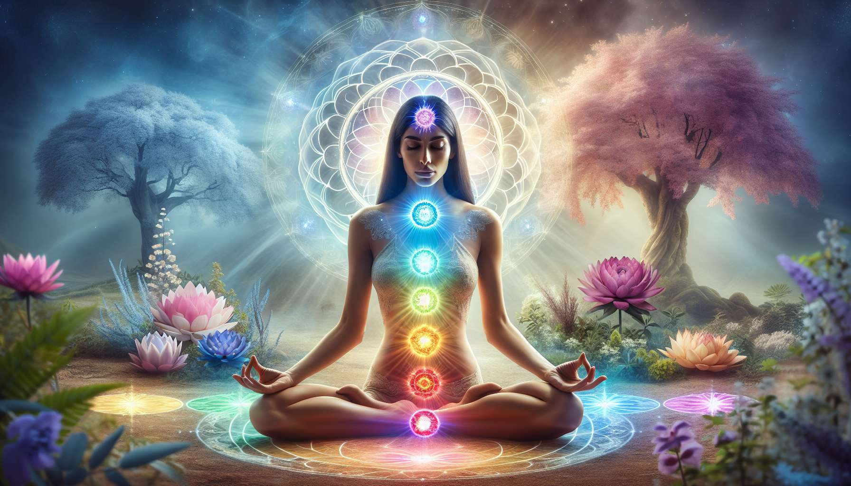

The meditations on the chakras are powerful practices for balancing and harmonizing our energy system. Chakras are subtle energy centers located along our spine, regulating various aspects of our physical, emotional, mental, and spiritual being. By focusing our attention on each chakra and nourishing them with light and intention, we can dissolve blockages, activate our potential, and deploy our full vitality.  
  
There are many ways to meditate on the chakras. A classic approach is to visualize each chakra as a lotus flower opening, focusing on its specific color and vibratory quality. Sounds, such as the Sanskrit syllables associated with each chakra (LAM, VAM, RAM, YAM, HAM, OM), can also be used to stimulate them through resonance. Some meditations invite us to imagine a luminous sphere traveling from chakra to chakra, permeating the entire body with awareness and energy.  
  
Particularly for women, meditations on the sacral and root chakras are essential for awakening and balancing feminine energy. Located in the lower abdomen, the sacral chakra is the seat of our creative power, our sensuality, and our ability to savor life. By nourishing it with orange light and activating it through circular pelvic movements, we unleash our vital impetus and open ourselves to the flow of abundance. The root chakra at the base of the spine anchors us in our body and the earth. By imbuing it with red light and visualizing a powerful tree connecting us to the center of the earth, we develop our sense of security and embodied presence.  
  
The heart chakra is another essential center to awaken to radiate our love and compassion. Located in the center of the chest, it is the seat of our deeper Self and our connection to all that is. By filling it with green or pink light, breathing deeply into the heart, we dissolve emotional wounds and open up to more harmony in our relationships. We can visualize a radiant sun in our heart, illuminating our entire being and radiating infinitely.  
  
Over time, with regular practice, chakra meditations help us become aware of our subtle anatomy and to take care of it. We learn to identify our areas of tension or weakness, and gently rebalance them. We become more sensitive to the movements of energy within us, and we can better direct and channel it. We develop our ability to self-heal and maintain our overall balance.  
  
Personally, I like to combine chakra meditations with physical practices like yoga or dance. By consciously moving my body, I can more concretely feel the effect of the attention paid to each chakra. For example, by swaying my hips or rotating my waist, I feel my sacral chakra awakening and spreading its energy throughout my being. By opening my arms and chest in a half-moon pose, I feel my heart chakra expanding and radiating all around me.  
  
I also encourage my students to create their own personalized meditations, using images and symbols that speak to them. One of them imagined a firebird spreading its flaming wings from her solar chakra, the seat of her power and assertion. Another visualized a peaceful lake in her sacral chakra, in which she could dive to recharge and purify herself. The important thing is to find representations that resonate with oneself and support our intention of balance and well-being.  
  
To integrate these meditations into daily life, you can set aside a time for daily practice, ideally in the morning to connect with your deeper self and set your intention for the day. Even five minutes of conscious connection to your chakras can help center and cultivate inner alignment. These techniques can also be used on the spot, when going through periods of stress or imbalance, to regain your grounding and vital impetus.  
  
Over time, chakra meditations develop our vibratory awareness and our mastery of subtle energy. We become more and more autonomous in managing our energetic, emotional, and mental well-being. We learn to draw from within the resources necessary to traverse life’s challenges and unfold our full potential. By balancing our energy centers, we radiate a more luminous and inspiring presence, for ourselves and for the world.  
  
Points to Remember:  
  
- Chakra meditations help balance and harmonize our subtle energy system.  
  
- There are various techniques for meditating on the chakras, such as visualization, use of sounds, or movements.  
  
- For women, meditations on the sacral and root chakras are essential for awakening feminine energy. The heart chakra is also important for radiating love and compassion.  
  
- Regular practice helps become aware of one's subtle anatomy, spot and rebalance tension areas, better direct the energy.  
  
- Combining meditations with physical practices like yoga or dance helps to feel concretely the effects on each chakra.  
  
- Creating your own personalized meditations with meaningful images boosts the effects.  
  
- Integrating a short daily practice helps center and cultivate one's inner alignment.  
  
- In the long term, these meditations develop vibratory awareness, mastery of subtle energy, and autonomy in managing one's overall well-being.