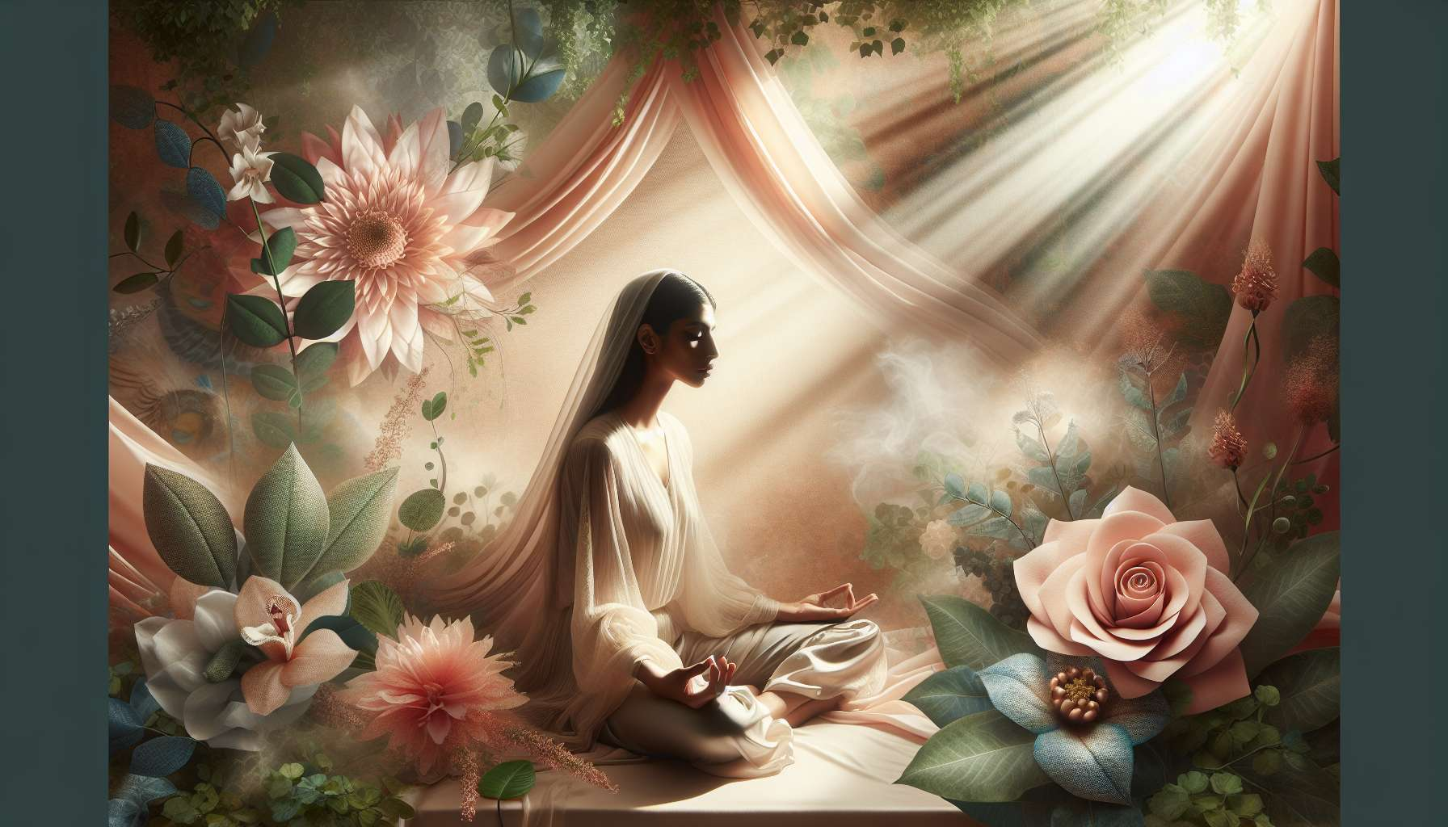

Guiding meditation or body practice is at the heart of the Divine Feminine Healing session. This is the moment when you invite your client to delve within herself, to reconnect with her body and her deepest essence, in a safe and nurturing space. Your role is to create optimal conditions to promote release, introspection, and the emergence of natural healing processes.  
  
Before beginning the practice, ensure your client is comfortably set up, using appropriate supports (yoga mat, meditation cushion, blanket, etc.). Guide her to find a position that's both stable and relaxing, whether sitting, standing or lying down according to the chosen practice. Encourage her to listen to her body's needs and adjust her posture throughout the session, never forcing or causing discomfort.  
  
Once your client is settled, take a few moments to help her center and connect with her breath. You can invite her to close her eyes, become aware of her body's contact points with the support, and feel the natural rise and fall of breath in her chest and stomach. These first few minutes are crucial to facilitating a shift from the mental state to a meditative state and a quality of self-presence.  
  
When you feel that your client is ready, you can start to guide her verbally through the chosen practice, using a calm, warm, and reassuring tone of voice. Adjust your pace and volume to your client's sensitivity, making sure to leave enough silence for her to absorb your words and live her inner experience. Your guidance should be both precise and open, supporting the process without constraining it within a pre-defined direction.  
  
If you have chosen a meditative practice, you can use different aids to help your client maintain her focus and deepen her inner experience. Guided visualizations, based on feminine archetypes or natural elements as we've seen in previous modules, are particularly powerful for stimulating imagination and transformation processes. You can also use mantras or positive affirmations to reinforce the practice's intention and instill new beliefs.  
  
If you've opted for a body practice like yoga or Qi Gong, your guidance will focus on the precision of postures and movements, while inviting subtle sensations listening. Make sure to propose options suited to your client's physical and emotional condition, encouraging her to respect her limits and gently welcome what comes. Your goal is to help her reclaim her body, release tension and blockages, and allow vital energy to flow in a spirit of kindness and celebration of femininity.  
  
No matter the guided practice, remember that your presence is the main transformation catalyst. Beyond words and techniques, it's your being and presence quality that will create a conducive healing space. Be fully available and attentive, adjusting in real-time to your client's needs. Don't hesitate to adapt your guidance if you sense resistance or discomfort, proposing gentler alternatives or inviting a return to the breath.  
  
Throughout the practice, maintain supportive and kind attention, ensuring your client feels safe exploring her inner world. Encourage her to gently welcome all that emerges: thoughts, emotions, physical sensations, reminding her there's nothing to reject or judge. Your role is to accompany her through this process of unconditional acceptance, key to a genuine reconciliation with herself and her feminine essence.  
  
When you feel the process is coming to an end, guide your client gradually back to grounding and everyday consciousness. You can invite her to gently move her body, take a few deep breaths, open her eyes when she feels ready. Give her the necessary time to emerge at her own pace, honoring the depth of her experience.  
  
In summary, guiding meditation or body practice is a subtle art requiring presence, listening, and adaptability. By creating a safe and kind space, using precise and open verbal guidance, adjusting in real-time to your client's needs, you allow her to live a deep and transformative inner experience. Your role is to be a catalyst for natural healing processes, supporting the unfolding of the body and psyche's innate wisdom. Trusting this organic intelligence while offering expert and personalized accompaniment is key to allow your client to reconnect with her feminine power and flourish in all dimensions of her being.  
  
Points to remember :  
  
- Guiding meditation or body practice is at the heart of the Divine Feminine Healing session, allowing the client to reconnect with her body and deepest essence.  
  
- Ensuring the client is comfortably set up using appropriate supports and encouraging her to find a stable and relaxing position.  
  
- Helping the client center and connect to her breath to promote a meditative state and self-presence.  
  
- Using a calm, warm, and reassuring voice tone, adjusting the pace and volume to the client's sensitivity and leaving silences.  
  
- For meditative practices, using aids such as guided visualizations, mantras or positive affirmations to deepen the inner experience.  
  
- For body practices, guiding with a focus on precise postures and movements, inviting subtle sensations listening, and proposing suited options.  
  
- A practitioner's kind presence and listening are the main transformation catalysts, creating a healing conducive space.  
  
- Encouraging the client to gently welcome all that emerges during the practice, without judgment.  
  
- Gradually guiding the client back to grounding and everyday consciousness at the end of the session, allowing her to emerge at her own pace.  
  
- The practitioner is a catalyst for natural healing processes, supporting the unfolding of the client's body and psyche's innate wisdom.