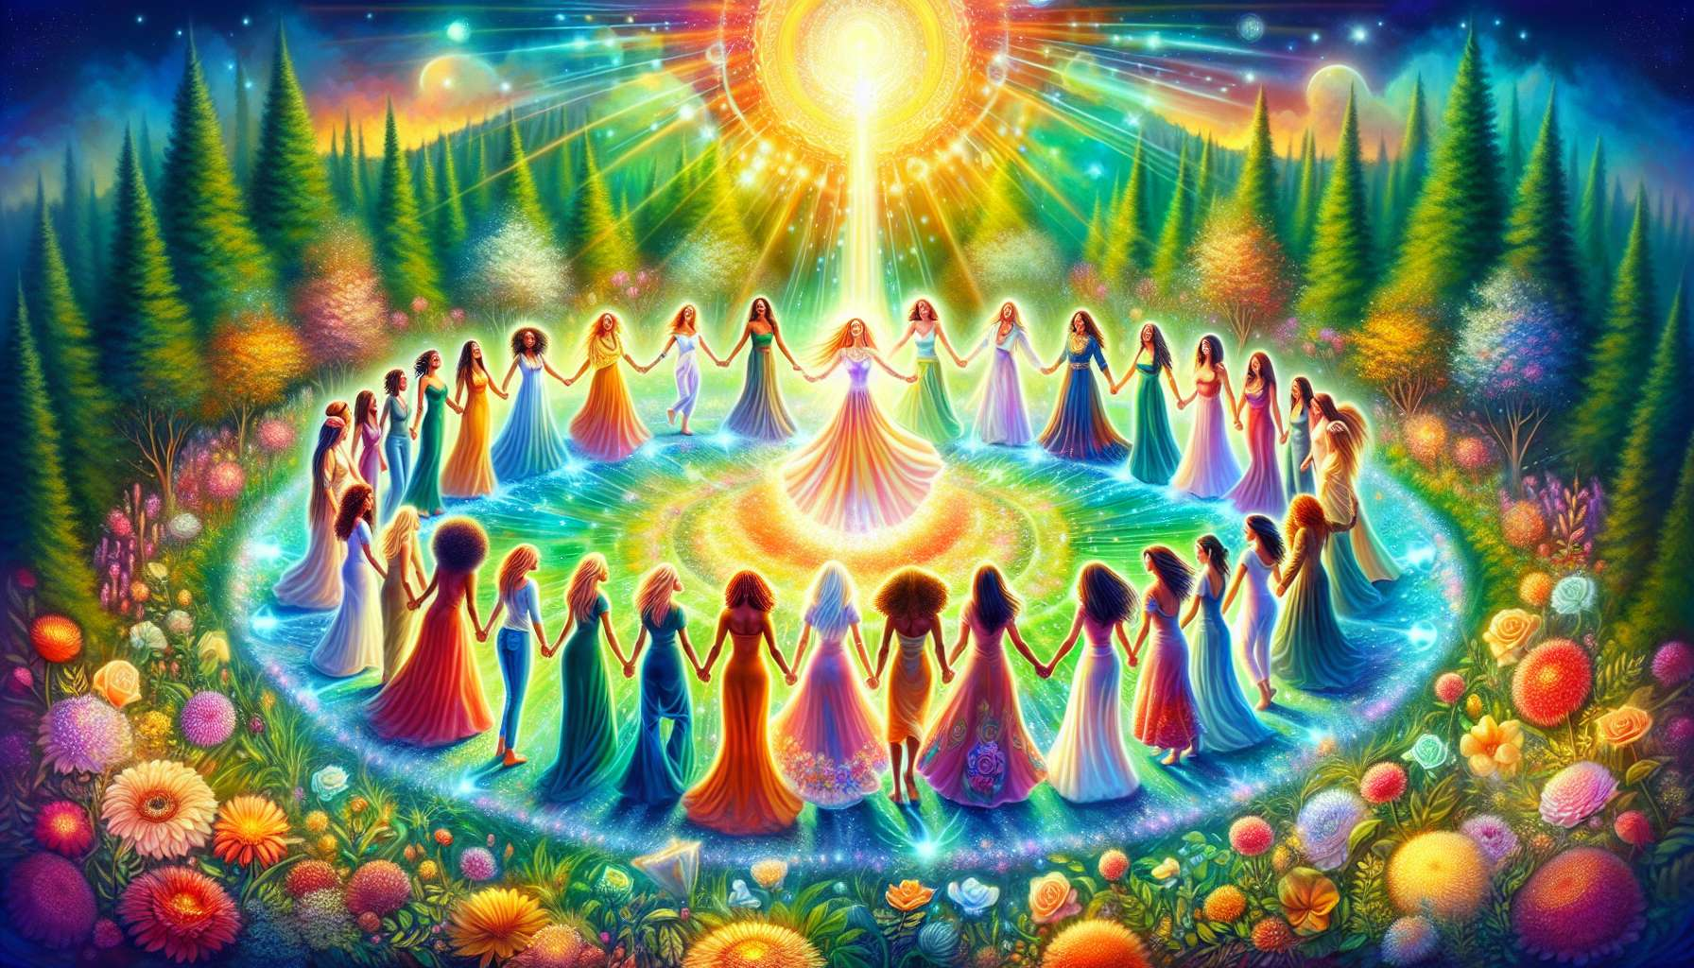

The celebration of successes and accomplishments is a crucial yet often overlooked step in the process of accompaniment in Divine Feminine Healing. In a society that constantly pushes us forward, towards the next goal to be achieved, it is essential to take the time to stop, look at the path travelled and savor victories, both small and big. As a practitioner, your role is to encourage your clients to cultivate this attitude of gratitude and celebration, in order to nourish their self-confidence and motivation.  
  
Celebrating one's successes is above all learning to recognize and validate them. Too often, we tend to minimize our successes, to find them "normal" or insufficient compared to our expectations. We are more quick to see what is wrong rather than what is going well. To counter this negativity bias, you can invite your client to keep a victories journal, where she will note three things she has succeeded in or is proud of each day. This could be a successful project, a compliment received, a milestone reached in her spiritual practice, a moment of connection with a loved one, etc. The goal is to help her to adopt a benevolent perspective on her journey and to become aware of her progress, however minuscule.  
  
Once the successes are identified, it is about giving them body and meaning through celebration rituals. These can take many forms, the main thing being that they resonate with your client's values and personality. It can be a moment of meditation in nature to show gratitude, a festive dinner with friends to share joy, a symbolic gift to mark a stage, a free dance to express her energy, a letter of gratitude addressed to oneself, etc. The idea is to create a sacred space to honor her journey, root her acquisitions, and replenish before setting off towards new challenges.  
  
Beyond the occasional successes, it is important to help your client to celebrate her deep being, her unique qualities, her inner beauty. In a world that fosters comparison and competition, learning to appreciate oneself and to love unconditionally is a revolutionary act. You can invite her to create a personal altar where she will display objects, photos, and symbols that reflect her essence and nourish her self-esteem. You may also suggest exercises such as self-massage, intuitive dance, or spontaneous song to help her fully inhabit her body and accept herself in all her facets. By cultivating this relationship of love and celebration towards herself, your client will develop unshakeable confidence and infectious radiance.  
  
Celebrating others is also a powerful way to nourish one's own light. Encourage your client to express her gratitude and appreciation towards those who inspire her, support her, and uplift her. This can be done through touching words, caring gestures, personalized gifts or shared rituals. By highlighting the qualities and achievements of her environment, she will cultivate a positive and benevolent outlook that will reflect on her own self-perception. She will also learn to receive celebration with grace and to nourish herself with it to continue to shine.  
  
At the collective level, celebration is a powerful vector of cohesion and social transformation. By creating women's circles where vulnerability, mutual support, and recognition are at the heart of the shared experiences, you contribute to weaving a new relational web based on sisterhood and empowerment. You can organize collective rituals to celebrate important passages (births, unions, menopause, bereavements...), lunar cycles, or seasons. By connecting individual stories to the grand History of women, you help each one to feel part of a larger movement of healing and re-enchantment of the feminine.  
  
Cultivating the art of celebration is a life path that requires practice, creativity, and audacity. As a practitioner, you can embody this art in your way of being and accompanying, by pointing out the wonders, encouraging the spurts, offering your sincere recognition. You can also nurture your own flame by regularly celebrating your successes, your learnings, and your commitment to the service of feminine healing. Don't be afraid to be generous and demonstrative in your celebrations, as they are essential food for the soul.  
  
Dare to step outside the box and invent new forms of celebration that resemble you. Why not create a song, a poem, or a dance to honor a client who has reached a major milestone? Why not launch a collaborative artistic project where each woman will be able to express her vision of feminine beauty? Why not imagine a ritual of passage to symbolically mark the end of the accompaniment? Let your imagination run free to create memorable and meaningful experiences.  
  
By integrating celebration at the heart of your practice, you offer your clients a precious remedy against fear, doubt, and stagnation. You help them reconnect with their deep joy, their creativity, and their power of co-creation. You show them that every step, every cycle, every season of their life deserves to be honored and celebrated for its perfection and its teaching. You pass on the sacred flame of appreciation and gratitude, which turns life into a bright and inspiring dance. What a wonderful gift to see them flourish in the joy of being and becoming fully themselves!  
  
Key points:  
  
- Celebrating one's successes is crucial in the process of accompaniment in Divine Feminine Healing to nourish self-confidence and motivation.  
  
- Recognizing and validating one's successes by keeping a "victory journal" helps adopt a benevolent perspective on one's journey.  
  
- Personalized celebration rituals allow honoring one's journey, rooting her acquired knowledge, and replenishing.  
  
- Learning to appreciate and love oneself unconditionally by creating a personal altar or through body practices develops self-esteem.  
  
- Expressing gratitude to others nourishes one's own light and positive outlook.  
  
- Creating women's circles based on mutual support and recognition contributes to a social transformation towards sisterhood.  
  
- The practitioner can embody the art of celebration in her posture and propose creative and symbolic forms of ritualization.  
  
- Integrating celebration into accompaniment helps clients reconnect with their deep joy, their creativity, and their power of co-creation.