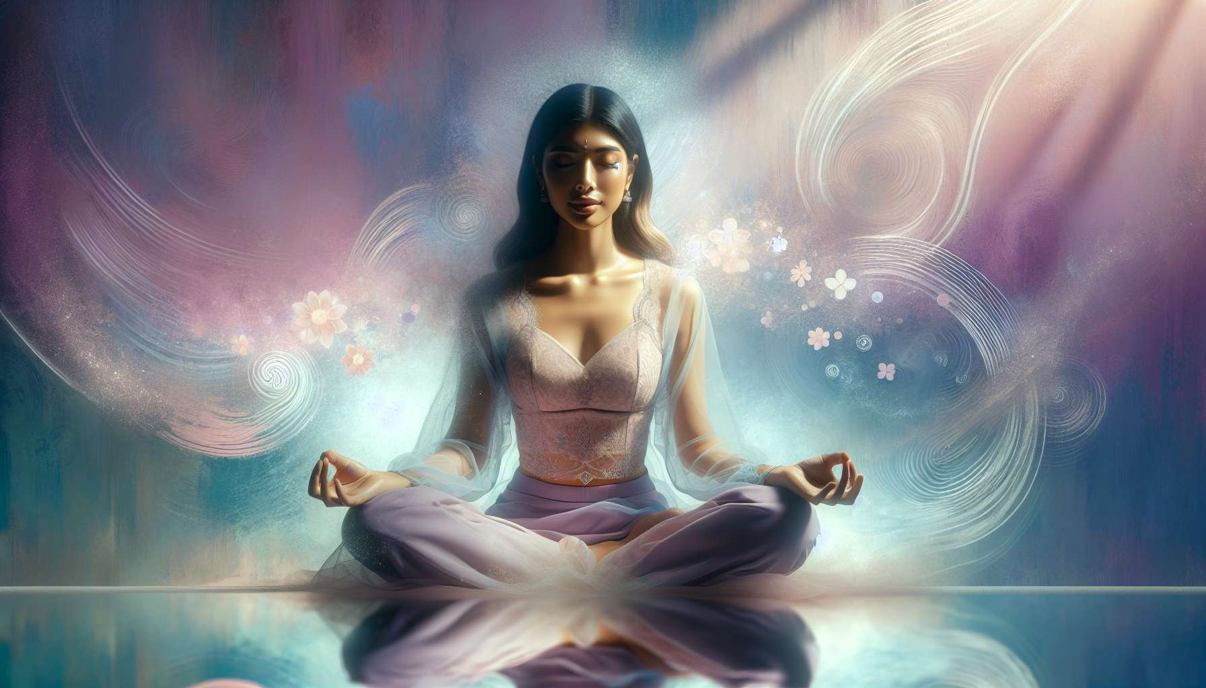

Yoga is an ancestral practice that offers numerous benefits for the physical, mental, and emotional health of women. Among the different styles of yoga particularly suited to women's needs, we find Yin Yoga, Vinyasa Yoga, and Kundalini Yoga.  
  
Yin Yoga is a gentle, introspective practice that focuses on the body's deep connective tissues (ligaments, joints, bones, and fascias). Postures are held for several minutes, allowing for a deep release of tension and a soothing of the nervous system. This approach is particularly beneficial for women who tend to constantly be in action and mentality, allowing them to reconnect with their body and interiority. Yin Yoga is also very useful during hormonal transition periods such as menstruation or menopause, helping to balance emotions and alleviate physical discomforts.  
  
Vinyasa Yoga is a more dynamic style that synchronizes movement with breath. Fluid sequences of postures help strengthen and stretch the body while calming the mind. This practice is ideal for women seeking to develop their inner strength, grace, and confidence. Vinyasa Yoga also helps stimulate blood and lymph circulation, thus promoting the elimination of toxins and hormonal regulation. In working on creative and intuitive sequences, women can reconnect with their cyclical nature and creative energy.  
  
Kundalini Yoga is a powerful practice aimed at awakening the spiritual energy coiled at the base of the spine. This style combines dynamic postures, specific breaths (pranayamas), mudras (hand gestures), mantras (sacred chants), and meditations. Kundalini Yoga is particularly effective in strengthening the endocrine system and balancing female hormones. It also allows for the development of self-awareness, intuition, and a connection to deep femininity. Kriyas (sequences of movements) specifically for women help to tone reproductive organs, alleviate menstrual troubles, and accompany the different stages of female life.  
  
Whatever the chosen style, a regular yoga practice brings many benefits to women: stress and anxiety reduction, improved sleep quality, strengthening of the immune system, better emotional management, development of physical and mental flexibility... By connecting to their body and breath, women learn to listen to themselves, respect their natural cycles, and cultivate self-love. Yoga then becomes a valuable ally for unveiling and flourishing the feminine power that sleeps within each.  
  
To integrate yoga into a practice of Divine Feminine Healing, for example, specific sequences can be proposed in connection with the female archetypes explored in module 1.4 or with the phases of the menstrual cycle discussed in module 2.4. Yoga can also be combined with guided meditations on the chakras (module 6.5) or conscious breathing practices (module 6.2) for a synergistic effect on feminine energy balance. It is important to adapt the practice to current needs, listening to the body and intuition.  
  
Key takeaways:  
  
- Yoga offers numerous benefits for the physical, mental, and emotional health of women.  
   
- Three styles of yoga particularly suited to women's needs are Yin Yoga, Vinyasa Yoga, and Kundalini Yoga.  
   
- Yin Yoga is a gentle practice that allows for deep tension release and a soothing of the nervous system. It is beneficial during hormonal transition periods.  
   
- Vinyasa Yoga is a dynamic style that strengthens and stretches the body while calming the mind. It helps to develop inner strength, grace, and self-confidence.  
   
- Kundalini Yoga aims to awaken spiritual energy and combines postures, breathing, mudras, mantras, and meditations. It is effective for balancing female hormones and developing intuition.  
   
- Regular yoga practice brings numerous benefits to women: stress reduction, sleep improvement, immune system strengthening, better emotional management, etc.  
   
- Yoga can be integrated into the practice of Divine Feminine Healing by proposing specific sequences linked with female archetypes, phases of the menstrual cycle, meditations on the chakras, or conscious breathing practices.