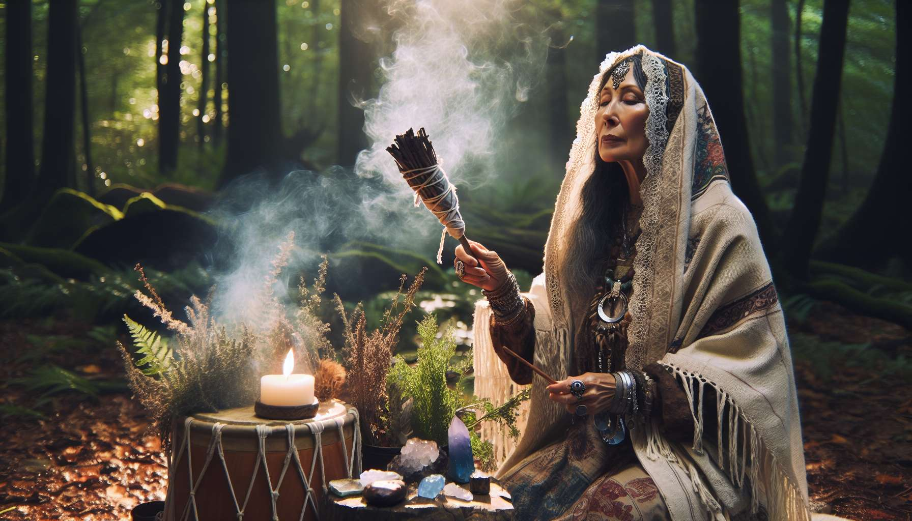

Shamanism and ancestral traditions are invaluable sources of wisdom and healing practices, particularly relevant in the context of Divine Feminine Healing. For millennia, shamans and traditional healers have developed a deep understanding of the forces of nature and their interaction with the human being, especially concerning feminine energy.  
  
In many cultures, the role of shaman or healer was traditionally entrusted to women, due to their natural connection to the cycles of life and their ability to communicate with the invisible world. Medicine women were thus considered intermediaries between the material world and the spiritual world, capable of channeling healing energies to cure the ailments of the body and soul.  
  
Among the fundamental principles of shamanism, we find the notion of interconnection between all living beings and the elements of nature. This holistic vision is particularly in resonance with feminine energy, which embodies the values of harmony, fluidity, and cyclicity. By working with the forces of Mother Earth, shamans honor and strengthen the creative and nurturing power of the sacred feminine.  
  
Shamanic practices use various tools and techniques to restore energy balance and promote healing. Purification rituals, such as smudging with sacred herbs or plant baths, help to clear blockages and stagnant energies. Collective ceremonies, such as speaking circles or ritual dances, foster the connection between women and the sharing of their inner wisdom.  
  
The shamanic journey, induced by the rhythm of the drum or other instruments, is a powerful practice for accessing the resources of the unconscious and dialoguing with spiritual guides and power animals. These allies can bring messages of healing, guidance, and transformation, in connection with the specific issues encountered by women.  
  
The study of ancestral shamanic traditions invites us to reconnect with the instinctive wisdom and life force present in every woman. By integrating these teachings into our practice of Divine Feminine Healing, we can reactivate our personal power and our natural ability to heal and evolve in harmony with the cycles of life.  
  
Points to remember :  
  
-The shamanism and ancestral traditions provide invaluable wisdom for Divine Feminine Healing, based on a profound understanding of the forces of nature and feminine energy.  
  
- Traditionally, women often occupied the role of shaman or healer, acting as intermediaries between the material and spiritual worlds.  
  
- Shamanism emphasizes the interconnection between all living beings and natural elements, a holistic vision resonating with the values of harmony and cycle of feminine energy.  
- Shamanic practices use various tools and techniques to restore energy balance, such as purification rituals, collective ceremonies, and the shamanic journey.  
  
- The shamanic journey allows access to the unconscious and communication with spiritual guides and power animals, sources of healing and transformation messages.  
  
- The study of shamanic traditions encourages women to reconnect with their instinctive wisdom and life force to reactivate their personal power and their natural ability to heal and evolve in harmony with life cycles.