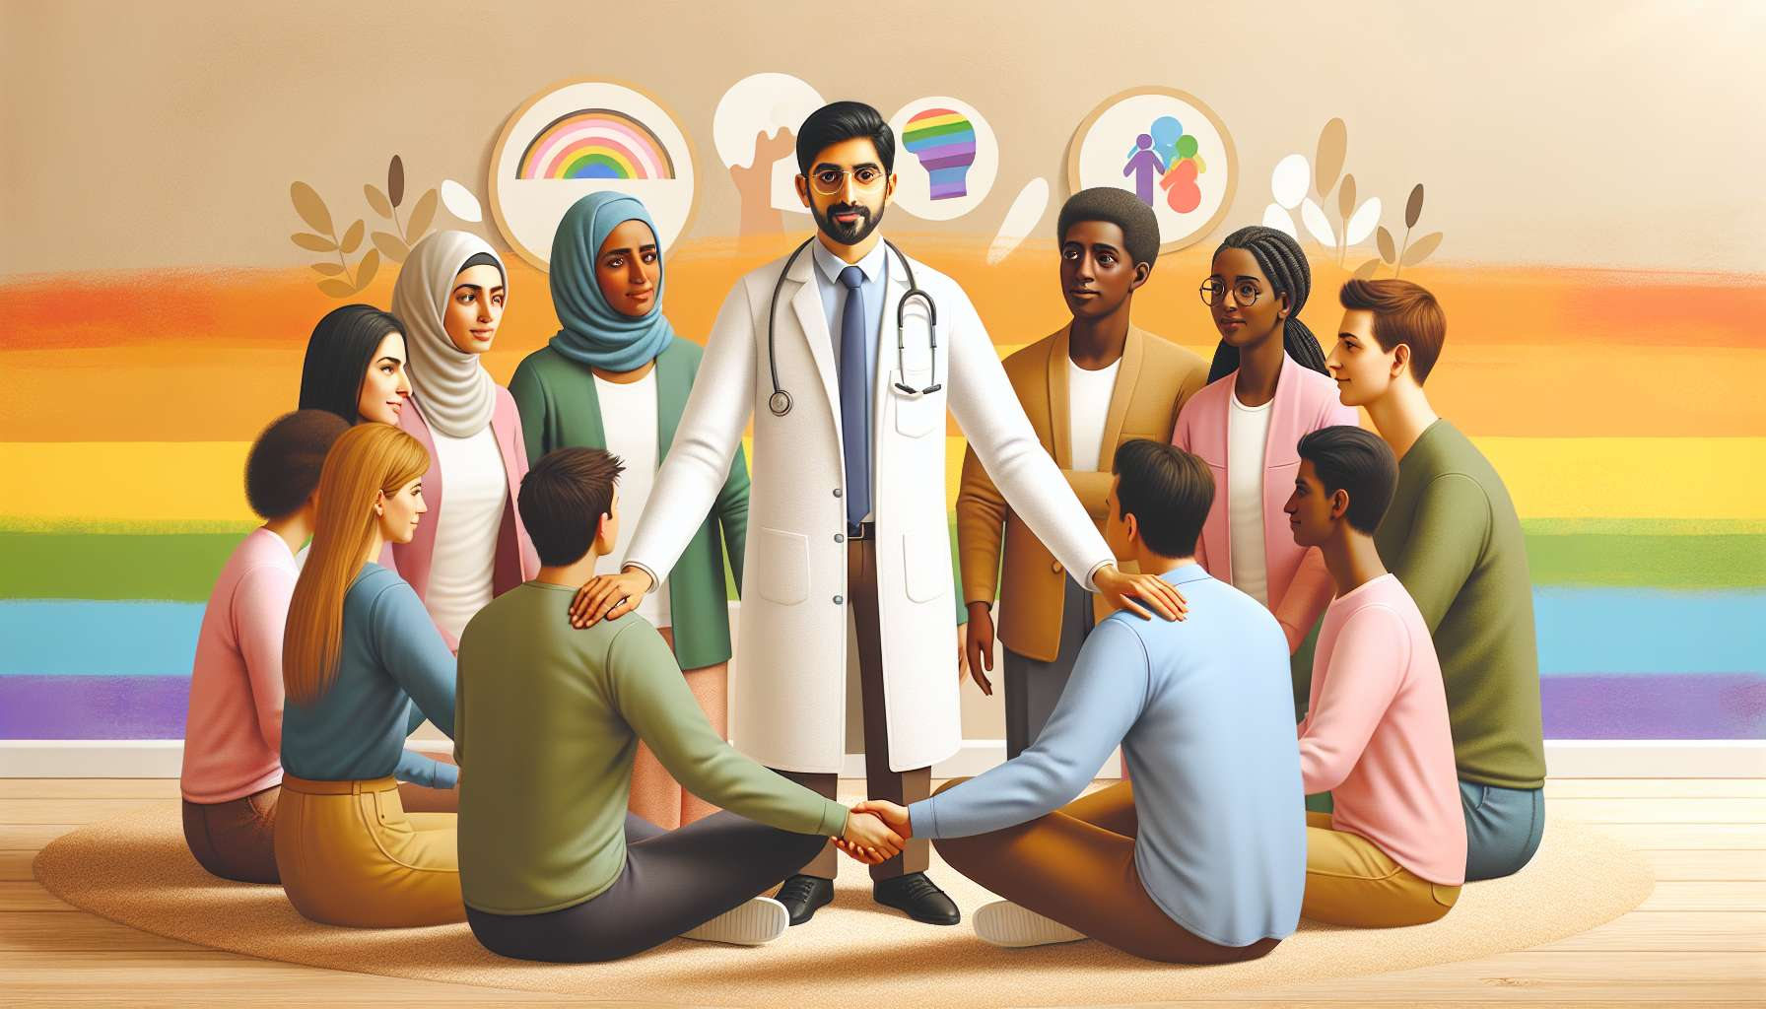

LGBTQ+ individuals are faced with specific health challenges requiring tailored care and targeted preventative measures. To meet these needs, there is an ecosystem of actors and resources that are mobilized daily. As a coach, it is essential to be well-acquainted with this network so as to best guide those being supported and to help them access quality care and support.   
  
LGBTQ+ associations are key players in prevention and support. Present across the country, they offer a wide range of services: reception and listening, discussion groups, STI screening, distribution of preventative materials, legal and social permanences, cultural and sports activities... They are often the first point of contact for those questioning or struggling, thanks to their benevolent and community approach. Some are generalist, like the LGBT Centre or SOS Homophobia, while others specialize in certain themes or populations, such as AIDS for HIV, OUTrans for transgender individuals or GREY Pride for LGBT seniors.  
  
Sexual health centres (CeGIDD, CPEF, CDAG...) are other essential resources. They offer sexual health consultations, STI screening and treatment, vaccination against hepatitis and HPV, contraception and gynecological monitoring, PrEP and TPE... The reception here is confidential, often free, and the staff are trained in LGBTQ+ specificities. Some centers have designated consultations, such as 190 in Paris for transgender individuals.  
  
For mental health issues, there are therapists and specialized organizations for the support of LGBTQ+ individuals. Directories list trained and benevolent practitioners, like PsyGay or Transidentity. Some offer online consultations, which can facilitate access for those who are remote or mobility impaired. Listening services such as SOS Homophobia or Ligne Azur also offer psychological support by phone or chat, anonymously.  
  
At an institutional level, public services are also mobilized around LGBTQ+ health issues. The DILCRAH (Interministerial Delegation for the Fight Against Racism, Anti-Semitism and Anti-LGBT Hatred) coordinates preventive actions and efforts against discrimination. Public Health France conducts epidemiological surveys (LGBT Health Barometer Report) and targeted prevention campaigns. The INPES (National Institute for Prevention and Health Education) publishes brochures and tools on LGBTQ+ sexual health.  
  
Health professionals are, of course, key resources. While not all are yet sufficiently trained, there is a progressive rise in competence on LGBTQ+ health issues. Initial and continuing training is being developed, driven by associations like the Association for LGBT Health Professionals (APSLGBT). Conferences and colloquiums also allow for the exchange of good practices, like the UEEH (Euro-Mediterranean Summer Universities of Homosexuality).  
  
Places of community sociability and sexuality (bars, clubs, saunas, sex clubs, beaches...) are also preferred spaces for the deployment of preventative measures close to the public. Associations have a regular presence here to distribute materials (condoms, gel, brochures), offer rapid screening (TROD) and engage with customers. This is the case, for example, with the SNEG (National Union of Gay Enterprises) and the ENIPSE (National Team for Intervention in Prevention and Health for Businesses) who train the managers and employees of LGBT establishments in prevention issues.  
  
Lastly, media and social networks are playing a growing role in the dissemination of prevention information. Youtubers and influencers are engaging with LGBTQ+ health issues to raise awareness in their communities, often with a playful and humorous tone. This is the case, for example, with Jérémie Gaspard with his "Monsieur Sida" channel or Lexie with her channel addressing trans issues. Web series and short films also allow for fun and accessible ways to address these topics, like "Les Engagés" on HIV or "Libre" on LGBT mental health.  
  
A few examples of referral situations:  
  
- Léa, a young lesbian of 20, wishes to undergo a sexual health check but does not dare to speak to her treating doctor. The coach directs her to the family planning clinic in her town, explaining the course of a consultation and the tests offered. He reassures her about the confidentiality and benevolence of the reception.  
  
- Tom, a 35-year-old trans man, has difficulties obtaining his hormone treatment and is considering self-medication. The coach strongly advises against this risky practice and directs him towards the OUTrans association which can help with access to care. He also suggests contacting the Santé Trans helpline for psychological support.  
  
- Samir, a 45-year-old gay man, is questioning PrEP after a risky behavior. The coach explains the functioning of this preventive treatment and directs him towards a CeGIDD for an eligibility consultation. He also informs him about the importance of regularly undergoing screenings and gives him addresses of sexual health centers.  
  
- Alix, a 30-year-old non-binary individual, is going through a period of ill-being and identity questioning. The coach directs them to a discussion group at the LGBT Centre in their city, run by a psychologist. He also advises them to consult the Psygenre directory to find a therapist trained in gender issues.  
  
In summary, the LGBTQ+ coach must be an expert on prevention resources, in order to quickly and accurately guide people according to their needs. This involves knowing the local network well, staying informed about initiatives and tools developed by associative and institutional actors, and maintaining links with health professionals. It is by building this partner network that the coach can fully play their role as a bridge to care and support. Their goal is to enable each individual to find resources tailored to their situation, in a benevolent and empowering approach. Referral is not an end in itself, but the starting point of a journey towards well-being, which the coach will support throughout the process.  
  
Key points to remember:  
  
- LGBTQ+ individuals face specific health challenges requiring targeted preventative measures and tailored care.  
  
- There is an ecosystem of actors and resources that mobilizes to meet these needs: LGBTQ+ associations, sexual health centers, specialized therapists, public services, trained health professionals, community sociability venues, media, and social networks.  
  
- The LGBTQ+ coach must know this network well in order to best guide those being supported to the care and support they need.  
  
- Referrals initiate a journey towards well-being, which the coach will support throughout in a benevolent and empowering approach.  
  
- For this, the coach must stay current on available resources, maintain relationships with professionals, and build a strong partnership network within their territory.