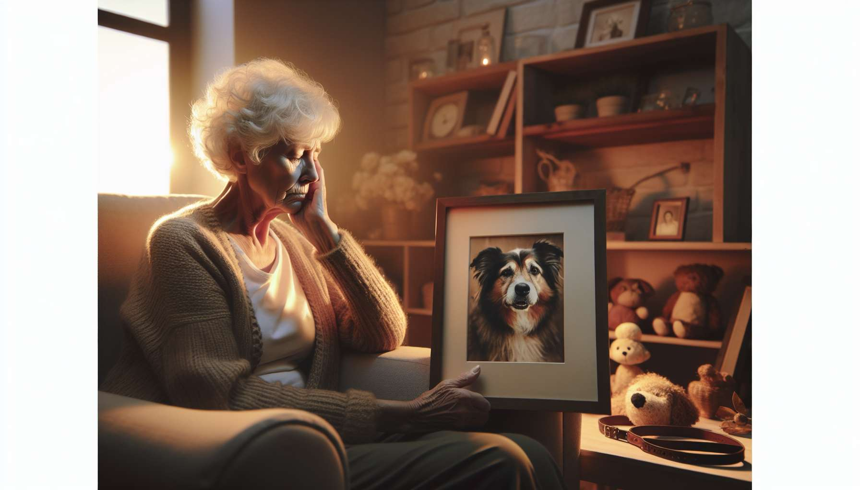

The loss of a pet is a particularly painful event for elderly people. At an age when losses and separations accumulate, when loneliness becomes an increasingly present companion, the pet often represents a final emotional bond, a bulwark against isolation and depression. Its disappearance then triggers old wounds and confronts one brutally with one's own end.  
  
To understand the particularities of pet grief among the elderly, one must first measure the unique place the animal occupies in their life. Often chosen after the death of a spouse or the departure of children, the pet becomes a full-fledged companion, one with whom one shares one's daily life, joys, and sorrows. The pet is a confidant, a loving and non-judgmental being who provides a comforting presence and a sense of security and continuity in a world that changes too quickly.  
  
Over the years, a real relationship of emotional dependence develops. The pet is the one for whom one gets up in the morning, the one who gives rhythm and meaning to one's days. It's a motivator to remain active, to leave one's home and encounter others. How many elderly people testify that without their dog, they wouldn't speak to anyone all day? The pet is a wonderful excuse to create social interaction, to exchange with other owners during walks.  
  
This fusion relationship explains the intensity of the grief felt at the loss of the pet. It is a real upheaval, which leaves a gaping void not only in the heart, but also in the daily life. From one day to the next, the benchmarks and rituals that structured life shatter. No more bowl to fill, no more caresses to give, no more reassuring presence at the foot of the bed. The house becomes silent, the absence cruel and omnipresent.  
  
For the very elderly, for whom the pet was sometimes the last companion, this loss is all the more heartbreaking as it echoes their own impending death. Having accompanied one's cat or dog to its last breath is to become acutely aware of one's own finitude. Many people wonder "what's the point of continuing without them?", expressing a deep desire to let go, to join the loved one.  
  
This feeling of loss of meaning is intensified by the often condescending attitude of those around them towards this grief. "It was just an animal," "At your age, you're not going to let yourself be beaten down like this!" are murderous phrases that deny the legitimacy of this grief. As if old age had to be accompanied by a stoic detachment from losses, as if mourning a pet was an old-timer's fancy. This injunction to minimize one's grief, to "be reasonable," is a violence that adds to the pain of grief.  
  
Yet, the grieving reactions among the elderly are often of great intensity. Tears, sleep and appetite disorders, concentration difficulties, and irritability are common in the weeks following the loss. Some people endlessly hash out the circumstances of the death, wondering if they did everything right for their companion. Others continue to talk to him, to look for his presence, refusing to acknowledge the reality of the loss.  
  
These manifestations, sometimes bewildering to those around them, must be received with kindness and without judgment. They reflect the enormity of the grief and the importance of the bond being broken. Wanting to silence them at all costs, encouraging the person to "pull themselves together" only reinforces their sense of isolation and lack of legitimacy to grieve.  
  
On the contrary, it is essential to offer the elderly person a space to express what they are going through, to talk about their lost companion and what they represent to them. Listening with patience, welcoming their tears, validating their grief is the most beautiful of comforts. Suggesting they participate in farewell rituals (choice of urn, memorial ceremony) also recognizes the importance of this bereavement and helps them fully experience it.  
  
In the months that follow, particular vigilance must be given to signs of depression or withdrawal. The temptation is great for some elderly people to let themselves slip, lose their taste for life now that the loved one is no longer there. Psychological support may be necessary to help them find reasons to live, to reinvest in relationships and joyful activities.  
  
Proposing the adoption of a new pet can also be beneficial, as long as it is not experienced as betraying or replacing the lost one. Some elderly people find great comfort in offering a home to another companion, creating new emotional bonds. Others prefer to cherish the memory of the departed animal, continuing to talk to it and honor its presence in their hearts. There is no right or wrong way to navigate this grief, only a crucial need for respect and validation of this precious bond.  
  
The grief of elderly people over the loss of a pet is also about gratitude and celebration. Gratitude for this unique relationship, for the loving and loyal presence that illuminated their twilight years. Celebration of the beauty of shared moments, of laughter and complicity that remain forever engraved. By accompanying the elderly on this journey of remembrance, by helping them connect this bond to their life story, we honor the indelible mark these four-legged companions leave on a person's life.   
  
A legacy of love and tenderness that begs to be passed on and perpetuated for future generations. By sharing their experience of pet loss, by testifying to what their companions have taught them about unconditional love and resilience, the elderly have much to teach us. It is up to us to be present, listening to this wisdom of the heart expressed in tears and smiles of remembrance. It is up to us to gather and bring to life these pieces of eternity that each pet deposits into our lives, to transform them into treasures of humanity.  
  
Takeaways:  
  
1. The loss of a pet is particularly painful for the elderly, as the pet often represents a last emotional bond and a barrier against loneliness.  
  
2. The pet occupies a unique place in the lives of the elderly, providing a comforting presence, a sense of security, and motivation to stay active and socialize.  
  
3. The fusion relationship explains the intensity of the grief felt when the pet is lost, which leaves a huge void in the heart and daily life.  
  
4. For the very elderly, this loss echoes their own mortality and can generate a feeling of loss of meaning, reinforced by the often condescending attitude of those around them.  
  
5. The grieving reactions among the elderly are often intense, and must be received with kindness and without judgment.  
  
6. It is essential to offer the elderly person a space to express their grief and to accompany them in the farewell rituals.  
  
7. Special vigilance must be given to signs of depression or withdrawal in the months following the loss.  
  
8. Suggesting the adoption of a new pet can be helpful, but there is no right or wrong way to navigate this grief.   
  
9. The grief of the loss of a pet for the elderly is also an opportunity to express gratitude and celebrate the beauty of the moments shared with the lost companion.  
  
10. By accompanying the elderly on this journey of remembrance, we honor the indelible mark these companions leave on a person's life and pass on this legacy of love to future generations.