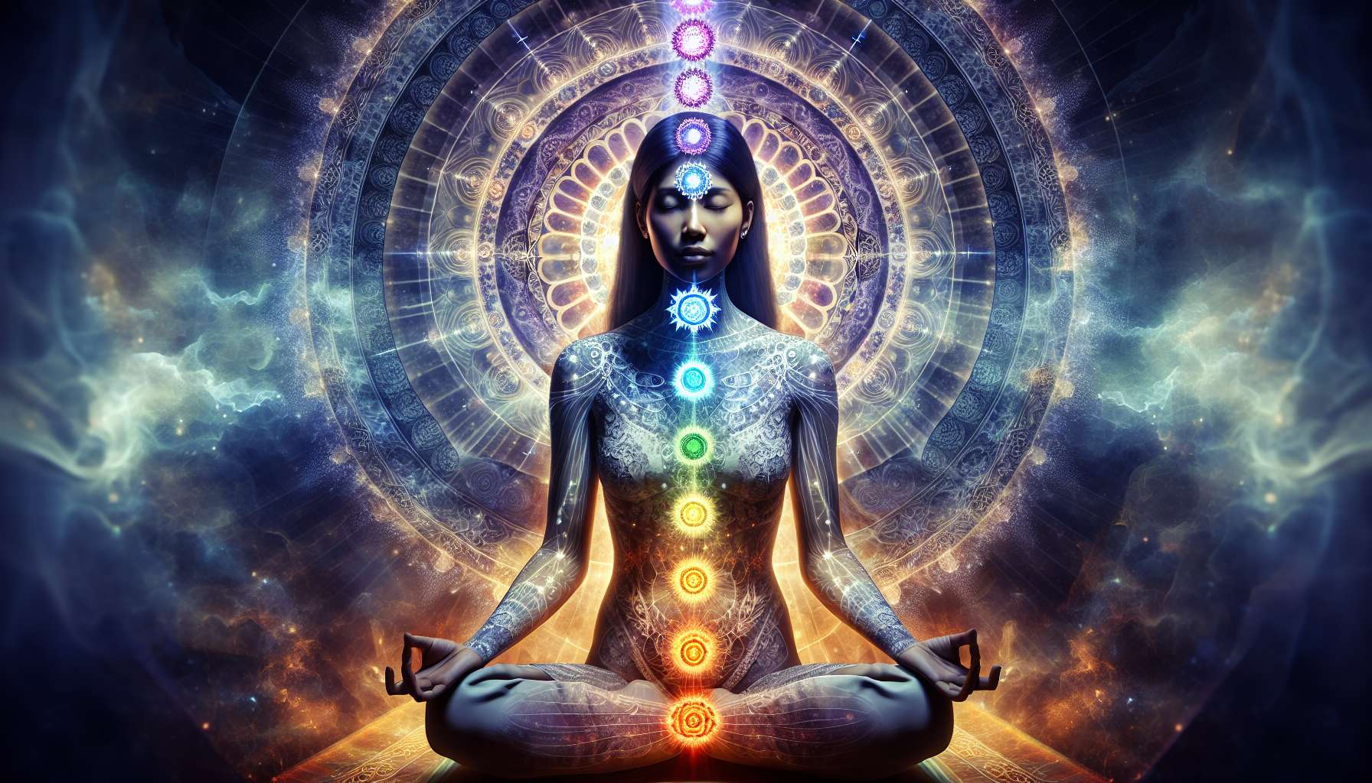

The chakra system is a key concept of energetic anatomy, which originates from yoga and tantric traditions of India. Chakras are centers of subtle energy located along the spine, each associated with specific physical, emotional, and spiritual functions. Understanding the role of the chakras is essential for any practitioner of Divine Feminine Healing, as they are intimately linked to the balance and circulation of feminine energy in the body.  
  
The seven main chakras are:  
  
1. Muladhara (root chakra): Located at the base of the spine, it is linked to safety, stability, and grounding. For women, it is particularly important as it governs the reproductive organs and the feeling of security in one's body and sexuality.  
  
2. Svadhisthana (sacral chakra): Located in the lower abdomen, it is associated with creativity, sensuality, and sexuality. A balanced second chakra allows a woman to flourish in her femininity and express her sensual and creative energy freely.  
  
3. Manipura (solar plexus chakra): Centered at the navel, it is linked to self-confidence, self-esteem, and assertion of personal power. For women, it is crucial to heal the wounds of this chakra often due to limiting social conditioning.  
  
4. Anahata (heart chakra): Located in the center of the chest, it governs the ability to give and receive love, compassion, and forgiveness. Feminine energy finds its full expression in the heart qualities embodied by this chakra.  
  
5. Vishuddha (throat chakra): Located in the throat, it is associated with authentic self-expression, communication, and creativity. Freeing this chakra allows women to find and express their unique voice with confidence.  
  
6. Ajna (third eye chakra): Centered between the eyebrows, it is linked to intuition, inner wisdom, and clear vision. By developing this chakra, women strengthen their ability to access their inner guidance and natural clairvoyance.  
  
7. Sahasrara (crown chakra): Located at the top of the head, it represents connection to universal consciousness and spiritual awakening. Its fulfillment allows women to connect to their divine nature and realize their full potential.  
  
Each chakra is associated with an archetypal feminine energy that, when balanced, supports the health and overall fulfillment of women. For instance, a woman with a harmonious sacral chakra will radiate the energy of the Goddess of Love, overflowing with sensual vitality and joy for life. Conversely, a disbalanced chakra will manifest as specific physical and emotional blockages. A woman with a blocked throat chakra might struggle to express and affirm herself.  
  
The key for practitioners is to learn to assess the state of the chakras, using tools like subtle sensation or the pendulum, to personalize their accompaniment. Certain guided meditations, yoga postures, or energetic practices will be particularly recommended depending on the chakras to be rebalanced primarily. Chakra work thus offers a valuable map for guiding women towards more vitality, authenticity, and inner harmony at all levels of their being.  
  
Key Takeaways:  
  
- Chakras are centers of subtle energy located along the spine, associated with physical, emotional, and spiritual functions.  
   
- There are 7 main chakras: Muladhara (root), Svadhisthana (sacral), Manipura (solar plexus), Anahata (heart), Vishuddha (throat), Ajna (third eye), and Sahasrara (crown).  
  
- Each chakra plays a specific role in feminine energetic balance. For instance, the 2nd chakra is linked to creativity and fulfilled sexuality.  
  
- A harmonious chakra enables the full expression of the associated archetypal feminine energy, like the Goddess of Love for the sacral chakra.  
   
- Conversely, a disbalanced chakra results in specific physical and emotional blockages.  
  
- Practitioners can assess the state of the chakras using subtle sensation or a pendulum to tailor their support.  
  
- Certain practices (meditations, yoga, energetic healing) can help rebalance the chakras.  
  
- Working on the chakras is a key to guide women towards more vitality, authenticity, and inner harmony.