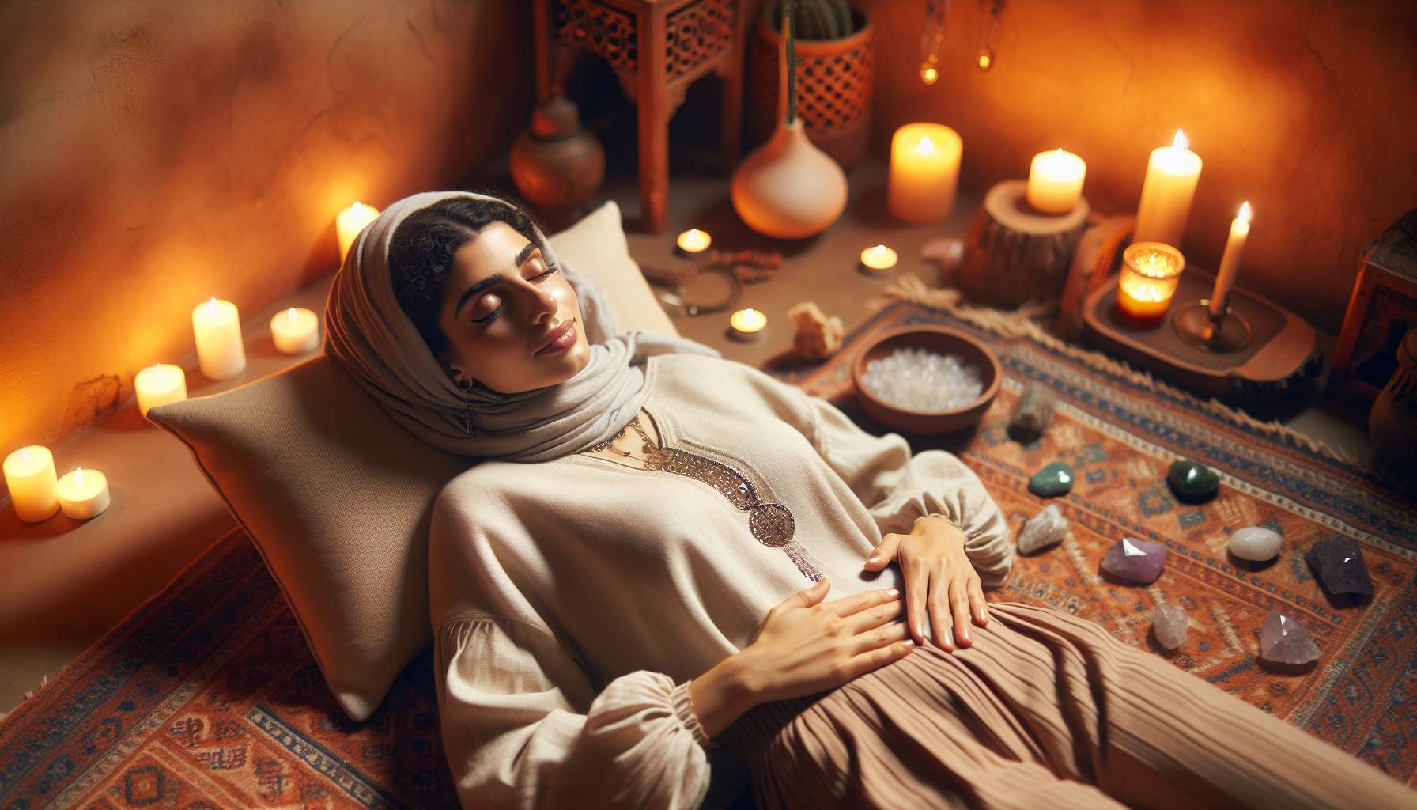

Massages and self-massages are valuable tools in the practice of Divine Feminine Healing. They allow women to reconnect with their bodies, to release physical and emotional tensions, and to offer themselves a moment of gentleness and kindness towards themselves.  
  
The massages are particularly recommended to soothe the nervous system, stimulate blood and lymphatic circulation, and alleviate pain related to the menstrual cycle or menopause. By working on the reflex areas of the body such as the feet, hands, or the stomach, it can also re-balance the organs and associated physiological functions. Some specific massage protocols, like the Mayan abdominal massage or Taoist breast massage, are particularly beneficial for gynecological health and women's sexual fulfilment. By learning to massage her uterus and ovaries gently and respectfully, it can relieve painful menstruation, promote fertility, or accompany a harmonious pregnancy.  
  
The self-massages are wonderful tools for women's empowerment and taking responsibility for their health and wellbeing. By massaging themselves regularly, they develop a better awareness of their body, its needs, and its limits. It also teaches them to listen to themselves, to allow themselves time and kind attention, away from stress and external demands. Self-massages can be practiced with hands, but also with the help of accessories like vegetable oils, roll-ons, massage balls or semi-precious stones. Depending on the body areas and therapeutic intentions, different techniques can be used like sliding pressures, effleurages, percussions or smoothing.   
  
To incorporate massages and self-massages into a Divine Feminine Healing practice, for example, protocols can be proposed related to the phases of the menstrual cycle (module 2.4) or feminine archetypes (module 1.4). Thus, during menstruation, one can massage her lower abdomen clockwise with a soothing calophyll oil, visualizing a red light that soothes contractions. During the pre-ovulation phase, one can massage her breasts from the outside inward to stimulate her creativity and radiance, like the archetype of the Mother. Massages can also be combined with specific essential oils (module 8.2), semi-precious stones (module 8.5), or sacred mantras (module 7.7) to magnify their energetic benefits.  
  
Here is a concrete example of a belly self-massage inspired by Taoist massage:  
1. Lay comfortably on your back, knees bent and feet on the ground. Apply a few drops of warm sesame oil to your lower abdomen and rub your hands to warm them.  
2. Place your hands flat on your lower abdomen and take a few deep breaths to centre yourself. Then, make circular movements clockwise around your navel, gradually widening the circles.  
3. Using the tips of your fingers, lightly palpate your lower abdomen looking for any points of tension. When you find one, make small pressured circles clockwise until you feel the knot release.  
4. Then place your hands on either side of your navel and perform deep smoothing of the midline, from the pubis to the sternum. Repeat this gesture several times in sync with your breathing.  
5. Finish by placing one hand on your lower abdomen and the other on your heart. Feel the warmth and relaxation spreading throughout your body. Take a moment to thank and congratulate yourself for taking care of you.  
  
By regularly practicing massages and self-massages, women reclaim their bodies and strengthen their self-healing power. They learn to listen to themselves, to love themselves, and to cherish themselves in all stages of their life and cycles. By granting themselves these moments of gentleness and presence to oneself, they cultivate a more intimate and harmonious relationship with their body, their emotions, and their femininity. Massages then become a subtle art to awaken the inner healer and deploy all her sacred feminine potential.  
  
Key points:  
  
- Massages and self-massages are valuable tools in the practice of Divine Feminine Healing, allowing women to reconnect with their bodies and release physical and emotional tensions.  
  
- Massages are beneficial in soothing the nervous system, stimulating circulation, relieving menstrual or menopause-related pain, and re-balancing organs by working on the reflex areas of the body.  
  
- Certain specific massage protocols, like the Mayan abdominal massage or the Taoist breast massage, are particularly relevant for gynecological health and women's sexual fulfillment.  
  
- Self-massages promote women's empowerment and taking responsibility for their health and well-being, by developing a better awareness of their body and allocating themselves time and kind attention.  
  
- Massages and self-massages can be incorporated into a Divine Feminine Healing practice related to the phases of the menstrual cycle or female archetypes, and can be combined with essential oils, semi-precious stones or sacred mantras.  
  
- A concrete example of a belly self-massage inspired by Taoist massage is detailed, involving circular movements, pressures on points of tension, deep smoothings and a moment of reconnecting with oneself.  
  
-By regularly practicing massages and self-massages, women reclaim their bodies, strengthen their self-healing power, and cultivate a more harmonious relationship with their femininity.