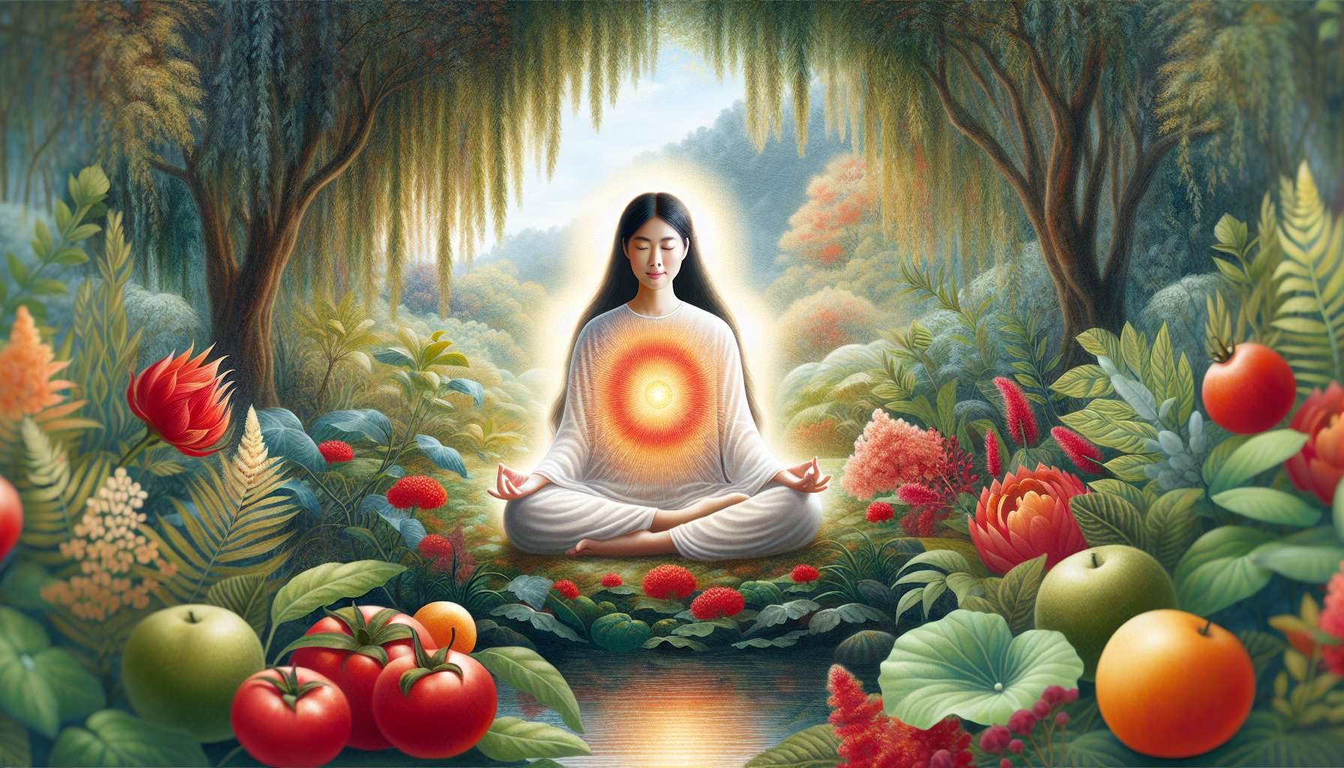

Understanding the impact of diet and lifestyle on female energy is an essential aspect of the practice of Divine Feminine Healing. As a practitioner, familiarising oneself with the principles of a diet and lifestyle tailored to the specific needs of women allows for holistic and integrative support, taking into account all dimensions of the individual. Beyond energy care, it is truly a feminine way of life that we transmit, to help each woman radiate health and vitality at every stage of her life.  
  
Diet plays a key role in women's hormonal and energetic balance. According to the principles of naturopathy and traditional Chinese medicine, certain foods are particularly beneficial for supporting female health. Foods rich in phytoestrogens like soy, flaxseeds or hops can help gently regulate hormonal balance, especially in the premenopausal period. Good fats like coconut oil, avocado or omega-3s are essential for nourishing the nervous system and maintaining supple and elastic skin. Bright red foods like beetroot, raspberries or black radish stimulate blood circulation in the pelvis and tone the uterus.  
  
Beyond the foods themselves, it's all about transforming our relationship with food. Many women have a conflicted relationship with their diet, fluctuating between deprivation and compulsion, depending on diets and thinness injunctions. By encouraging them to reconnect with their body's sensations and their true needs, we allow them to develop a more intuitive and benevolent approach to food. Eating then becomes a sacred act, a ritual of self-love and celebration that nourishes both the body and the soul.  
  
I particularly remember a client, Isabelle, who had completely lost the pleasure of eating due to years of eating disorder behaviour. By supporting her with mindfulness exercises and reconnection to her senses, she gradually relearned to listen to her body's messages and to choose food appropriate to her current needs. Over the course of our sessions, her relationship with food transformed into a genuine celebration of life, allowing her to radiate from within and reconcile with her body image.  
  
Beyond the plate, the whole lifestyle influences the energetic balance of women. Chronic stress, exhaustion, and lack of sleep are all factors that can unbalance the meridians and energy centres, as we have seen in the module on energetic anatomy. By helping women to implement self-care rituals on a daily basis, we enable them to create a conducive environment for healing and overall well-being.  
  
Practices such as gentle yoga, meditation or nature baths are precious allies in calming the nervous system and deeply refreshing oneself. They allow for the cultivation of an inner space of calm and serenity, which makes it easier to handle the daily challenges with grace and flexibility. Conscious breathing and relaxation exercises help to release accumulated tensions in the body and restore a smooth flow of vital energy.  
  
The menstrual cycle also becomes a valuable guide for adapting one's lifestyle throughout the month. As we explored in the dedicated sub-module, each phase comes with specific needs in terms of nutrition, physical activity and pace of life. By synchronising with this natural cycle, women can optimise their vitality and creativity, while preventing disorders linked to hormonal imbalances.  
  
Transmitting this cyclical way of life that respects feminine rhythms is at the heart of our holistic therapy practice. It is ultimately about inviting every woman to become the expert of her own body and its unique needs, to shape a tailor-made lifestyle that allows her to thrive at all levels of her being. By helping her identify the foods and practices that deeply nourish her, we give her the keys to her own healing and autonomy.  
  
More than just accompaniment, it is a real education in feminine health that we propose. A holistic and preventative approach that puts lifestyle hygiene at the heart of healing and wellness optimisation. By acting simultaneously on the physical body and the subtle bodies, diet and lifestyle become powerful levers for inner transformation and harmonisation of female energy.  
  
Like a modern day alchemist, the practitioner in Divine Feminine Healing guides women towards a global transmutation of their being, through dietary choices and a lifestyle in resonance with their deep nature. From the healing of hormonal imbalances to the optimisation of vitality and creativity, this integrative approach paves the way for enduring, radiant fulfilment. A path of awakening to oneself and one's own inner wisdom, to unleash all the potential of a free, creative and wildly alive woman.  
  
Key points:  
  
- Diet and lifestyle play a key role in women's hormonal and energetic balance. Certain foods such as soy, flaxseeds, coconut oil and bright red foods are particularly beneficial for female health.  
  
- It is important to develop an intuitive and benevolent relationship with food, by reconnecting to one's body sensations and true needs. Eating then becomes a sacred act that nourishes both the body and the soul.  
  
- Chronic stress, exhaustion and lack of sleep can unbalance female energy. Practices like gentle yoga, meditation and nature baths help soothe the nervous system and rejuvenate.  
  
- The menstrual cycle is a precious guide for tailoring one's lifestyle throughout the month, synchronising with the specific needs of each phase.  
  
- The practitioner in Divine Feminine Healing transmits a cyclical way of life that respects feminine rhythms, inviting each woman to become an expert of her own body and unique needs.  
  
- This holistic and preventative approach places lifestyle hygiene at the heart of healing and optimising well-being, acting simultaneously on the physical body and subtle bodies.  
  
- Divine Feminine Healing guides women towards a global transmutation of their being, paving the way for enduring, radiant fulfilment that resonates with their deep nature.