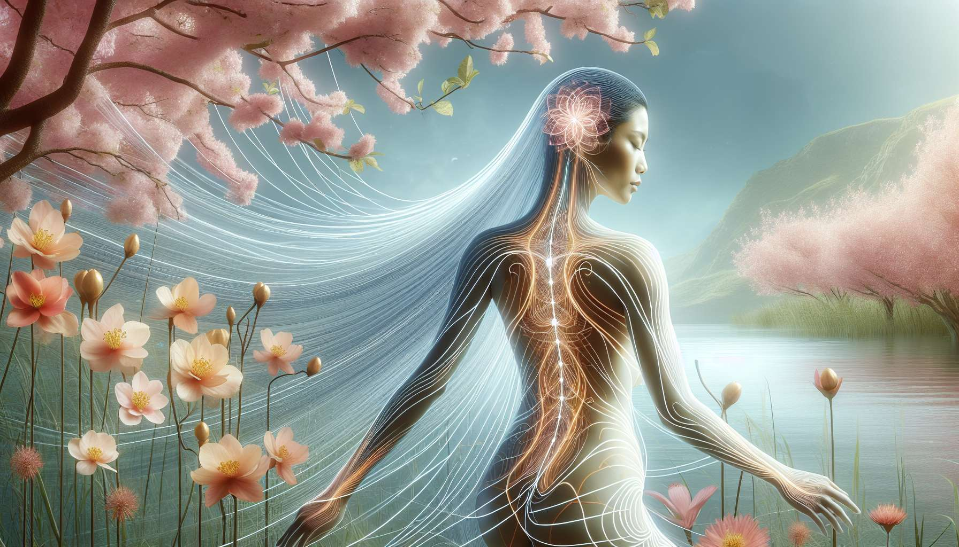

Meridians are a fundamental concept of Traditional Chinese Medicine (TCM), which describes a network of energy channels running throughout the body. According to this vision, vital energy, called "Qi", circulates in these meridians to nourish and maintain the balance of all organs and systems. Understanding the meridian system is essential for practitioners of Divine Feminine Healing, as it offers a valuable map for assessing and restoring the harmonious circulation of feminine energy.  
  
There are 12 main meridians, each associated with a specific organ: Lung, Large Intestine, Stomach, Spleen, Heart, Small Intestine, Bladder, Kidney, Heart Master, Triple Warmer, Gallbladder and Liver. Each meridian has a specific path on the body, with acupuncture points along it that serve as gateways to balance the flow of the Qi. In women, certain meridians play a key role in regulating female energy, such as:  
  
- The Kidney meridian, which governs sexual vitality, fertility and menstrual cycles. An imbalance in this meridian can manifest as disorders like infertility, painful or irregular periods.  
  
- The Liver meridian, responsible for the free circulation of Qi throughout the body and closely linked to emotional balance. A stagnant Liver is often at fault in problems of PMS, irritability or depression in women.  
  
- The Heart meridian, home of the mind and emotions. It is particularly important for cultivating joy, serenity and unconditional love, qualities at the heart of flourishing feminine energy.  
  
As a practitioner, it is essential to learn how to spot signs of meridian imbalances, both through energy diagnosis (perception of acupuncture points, pulse, tongue...) and attentive listening to the physical and emotional symptoms expressed by the client. For example, a woman suffering from bloating, fatigue and excessive mental ruminations will likely present a stagnation of Liver Qi that needs to be soothed.  
  
Working on the meridians involves various tools such as acupressure, point massage, cupping, Qi Gong or certain yoga postures. The goal is to unblock stagnation, tone deficient meridians, and promote fluent and harmonious circulation of Qi throughout the body. The results can be dramatic, as with Sophie, a 38-year-old client who consulted me for ovulation problems. After a session combining acupressure on the Kidney and Liver meridians and guided Qi Gong practice, she regained regular cycles and became pregnant two months later!  
  
Beyond the physical dimension, the meridians invite us to a deep reconnection with oneself. In our Western world that values the mind so much, connecting with the wisdom of our body and learning to decipher its messages is a powerful path to feminine balance. By guiding women on this path, the practitioner of Divine Feminine Healing becomes a true bridge between the visible and the invisible, helping each one to circulate her own life energy with fluidity and confidence.  
  
Key points:  
  
- Meridians are energy channels running through the body, in which the Qi, the vital energy according to traditional Chinese medicine, circulates.  
  
- There are 12 main meridians, each associated with a specific organ. In women, the Kidney, Liver and Heart meridians play a key role in regulating feminine energy.  
  
- Meridian imbalances can manifest as physical and emotional disorders. The practitioner must be able to spot these signs through energy diagnosis and listening to symptoms.  
  
- Work on the meridians aims to unblock stagnation, tone deficient meridians and promote harmonious Qi circulation, using tools such as acupressure, Qi Gong or yoga.  
  
- Beyond the physical aspect, meridians encourage women to reconnect with their bodies and decipher their messages, thus paving the way to feminine balance.  
  
- By guiding women on this path, practitioners of Divine Feminine Healing become bridges between the visible and the invisible, helping each one to circulate her own life energy with fluidity and confidence.