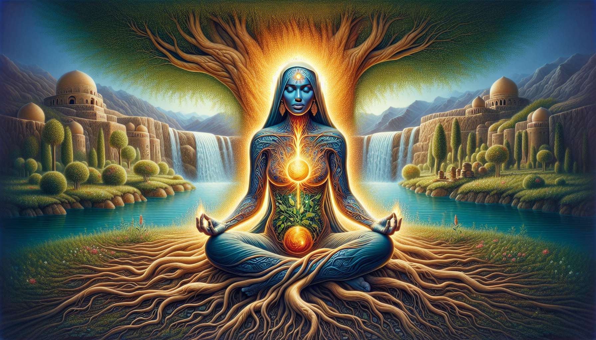

Meditations with the elements are powerful practices for reconnecting with nature and its primal forces. By consciously connecting to the earth, water, fire, and air, we awaken within ourselves the vibratory qualities of these elements and restore our deep balance. These meditations are particularly beneficial for women, who often have a natural sensitivity to the subtle energies of nature and seek to embody their organic essence.  
  
Earth meditation invites us to ground ourselves deeply in our bodies and in the present moment. By visualizing powerful roots departing from our feet and diving into the heart of the earth, we develop our sense of stability, security, and trust. We can imagine the nourishing earth transmitting its calm strength, patience, and serenity to us. By breathing deeply into our pelvis and legs, we honor our foundation and connect to our embodied power.  
  
Water is the element of fluidity, receptivity, and emotional healing. By meditating with water, we learn to welcome and freely circulate our emotions, without attempting to retain or control them. We may envisage being immersed in a peaceful sea, cradled by the ebb and flow of waves, or visualize ourselves as a river gracefully flowing toward the ocean. By focusing attention on our belly and pelvis—hubs of feminine creative energies—we connect to our natural ability to give life and regenerate.  
  
Fire is the element of transformation, passion, and self-assertion. By meditating with fire, we awaken our vitality, courage, and capacity to act in the world. We can visualize a vibrant flame in our solar chakra, radiating through our whole being, dissolving fears and doubts. By breathing deeply into our belly, we nourish this inner fire and connect to our will and determination. We learn to channel this powerful energy to realize our dreams and inspire those around us.  
  
Air is the element of freedom, mental clarity, and communication. Meditating with air, we cleanse our minds of toxic thoughts and open ourselves to new perspectives. We can imagine breathing in luminous air that fills our lungs and our entire being, dissolving tensions and fixed ideas. By focusing our attention on our chest and throat, we free our creativity, and express ourselves with greater ease and authenticity. We connect to our intuition and inner wisdom, beyond conditioning.  
  
By combining the four elements in the same meditation, we can have a profound experience of unity and harmony. For instance, we can imagine ourselves standing, deeply rooted in the earth, with a pure waterfall flowing onto our back, a radiant fire sphere in our belly, and the luminous air filling our heart and head. By connecting these elements within, we embody our full potential as divine beings—both stable and fluid, powerful and light.  
  
Personally, I enjoy meditating in nature to connect directly with the elements. Lying on the grass, feeling the firm earth beneath my back, immersing myself in a lake or ocean, basking in the flow of water, gazing at a campfire and absorbing its heat, breathing the fresh morning air and feeling my consciousness expand... All are sensory experiences that nurture my meditations and give them a tangible, living dimension.  
  
I also encourage my students to create personal rituals with the elements, to mark significant moments in their life or to navigate periods of transition. For instance, burying a seed in the earth while formulating an intention for a fresh start, throwing a pebble signifying what one wants to let go of into a stream, performing a purifying ritual with sage smoke, or taking deep breaths while visualizing dreams coming true. By engaging our bodies and creativity in these rituals, we powerfully anchor our intentions in the material world and align with life forces.  
  
Over time, through regular practice, meditations with the elements develop our ecological awareness and our sense of profound connection with the web of life. We realize that we are not separate from nature, but rather that we intimately belong to it. By honoring the earth, water, fire, and air within us, we learn to respect them externally and to live in harmony with our environment. We become earth guardians, working at every moment to preserve its beauty and balance.  
  
For women especially, reconnecting with the elements is a potent pathway to awakening and embodying the sacred dimension of their femininity. By merging with the primal forces of life, they honor their cyclical essence, their instinctive wisdom, and their power to love and create. They understand that they carry within themselves the original matrix from which all life emerges, and that they have the power to regenerate it at every moment, within themselves and around them. By grounding themselves in their profound nature, they become radiant ambassadors of a new paradigm, based on unity, harmony, and respect for the living.  
  
Key takeaways:  
  
1. Meditations with the elements (earth, water, fire, air) help us reconnect with nature and its primal forces, thereby restoring our deep balance.  
  
2. Each element offers specific benefits:   
 - The earth promotes stability, security, and trust.  
 - Water facilitates fluidity, receptivity, and emotional healing.  
 - Fire awakens vitality, courage, and self-assertion.  
 - Air promises freedom, mental clarity, and improved communication.  
  
3. Combining all four elements in a single meditation leads to deeply harmonious and unitive experiences.  
  
4. Meditating in nature and creating personal rituals with the elements enhance the connection and anchor intentions in the material world.  
  
5. Regular practice enhances ecological awareness and the sense of being part of the web of life.  
  
6. For women, reconnecting with the elements aids in awakening and embodying the sacred dimension of their femininity, honoring their cyclical essence, instinctive wisdom, and creative power.  
  
7. By grounding in their profound nature, women become ambassadors of a new paradigm based on unity, harmony, and respect for the living.