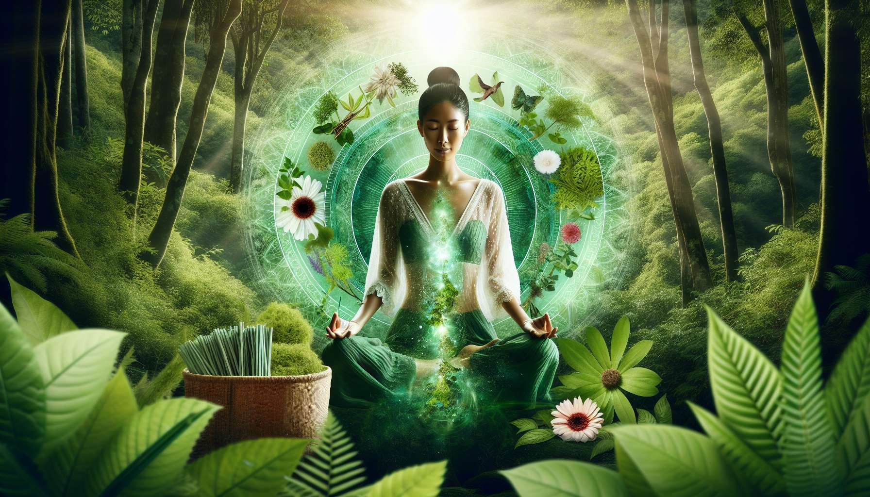

Purification and detoxification practices are essential elements in a Divine Feminine Healing approach. They allow to free the body and the mind from accumulated toxins, energetic blockages and limiting memories, in order to regain clarity, vitality and inner alignment. For women, these practices are particularly beneficial to regulate hormonal cycles, alleviate digestive disorders and strengthen the immune system.  
  
Purification can take place at different levels: physical, emotional, mental and spiritual. At the physical level, it involves a healthy and living diet, rich in fresh fruits and vegetables, good fats and vegetable proteins. It is recommended to limit processed foods, refined sugar, caffeine and alcohol which clog the body and create inflammation. Certain fresh juice cures, draining herbal teas, or dietary supplements (spirulina, chlorella, probiotics) may be useful for deep cleansing the digestive system and revitalizing the body.  
  
At the emotional and mental level, purification involves work on negative thoughts, limiting beliefs, and repressed emotions. Practices such as meditation (module 6), EFT (module 5.7), or creative journaling allow for awareness of these unconscious patterns and their transformation into resources. It is also important to surround yourself with caring people, set healthy boundaries, and create self-care rituals to free yourself from toxic relationships and harmful influences.  
  
On a spiritual level, purification involves reconnecting to one's essential nature, beyond the conditioning and illusions of the ego. Practices like prayer, contemplation, or silent retreats allow connection to something greater than oneself and rejuvenation in Presence. Certain rituals like salt baths, saunas, or white sage smudging help to dissolve stagnant energies and recenter in one's body-temple.  
  
Among the most powerful detoxification practices for women is fasting, an ancestral method of physical and mental cleansing. Fasting can be practiced for a short duration (1 to 3 days) or for an extended period, under medical supervision. It involves refraining from solid food for a given period, while hydrating abundantly with water or herbal teas. Fasting allows the digestive system to rest, regenerates cells, and eliminates accumulated waste. It also induces a state of mental clarity and spiritual connection conducive to deep awareness and change.  
  
For women suffering from hormonal disorders such as premenstrual syndrome, endometriosis or difficult menopause, certain adaptogenic plant remedies such as lady's mantle, clary sage or vitex can be very beneficial. These plants help to rebalance the endocrine system, regulate cycles and alleviate physical and emotional symptoms. They are usually taken in the form of herbal tea, liquid extract, or capsules, for cures of 3 to 6 months. It is recommended to be accompanied by a naturopath or a phytotherapist to adapt the protocol to one's specific needs.  
  
At the energetic level, certain practices such as reiki (module 4.9), magnetism or shamanism allow to unclog emotional knots and rebalance life centers. By working directly on the subtle bodies, these techniques promote a harmonious flow of energy and reconnection to one's creative power. They are particularly indicated in cases of burn-out, depression, or chronic illnesses, to reactivate the self-healing power of the body.  
  
Here is a practical example of a detoxification protocol for season change, to be adapted according to your needs and sensitivity :  
1. Start with a day of water fast (water and herbal teas only) to rest your digestive system and activate the elimination of toxins. Drink at least 1.5L of fluid throughout the day.  
2. In the morning on awakening, practice an abhyanga massage (module 7.4) with warm sesame oil to loosen tensions and activate lymphatic circulation. Massage yourself from feet to head with circular motions, insisting on the belly in a clockwise direction.  
3. Prepare a detoxifying herbal tea made with rosemary, dandelion, and milk thistle. Let it infuse for 10 minutes and drink 3 to 4 cups throughout the day, between meals. These plants stimulate liver and kidney functions for better waste elimination.  
4. At noon, savor a large bowl of leafy green vegetables (spinach, chard, cabbage ...) steamed with a drizzle of olive oil and gomasio. Green vegetables are rich in chlorophyll which purifies the blood and alkalinizes the body.  
5. In the afternoon, treat yourself to a session of foot reflexology (module 7.5) focusing on the areas of liver, gallbladder, and kidneys. This practice stimulates the excretory organs and promotes deep detoxification.  
6. In the evening, prepare a broth of root vegetables (carrots, turnip, celery ...) with mild spices (cumin, turmeric, ginger). This light and nourishing meal soothes the digestive system and prepares for a regenerative night.  
7. Before going to bed, meditate for about ten minutes visualizing a purifying white light bathing each cell of your body. On the exhale, imagine that you release all the toxins and negative thoughts. Then formulate a positive intention for your overall health.  
  
By regularly practicing purification and detoxification techniques, women enhance their vitality, immunity, and well-being at all levels. They learn to listen to the messages of their body and offer it what it needs to thrive. By freeing themselves from physical and psychic blockages, they regain their clarity of mind, their joy of life and their creative power. They become actors of their health and radiate this vital energy around them. Detox practices then become precious rituals to celebrate the wisdom of the body and honor the temple of the soul it houses.  
  
Key takeaways:  
  
- Purification and detoxification practices are essential in a Divine Feminine Healing approach to free the body and the mind from toxins, blockages and limiting memories.  
  
- Purification happens at the physical (healthy diet, cures), emotional and mental (meditation, EFT, creative journaling), and spiritual (prayer, rituals) levels.  
  
- Fasting is a powerful ancestral method of physical and mental cleansing.  
  
- Adaptogenic plants (lady's mantle, clary sage, vitex) help rebalance the female hormonal system.  
  
- Energy practices (reiki, magnetism, shamanism) allow to unclog emotional knots and rebalance life centers.  
  
- A sample season change detoxification protocol includes: water fast, abhyanga massage, detoxifying herbal tea, green vegetables, foot reflexology, root vegetable broth, and meditation.  
  
- By freeing themselves from physical and psychic blockages through these regular practices, women enhance their vitality, their immunity, and their overall well-being. They regain clarity of mind, joy of life, and creative power.