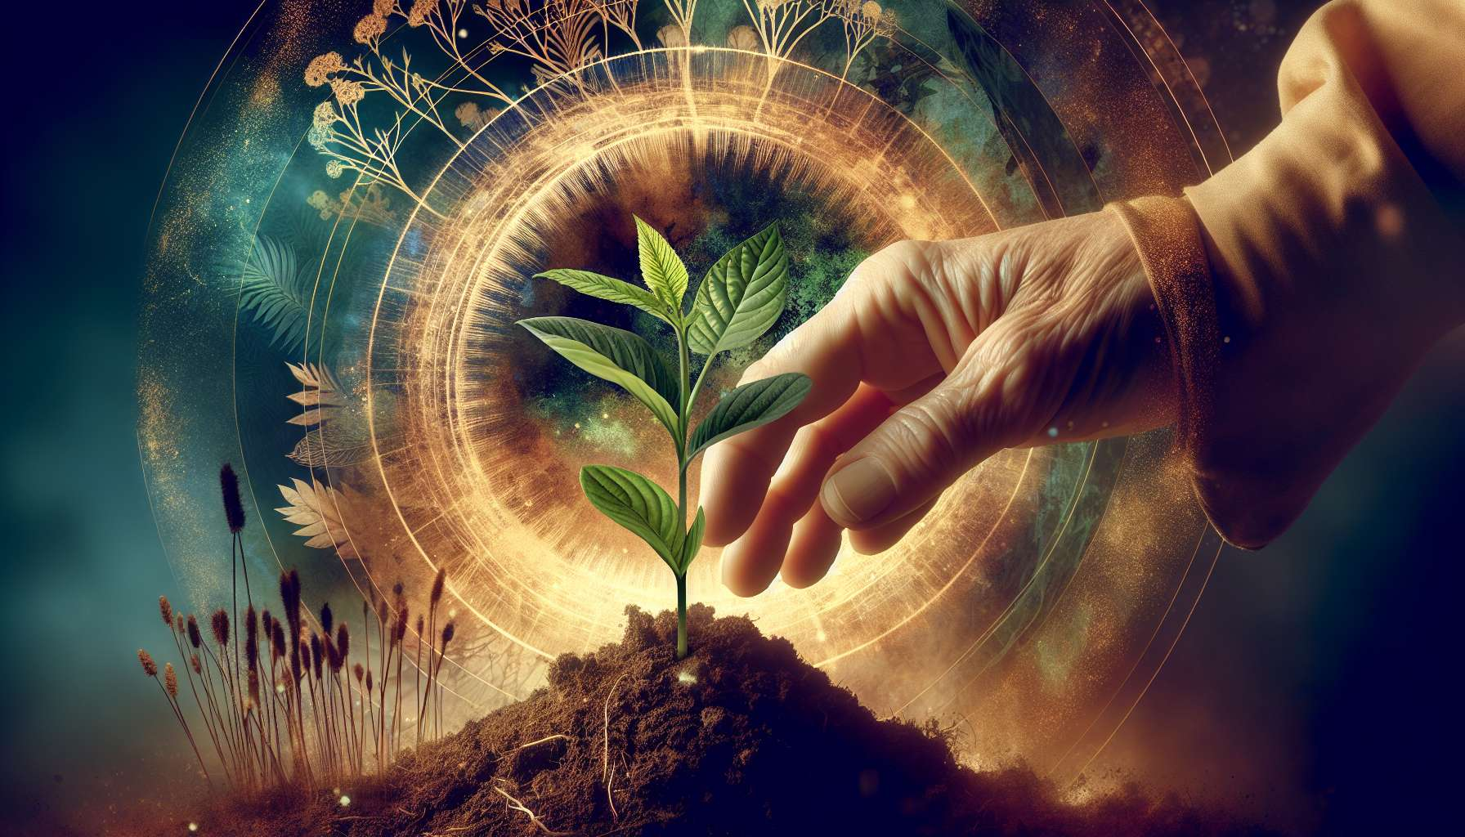

Gemmotherapy is a branch of phytotherapy that uses growing plant embryonic tissues, such as buds and young shoots of trees and shrubs, to maintain or restore health. The buds concentrate all the vital force and growth potential of the plant, as well as an exceptional wealth of active ingredients, vitamins, minerals, and oligo-elements.  
  
Each bud has a unique biochemical and energetic signature, which gives it specific therapeutic properties. Some buds are particularly suited to the needs and challenges encountered by women throughout their lives, such as the blackcurrant bud to regulate hormonal cycles, the rosemary bud to stimulate vitality, or the fig bud to promote detoxification.  
  
The buds are harvested in the spring, when they are full of sap and energy, and then they are stabilized and transformed into glycerinated macerates. This preparation method allows to preserve all the properties of the fresh plant and to make them bioavailable for the body. Bud macerates are usually used orally, at the rate of a few drops per day, diluted in a little water.  
  
It is essential to choose buds from wild strains or grown under optimal conditions, without pesticides or chemical fertilizers. The quality of the buds determines their effectiveness and safety. It is recommended to source from specialized laboratories that perfectly master the harvesting and processing of buds.  
  
Here are a few examples of indispensable buds for women's health:  
  
- The blackcurrant bud, to regulate menstrual cycles, relieve premenstrual symptoms and promote hormonal balance.  
- The rosemary bud, to stimulate vitality, strengthen the immune system and fight fatigue.  
- The fig bud, to promote liver detoxification, relieve digestive disorders and regulate transit.  
- The hawthorn bud, to soothe the nervous system, reduce anxiety and promote restful sleep.  
- The raspberry bud, to tone the uterus, prepare for pregnancy, and facilitate childbirth.  
  
Glycerinated macerates are generally well tolerated, even during pregnancy and breastfeeding, but it is always preferable to seek the advice of a health professional before using them. Some buds may be contraindicated in certain medical situations or interact with ongoing treatments.  
  
Beyond their therapeutic properties, buds also bring a symbolic and energetic dimension to the practice of Divine Feminine Healing. Each bud embodies the qualities of the tree from which it originates and can be associated with a female archetype. For example, the apple bud evokes the gentleness and generosity of the Nurturing Mother, while the cherry bud embodies the grace and beauty of the Blossoming Maiden.  
  
Gemmotherapy invites us to reconnect with nature's cycles, the rhythms of the seasons, and the wisdom of trees. Using buds in the practice of Divine Feminine Healing allows one to benefit from their regenerative force and life impulse to support the processes of internal transformation. It is a precious tool to accompany women on their journey towards more vitality, balance, and fulfillment.  
  
As a practitioner, it is important to train in gemmotherapy to be able to advise bud macerates in a personalized and adapted way to each woman. Gemmotherapy fits perfectly into a holistic and natural approach to women's health, in synergy with other tools such as phytotherapy, aromatherapy, or intuitive eating. It offers a gentle, profound, and life-respecting healing path, in resonance with the values of Divine Feminine Healing.  
  
Key points:  
  
- Gemmotherapy uses growing plant embryonic tissues, such as buds and young shoots, to maintain or restore health.  
  
- Each bud has a unique biochemical and energetic signature, giving it specific therapeutic properties.  
  
- The buds are harvested in the spring, then transformed into glycerinated macerates to preserve their properties.  
  
- It is essential to choose buds from wild strains or grown under optimal conditions, without pesticides or chemical fertilizers.  
  
- Some buds are particularly suited to women's needs, such as the blackcurrant, rosemary, fig, hawthorn and raspberry buds.  
  
- Glycerinated macerates are generally well tolerated, but it is preferable to seek the advice of a health professional before using them.  
  
- Each bud embodies the qualities of the tree from which it originates and can be associated with a female archetype.  
  
- Gemmotherapy invites us to reconnect with nature's cycles and the wisdom of trees, supporting the processes of internal transformation.  
  
- As a practitioner, it is important to train in gemmotherapy to be able to advise bud macerates in a personalized and adapted way to each woman.