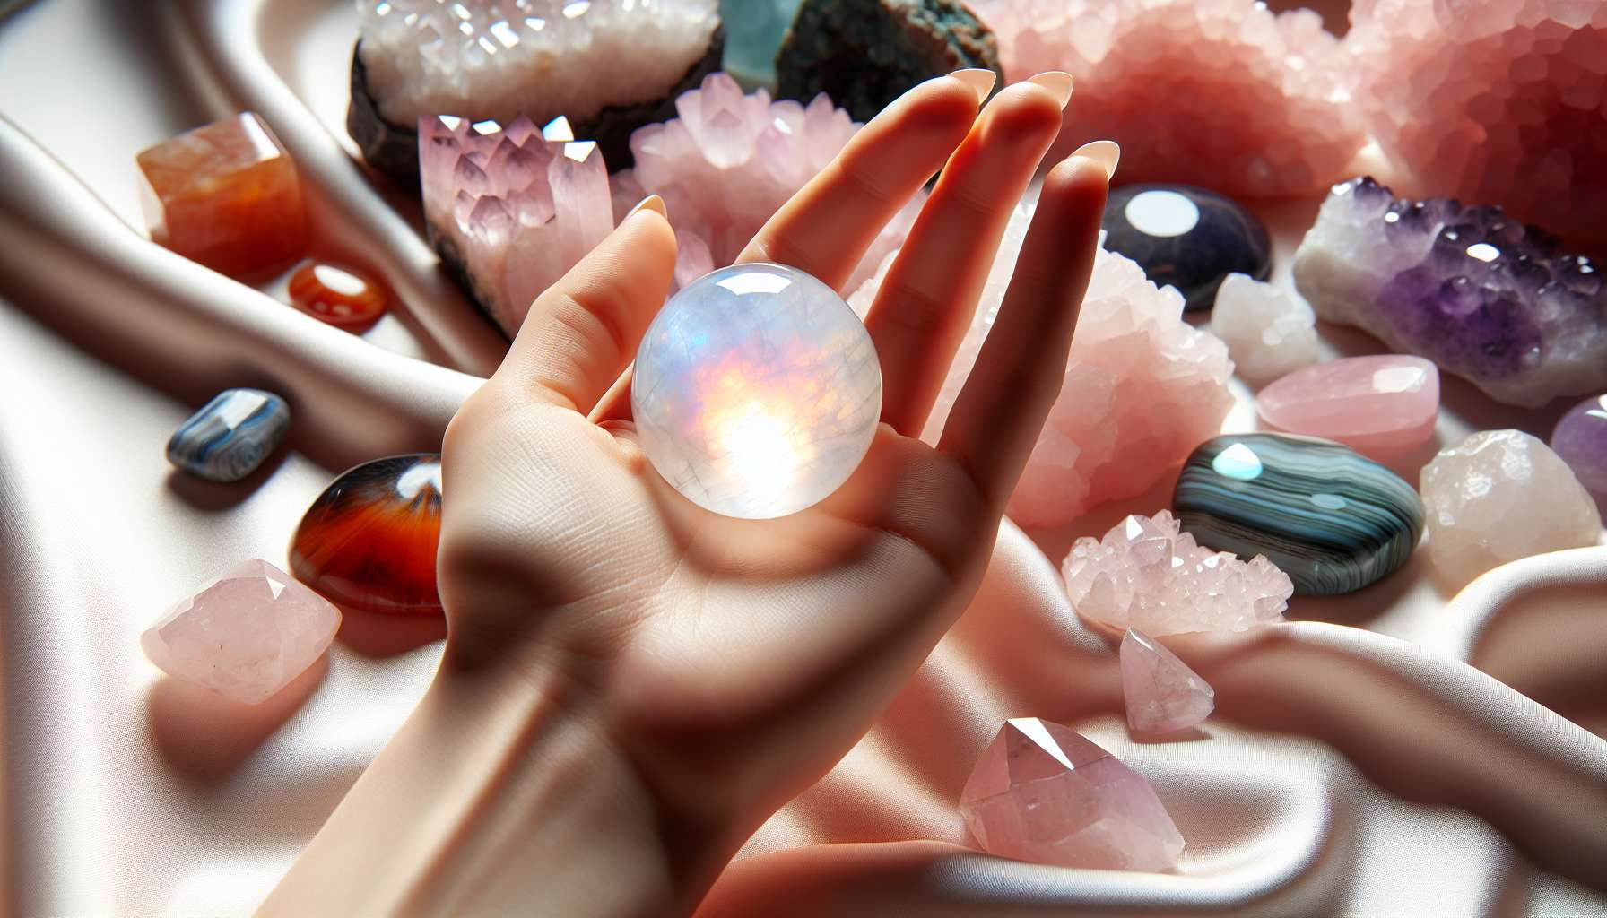
Lithotherapy is a branch of energetic medicine that uses the vibratory properties of crystals and stones to rebalance the physical, emotional and energetic bodies. Each crystal has a unique frequency that resonates with different aspects of our being and can be used to support healing and transformation processes.
Crystals are valuable allies for women, as they can help them reconnect with their feminine essence, balance their hormonal cycle, and navigate the different stages of their life with grace and serenity. Certain crystals have a particular affinity with feminine energy, such as moonstone which promotes intuition and creativity, rose quartz which opens the heart and soothes sorrows, and carnelian which stimulates sexual vitality.
There are many ways to use crystals in lithotherapy: by wearing them as jewelry on the areas of the body to be harmonized, by placing them in your environment to create a favorable energetic space, by using them in meditation to refocus and recharge, or by incorporating them into energy treatments such as massages or reiki sessions.
Here are some examples of essential crystals for women's health:
- Moonstone, to balance menstrual cycles, boost fertility and accompany transitions from puberty to menopause.
- Rose Quartz, for healing heart wounds, developing self-love and cultivating gentleness in relationships.
- Carnelian, to awaken sexual creativity, tone reproductive organs, and relieve menstrual pain.
- Amethyst, to soothe the mind, promote restful sleep, and connect with spirituality.
- Malachite, to release repressed emotions, cleanse the uterus and facilitate childbirth.
Before using a crystal, it is important to purify and energetically recharge it, so that it regains its original frequency. This can be done by placing it in saltwater, passing it through sage smoke, or letting it replenish under moonlight. It is also recommended to connect with the crystal by meditating with it and transmitting your healing intention.
Beyond their therapeutic properties, crystals also bring a symbolic and sacred dimension to the practice of Divine Feminine Healing. Each crystal carries a teaching and can be a support for meditation and contemplation. For example, lapis lazuli invites us to express our truth and deploy our gifts, while labradorite helps us navigate fear and trust in the unknown.
Lithotherapy perfectly integrates into a psycho-energetic approach to women's health, in synergy with other tools such as floral elixirs, aromatherapy, or yoga. Combining a crystal with an essential oil or a floral elixir enhances their effects and creates powerful vibratory synergies. For example, combining moonstone with Apple floral elixir and clary sage essential oil encourages a return to sensuality and feminine creativity.
As a Divine Feminine Healing practitioner, it is essential to develop energetic sensitivity and knowledge of crystals to use them appropriately and intuitively. This requires creating an intimate relationship with stones, listening to and being guided by their wisdom. Crystals are living beings, bearing consciousness and ancestral memory. They can teach us much about ourselves and the laws of the universe.
Integrating lithotherapy into one's practice offers women a healing path that is both gentle and powerful, inviting them to connect with the magic of the earth and awaken their priestess and healer memories. Crystals are consciousness catalysts that help us remember who we are and embody our light. They are valuable allies on the path of Divine Feminine Healing.
Key takeaways:
- Lithotherapy uses the vibratory properties of crystals to rebalance the physical, emotional, and energetic bodies. Each crystal has a unique frequency that resonates with different aspects of our being.
- Crystals are valuable allies for women, helping them reconnect with their feminine essence, balance their hormonal cycle, and navigate life stages with grace and serenity.
- There are several ways to use crystals in lithotherapy: as jewelry, within the environment, in meditation, or in energy treatments.
- Some essential crystals for women's health, each with their specific properties, include moonstone, rose quartz, carnelian, amethyst, and malachite.
- Before using a crystal, it's important to purify and energetically recharge it so it regains its original frequency.
- Crystals bring a symbolic and sacred dimension to the practice of Divine Feminine Healing, each carrying a unique teaching.
- Lithotherapy integrates well within a psycho-energetic approach to women's health, synergizing with other tools such as floral elixirs and aromatherapy.
- To use crystals appropriately and intuitively, it's essential to develop energetic sensitivity and crystal knowledge, cultivating an intimate relationship with stones.

